Contents

Network Devices 1

Interfaces & Cables 3

OSI & TCP/IP 10

Intro to CLI 16

Ethernet LAN Switching 26

Ethernet LAN Switching (Part 1) 26

Ethernet LAN Switching (Part 2) 31

IPv4 Addressing 39

IPv4 Addressing (Part 1) 39

IPv4 Addressing (Part 2) 43

Switch Interfaces 49

IPv4 Header 56

Routing Fundamentals 62

Routing Fundamentals 62

Static Routing 67

Life of a Packet 73

Subnetting 75

VLAN 84

VLAN Intro 84

Trunk Ports 88

# Network Devices

**Network**

* A computer network is a digital telecommunications network which allows nodes to share resources

**Client**

* A device that accesses a service made available by a server

**Server**

* A device that provide functions or services to clients
* Can be as simple as a smartphone or pc

**Switch**

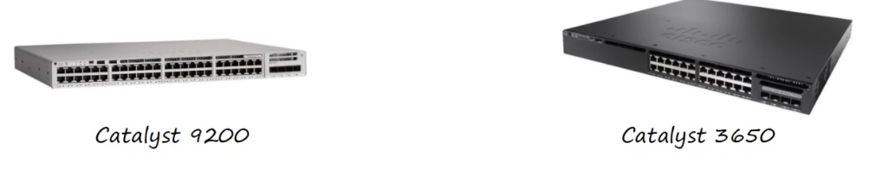

* Have many network interfaces/port  for end hosts to connect (usually 24+)
* Provide connectivity to hosts within the same LAN (Local Area Network)
* Do not provide connectivity btw LAN or the Internet

**Router**

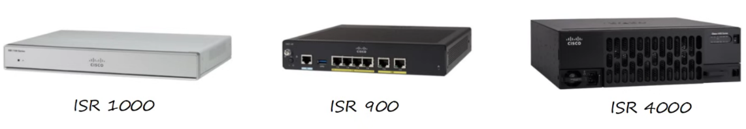

* Fewer network interfaces than switches
* Used to provide connectivity btw LANs
* Therefore used to send data over the Internet
* Can provide some basic security features

**Firewalls**

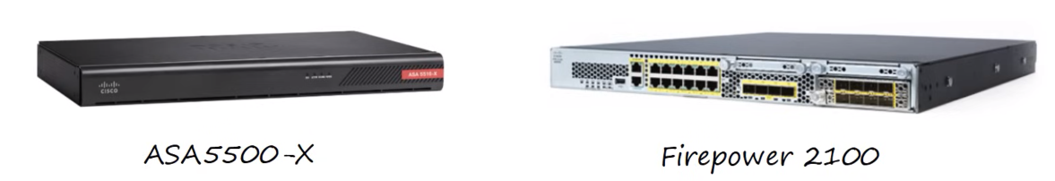

* Monitor and control network traffic based on configured rules
* Can be placed 'inside' or 'outside' the network
* Are known as 'Next-Generation Firewalls' when they include more modern and advanced filtering capabilities
* The 2 firewalls above are next-gen
* Types of firewalls:
  + **Network firewalls**
    - Hardware devices that filter traffic between networks
  + **Host-based firewalls**
    - Software applications that filter traffic entering and exiting a host machine, like a PC

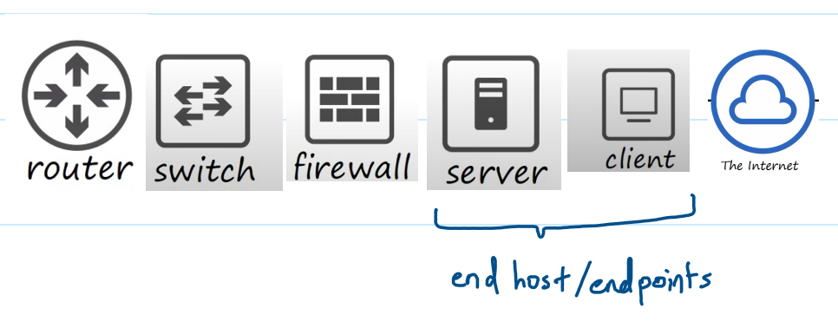

# Interfaces & Cables

RJ45

* Registered Jack
* Used at the end of a copper ethernet cable

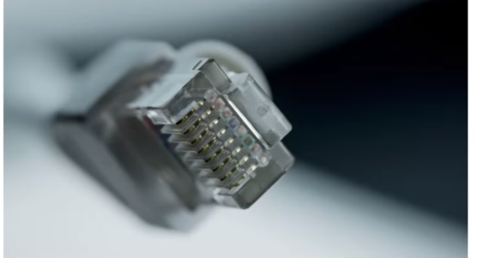

Ethernet

* A collection of network protocols/standards
* For the lesson, we will focus on type of cabling for ethernet

Network Protocols

* Allow devices to communicate with each other without issues

Bits & Bytes

* 1 byte = 8 bit
* Speed measured in bits/s
* Data on drives measured in bytes

Ethernet Standards

* Defined in the IEEE 802.3 standard
* IEEE: Institute of Electrical and Electronics Engineers
* Ethernet Standards (Copper)

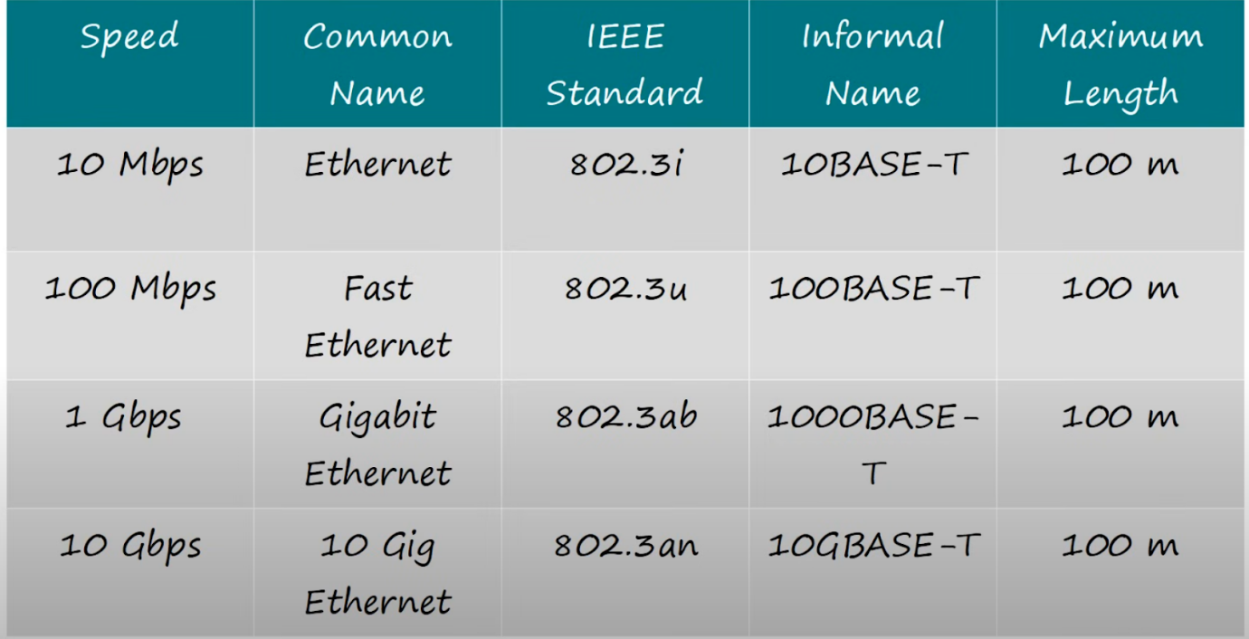

* BASE: refers to baseband signalling
* T: twisted pair

UTP Cables

* Unshielded Twisted Pair
* The twist protects against Electromagnetic Interference

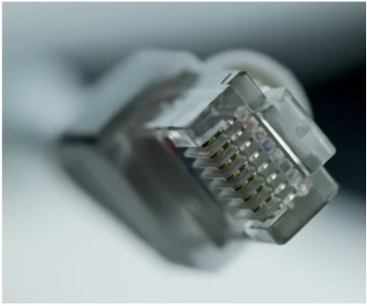

* Consists of 8 wires
  + 10/100BASE-T: 2 pairs (4 wires)
  + 1000/10GBASE-T: 4 pairs (8 wires)
* 10/100BASE-T
  + Straight-through cable
    - Pin 1 -> Pin 1

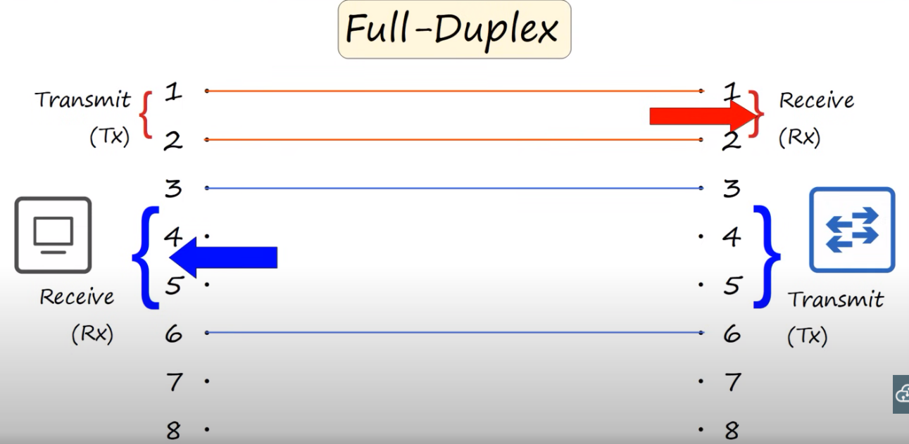

* Crossover cable
  + Pin 1 -> Pin 3

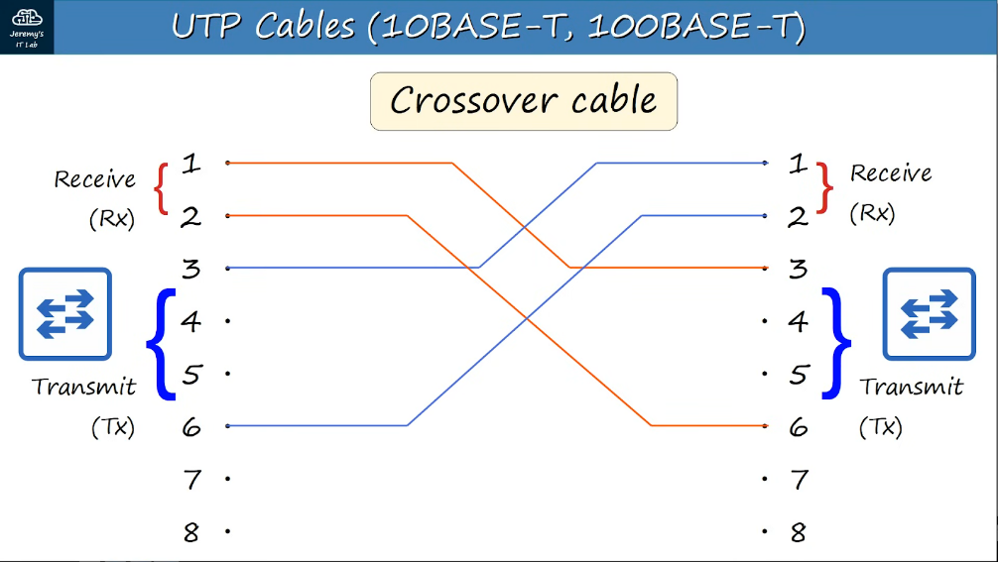

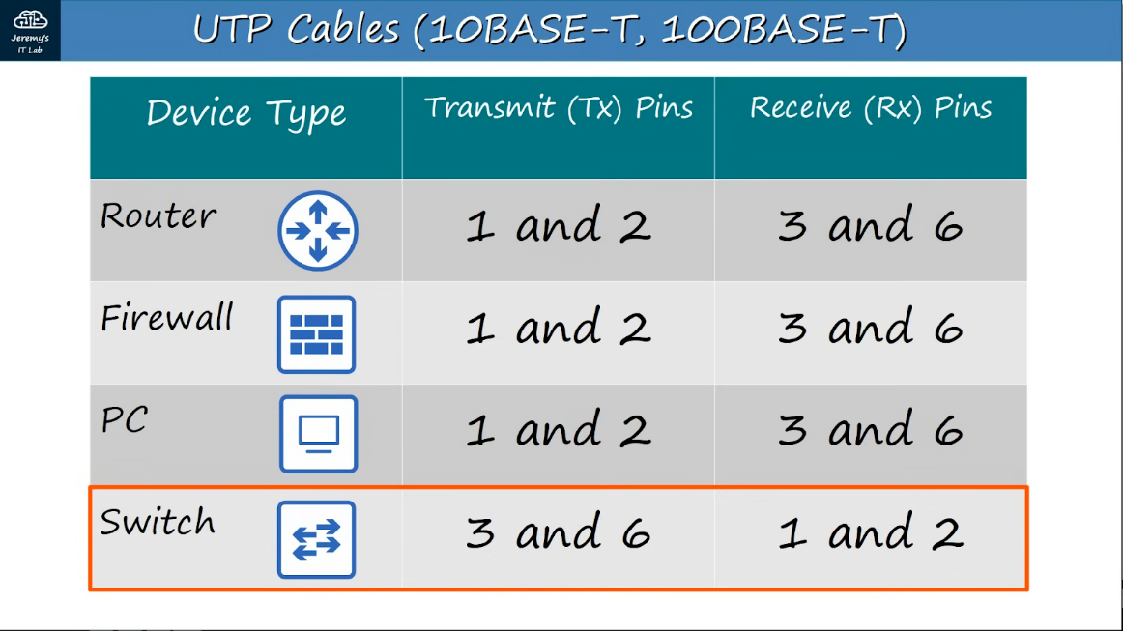

* Auto MDI-X
  + New network devices has a feature called Auto MDI-X that allows the transmit and receive pins to be connected incorrectly and still work

* 1000/10GBASE-T
  + 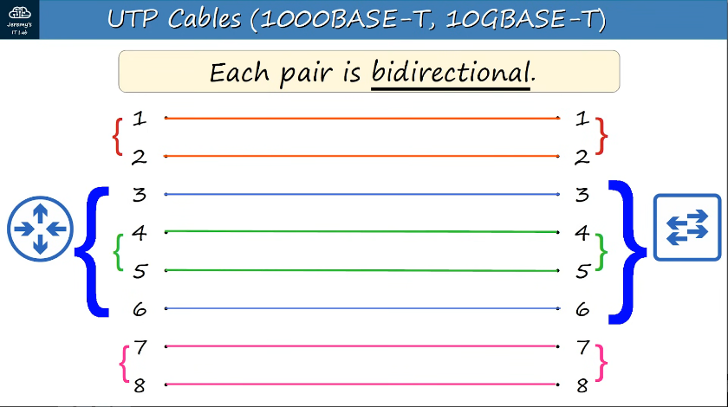

Fibre-Optic Connections

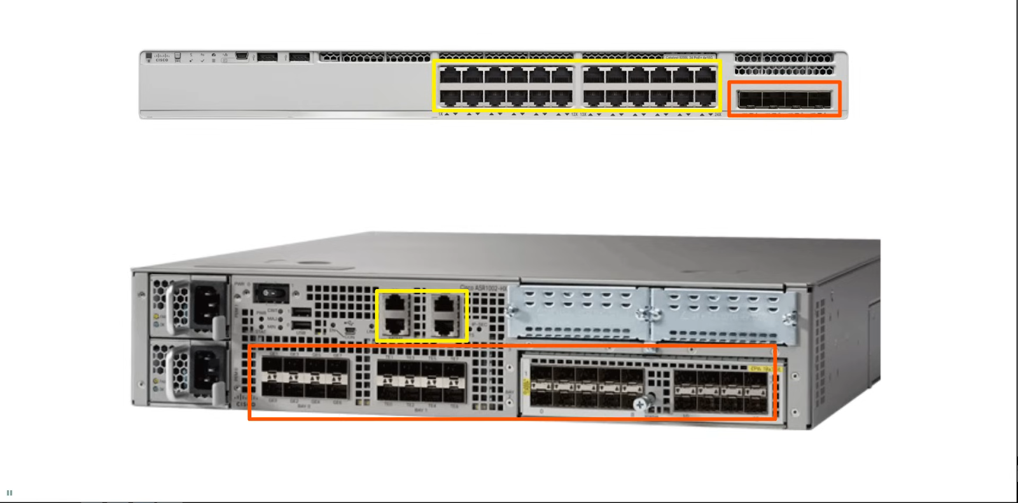

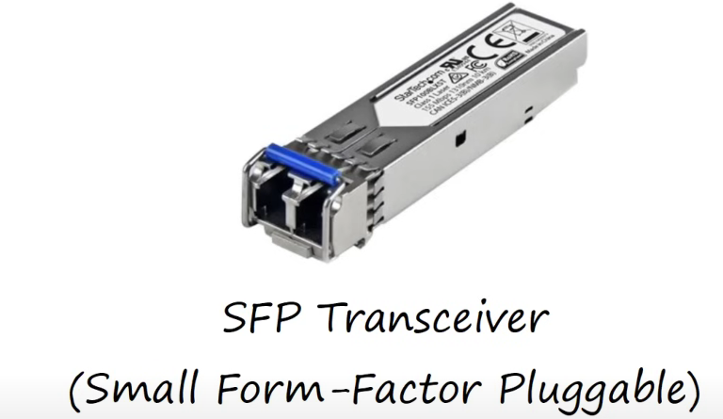

* Plugged into the fibre optic connection
* They are connected to fibre optic cables

Fibre Optic Cables

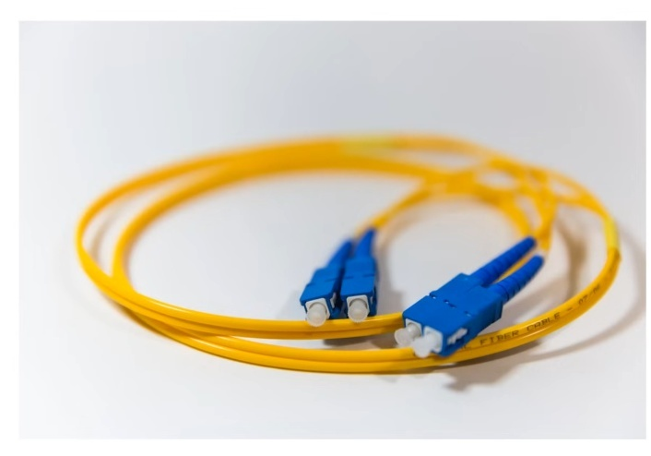

\

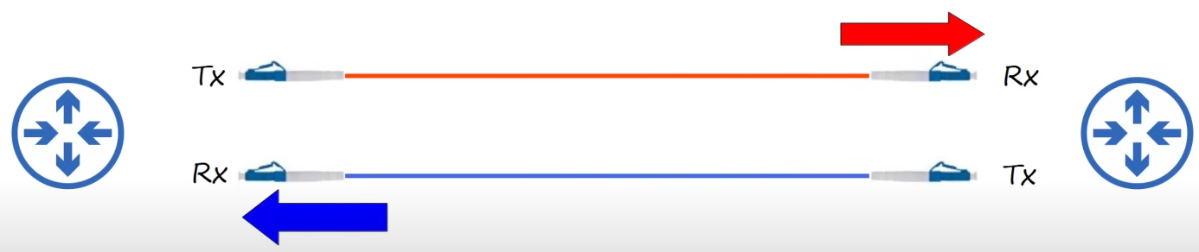

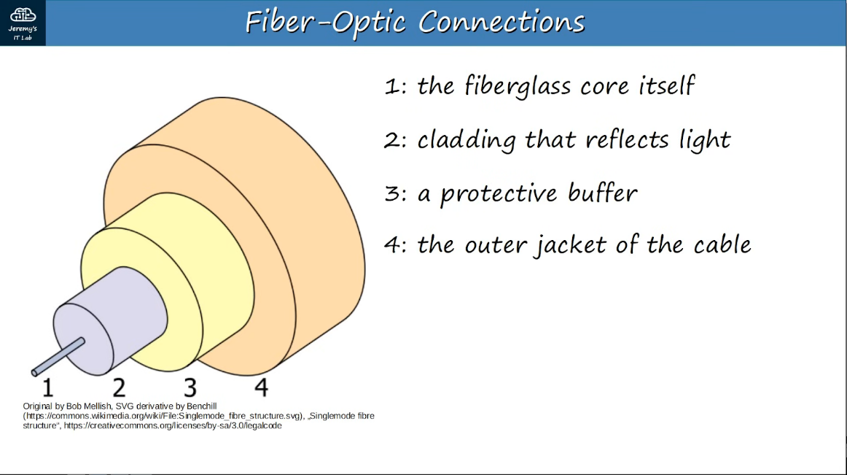

* They are different types of fibre cables
  + Single-mode
  + Multi-mode
* Multi Mode

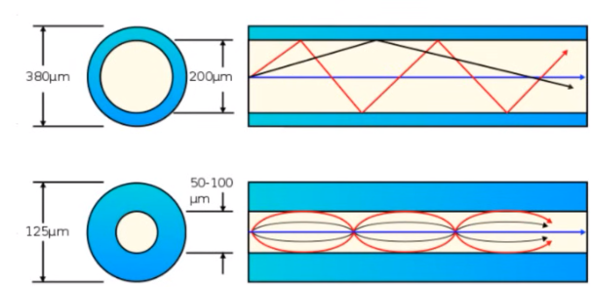

* Core diameter is wider than single-mode fibre
* Allow multiple angles (modes) of light waves to enter the fibreglass core
* Allow longer cables than UTP, but shorter than single-mode
* Cheaper than single-mode (due to cheaper LED-based SFP transmitter)
* Single-Mode

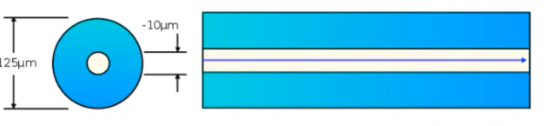

* Core diameter is narrower than multi-mode fibre
* Light enters from a single angle (mode) from a laser based transmitter
* Allow longer cables than both UTP and multi-mode fibre
* More expensive than multi-mode fibre (due to more expensive laser-based SFP transmitter)

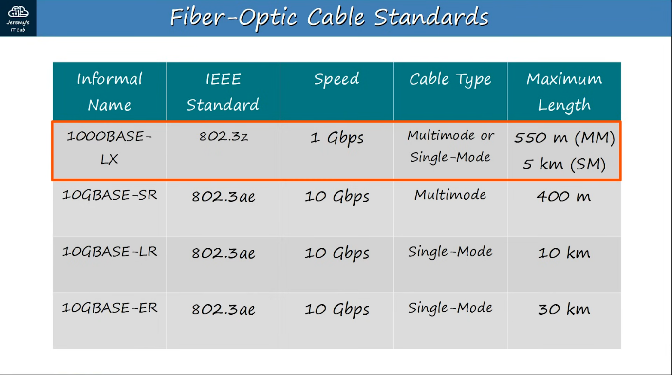

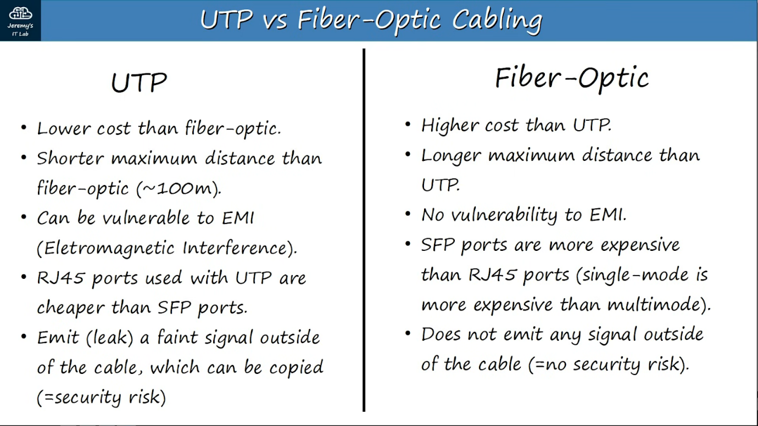

# OSI & TCP/IP

**What is a networking model?**

* Networking models categorize and provide structure for networking protocols and standards
* Protocols
  + A set of logical rules (non-physical) defining how a network device and software should work

**OSI Model**

* Open Systems Interconnection model
* A conceptual model that categorizes and standardizes the different functions in a network
* Divided into 7 layers
* The layers work together to make the network work
* Layer 7: Application
  + Layer closest to end user
  + Interacts with software applications (e.g.web browser - chrome)
  + HTTP and HTTPS are Layer 7 protocols
  + Doesn’t include the applications, but rather the protocols that interact with the app like HTTP
  + Functions include
    - Identifying communication partners
    - Synchronising communication

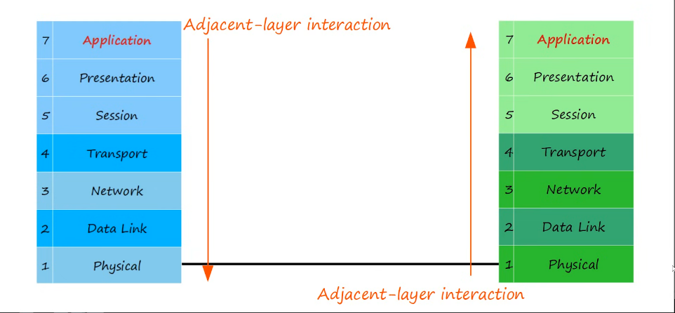

* Same-layer interaction in the application layer allows the layer 7 functions
* Layer 6: Presentation
  + Data in the presentation layer is in 'application format'
  + It needs to be translated to a different format to be sent over the network
  + The presentation layer's job is to translate btw application and network formats
  + Eg. Encryption of data as it is sent, and decryption as it is received
  + Translates btw different application-layer formats
  + Basically - translates data into the appropriate format
* Layer 5: Session
  + Control dialogues (sessions) btw communicating hosts
  + Establishes, manages, and terminates connections btw the local application (e.g. your web browser)  and the remote application (e.g. YouTube)
  + YouTube services are used by many people and there is a need to manage the sessions, which is the purpose of the Session Layer

* Network engineers don't usually work with top 3 (upper) layers
* Application developers work with the upper layers to connect their applications over networks

* Layer 4: Transport
  + Segments and reassembles data for communications btw end hosts
  + Break large pieces of data into smaller segments which can be more easily sent over the network and are less likely to cause transmission problems if errors occur
    - e.g. If want to watch video but there is error, cannot watch at all. But if video data divided into small units, still can watch some
  + Provides host-to-host communication
* Layer 3: Network
  + Provides connectivity btw end hosts on different networks (e.g. outside of LAN)
  + Provides logical addressing (IP addresses)
  + Provides path selection btw source and destination
    - There are many path the data can take, layer 3 selects the best path
  + Routers operate at layer 3
* Layer 2: Data Link
  + Provides node-to-node connectivity and data transfer (e.g. PC to switch, switch to router, router to router)
  + Defines how data is formatted for transmission over a physical medium (e.g. copper UTP cables)
  + Detects and (possibly) corrects Physical Layer errors
  + Uses Layer 2 addressing, separate from Layer 3 addressing
  + Switches operate at Layer 2
* Layer 1: Physical
  + Defines the physical characteristics of the medium used to transfer data btw devices
    - E.g. Voltage levels, max transmission distances, physical connectors, cable specifications, etc
  + Digital bits are converted to electrical (for wired connections) or radio (for wireless connections) signals
  + All the info in day 2 is related to Layer 1

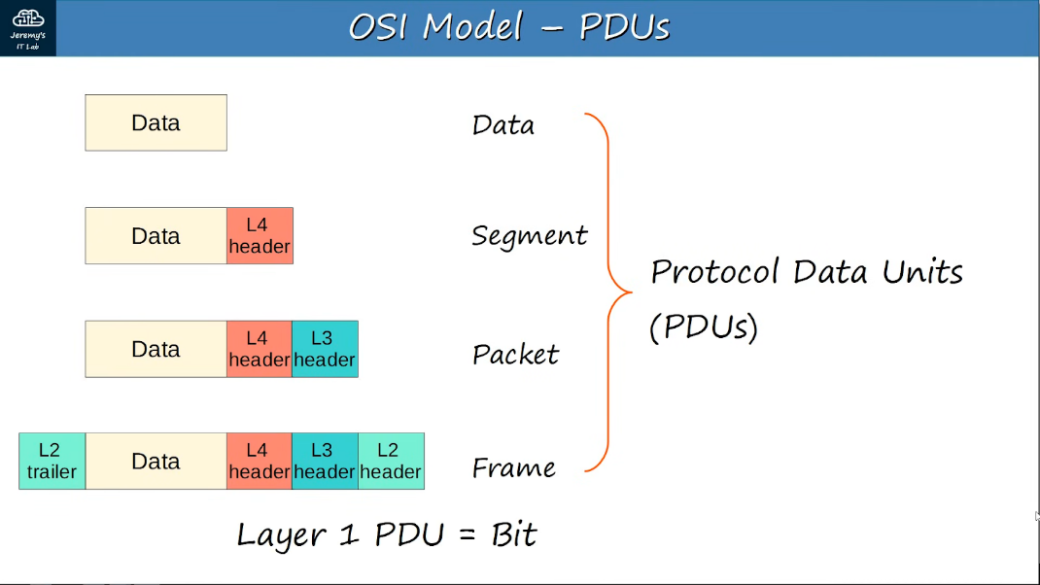

Acronyms

* All People Seem To Need Data Processing
* Please Do Not Teach Students Pointless Acronyms

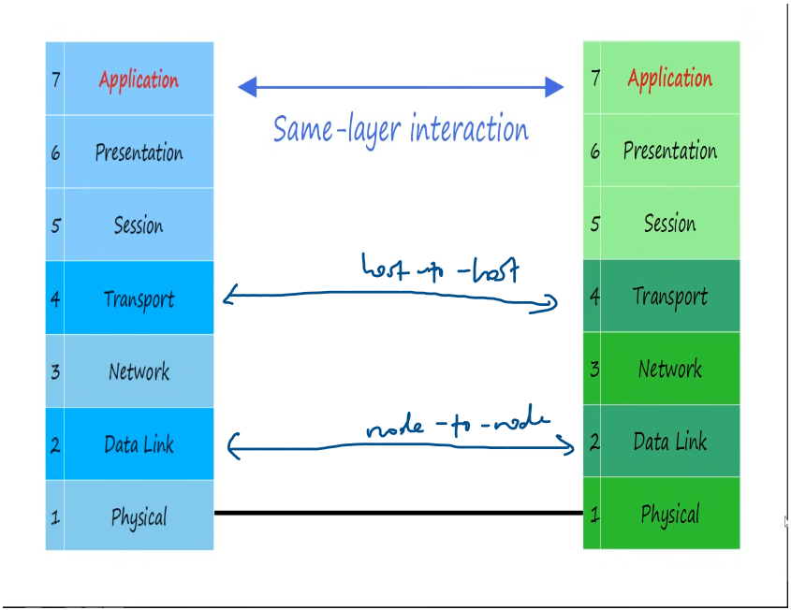

**TCP/IP suite**

* Conceptual model and set of communications protocols used in the Internet and other networks
* Known as TCP/IP because those are 2 of the foundational protocols in the suite
* Similar to OSI but lesser layers
* Used in modern networks
* OSI model still influences how network engineers think and talk about networks

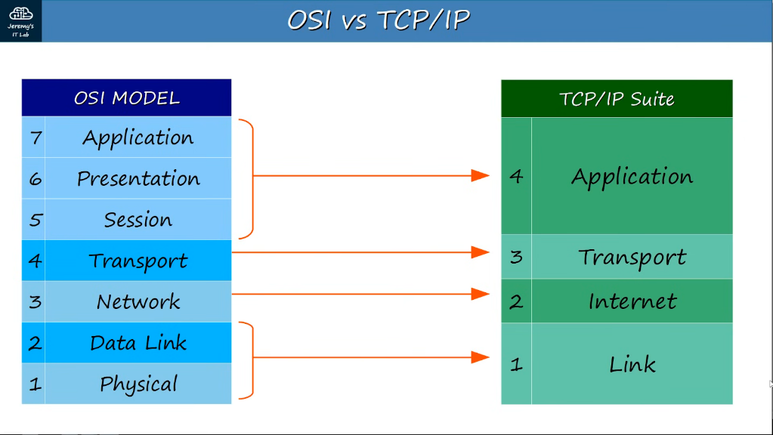

* When talking about layers, refer to the OSI
  + E.g. there is a layer 4 problem - refers to transport layer

Different naming conventions for the TCP/IP suites

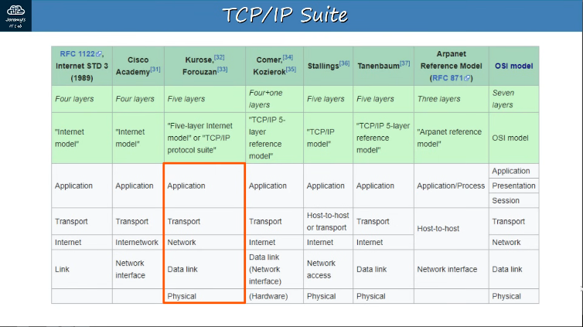

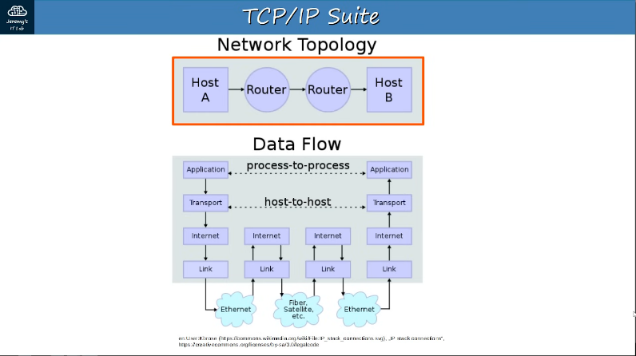

* De-encapsulate till the internet layer only as they only need the IP address to know where to send to

# Intro to CLI

What is a CLI?

* Command Line Interface
* Used to configure Cisco devices
* GUI: Graphical User Interface

How to connect a Cisco device? (Console port)

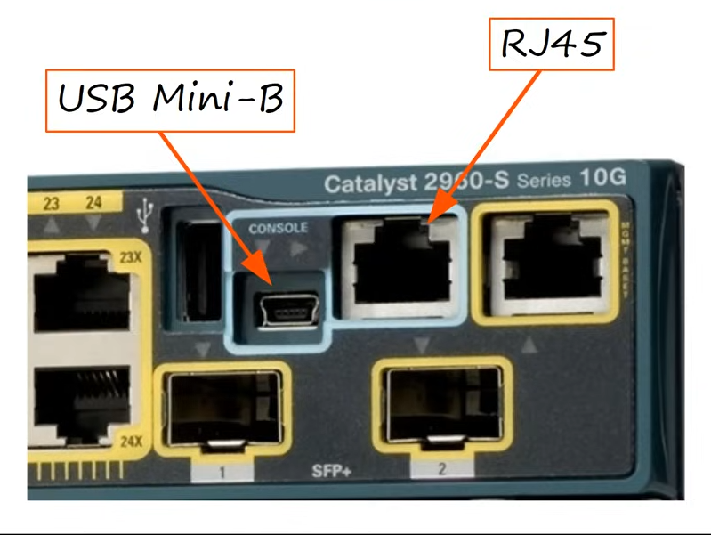

* Can connect to either of them

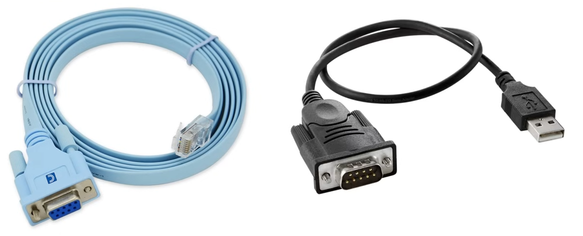

* Will need to use a rollover cable

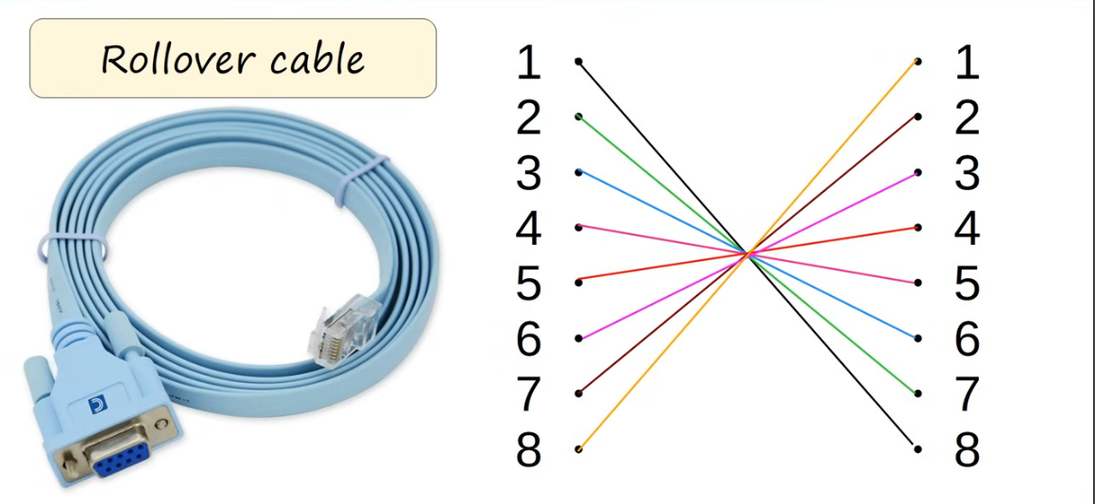

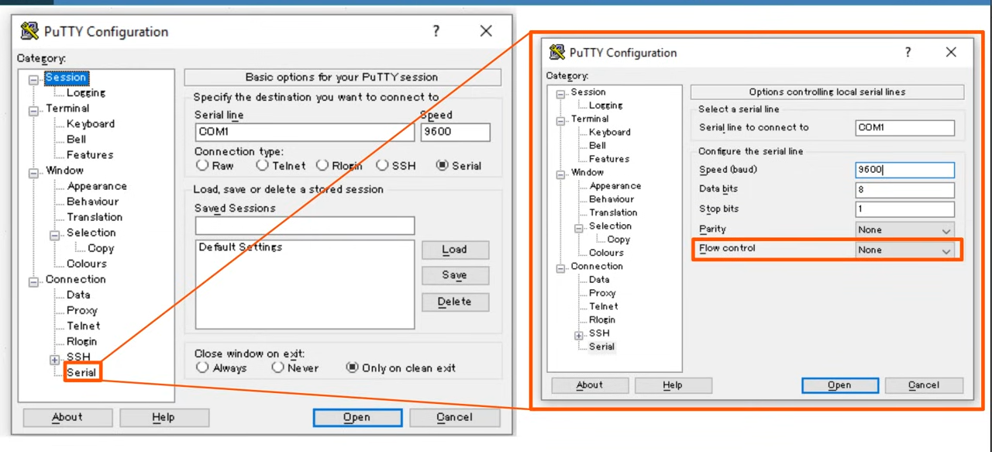

* Connect to CLI using PuTTy
* Settings (default settings)
  + Serial
  + Speed (baud) : 9600
  + Data bits: 8
  + Stop bits: 1
  + Parity: None
  + Flow Control: None

User EXEC Mode

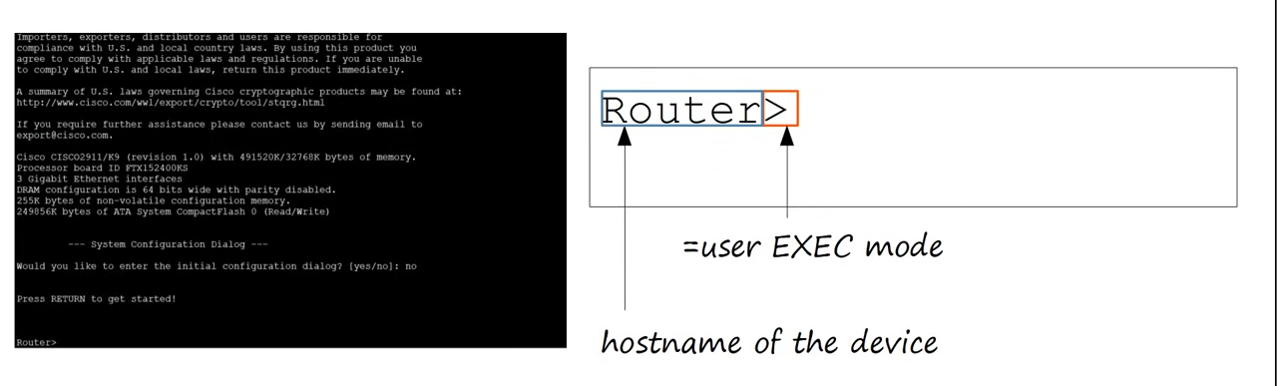

* User EXEC mode is very limited
* Users can look at some things, but can't make any changes to configuration
* Also called 'user mode'

Privileged EXEC Mode

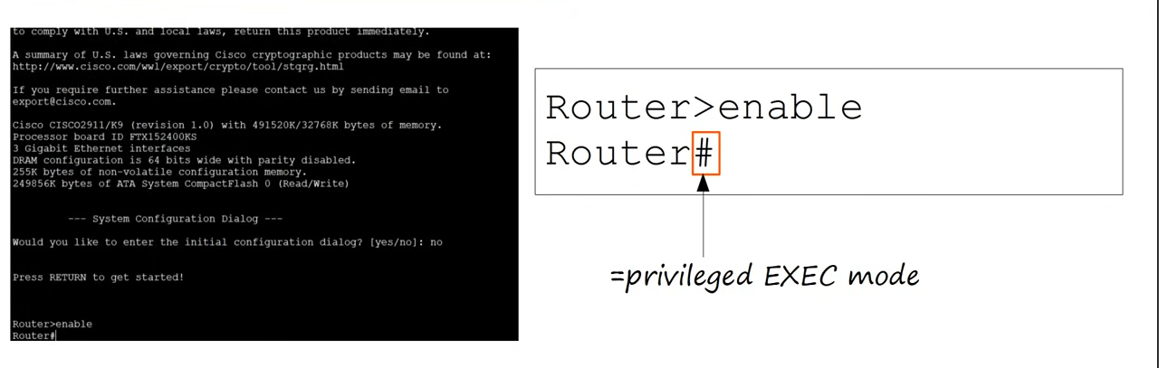

* Provides complete access to view the device's configuration, restart the device, etc
* Cannot change the configuration, but can change the time on the device, save the configuration, etc

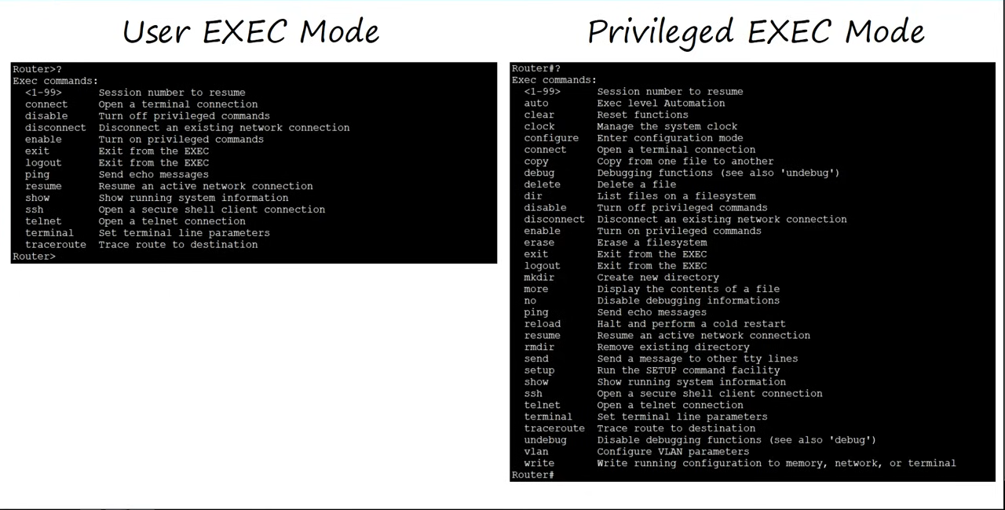

* Use 'en' or 'enable' to go to privileged mode

Global Configuration Mode

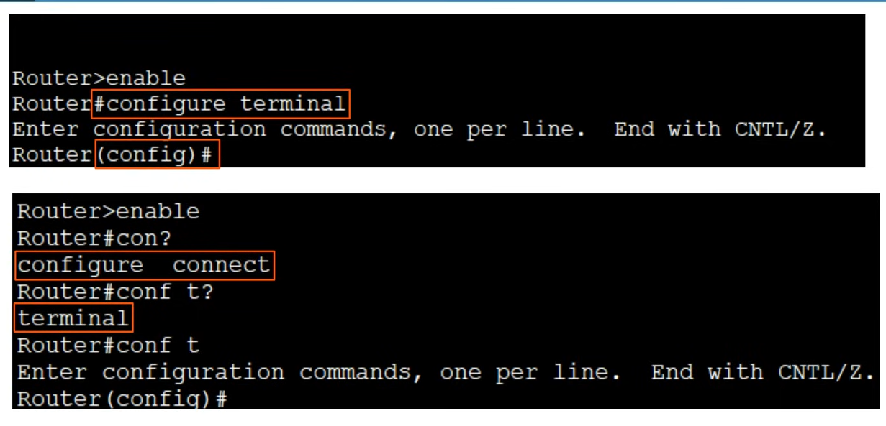

Enable Password

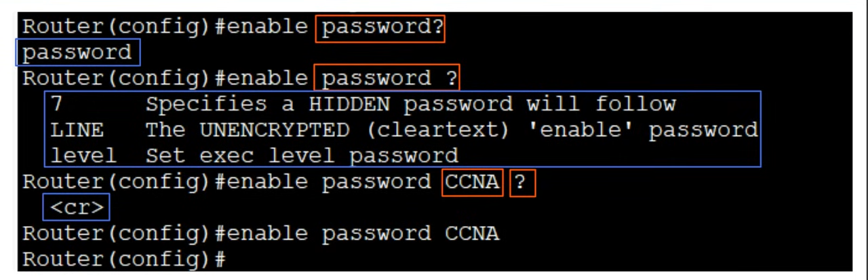

* Passwords are case sensitive

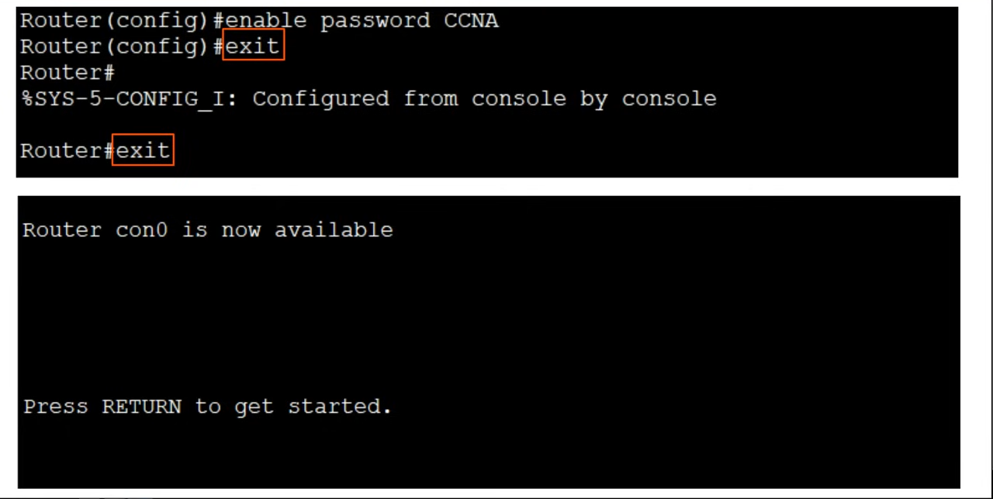

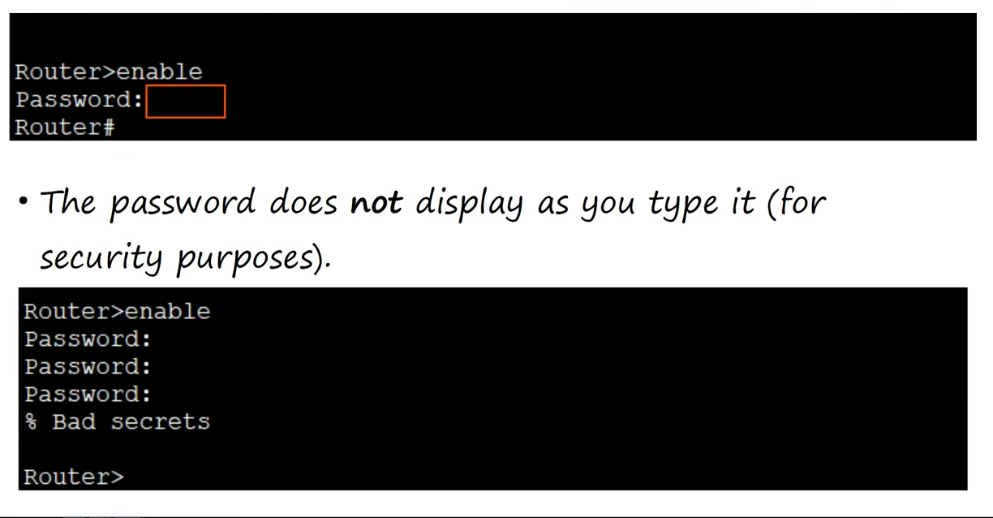

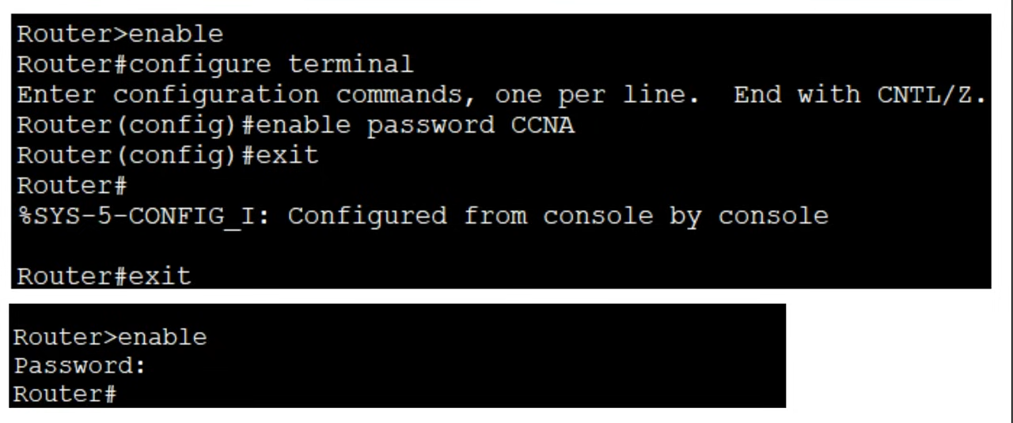

running-config / startup-config

* There are 2 separate config files kept on the device at once
* Running-config
  + The current, active config file on the device
  + As you enter commands in the CLI, you edit the active config
* Startup-config
  + The config file that will be loaded upon restart of the device

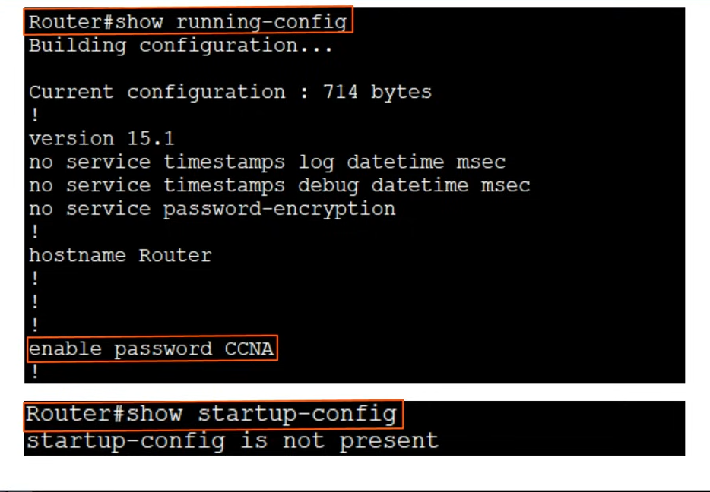

Saving the configuration

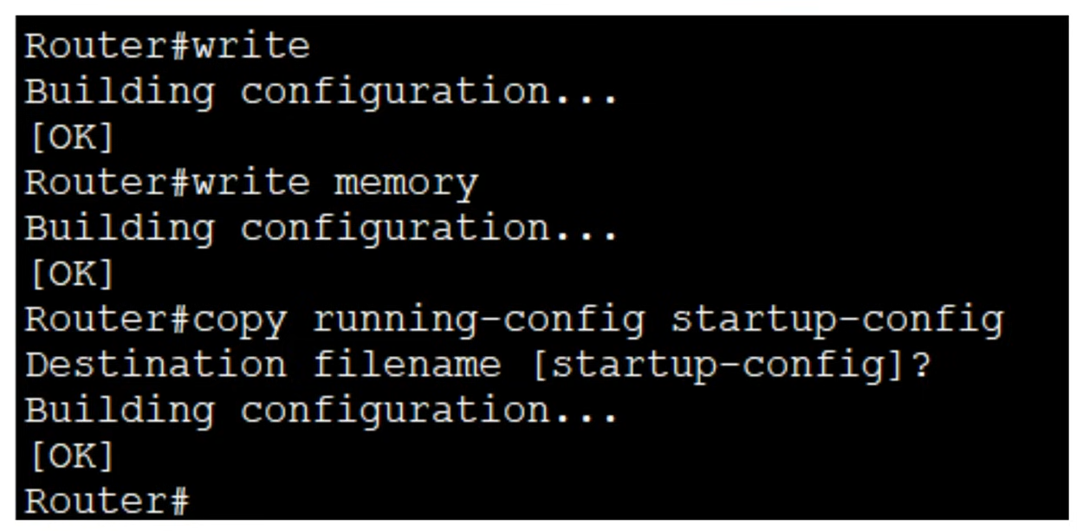

Service password-encryption

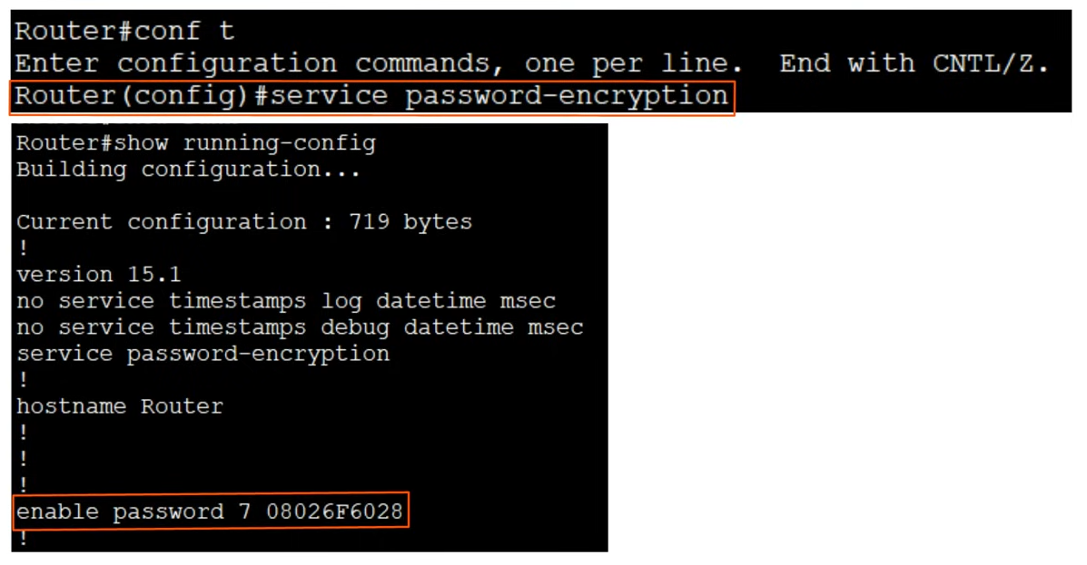

* Encrypted password can easily be decrypted by basic online tools

Enable secret

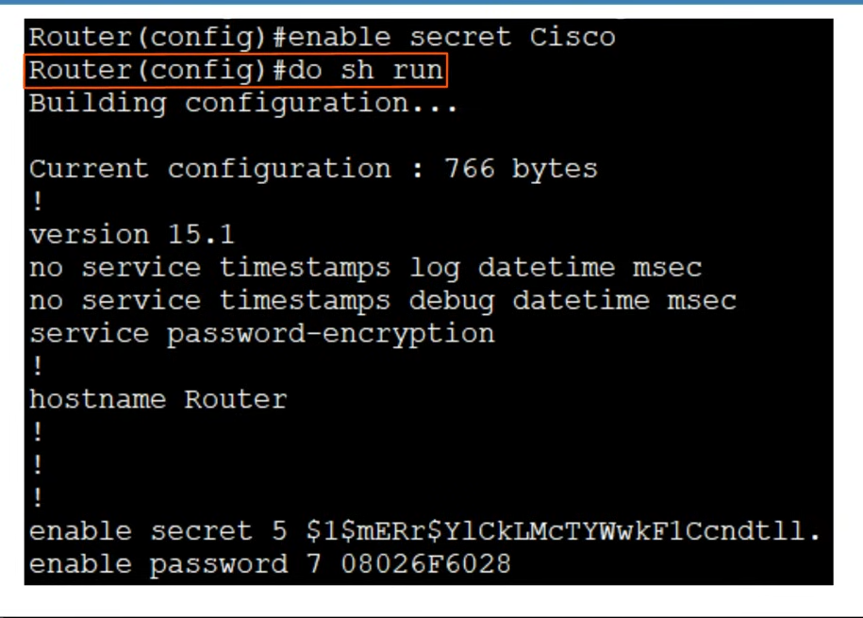

* At the last 2 lines, both "enable secret" and "enable password" shown
* It will automatically choose the "enable secret" and ignore "enable password"
* "enable secret" will always be encrypted, don't need to use "service password-encryption" command as previously used with "enable password"
* Should always use "enable secret"

Cancelling Commands

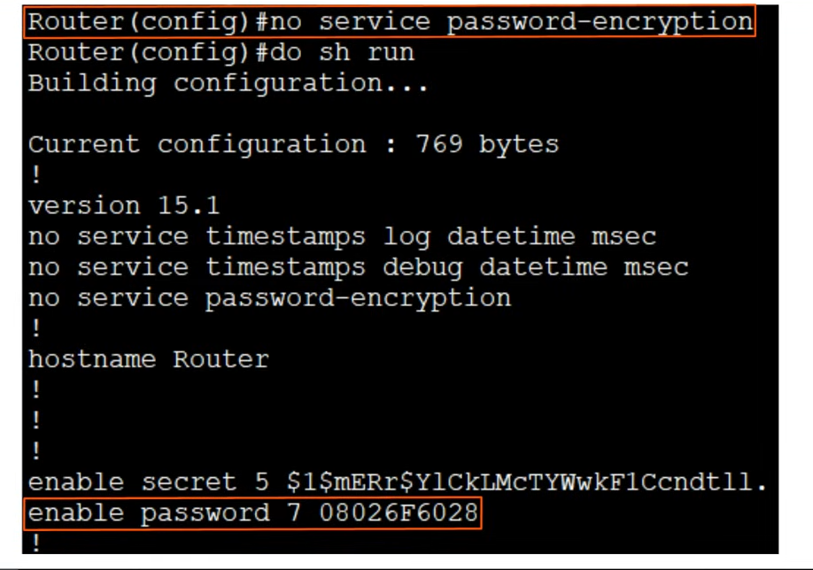

* Write a "no" in front of the command you want to cancel

"service password-encryption"

* If enable "service password-encryption"
  + Current passwords will be encrypted
  + Future passwords will be encrypted
  + "enable secret" will not be affected
* If disable
  + Current passwords remain encrypted and will not be decrypted
  + Future passwords will not be encrypted
  + "enable secret" will not be affected

Modes Review

* Router>  :         user EXEC mode
* Router#  :         privileged EXEC mode
* Router(config)# : global configuration mode

Command Review

* Router>**enable**
  + Used to enter privileged EXEC mode
* Router#**configure terminal**
  + Used to enter global config mode
* Router(config)#**enable password** password
  + Configures a password to protect privileged EXEC mode
* Router(config)#**service password-encryption**
  + Encrypts the enable password (and other passwords)
* Router(config)#**enable secret** password
  + Configures a more secure, always encrypted enable password
* Router(config)#**run** privileged-exec-level-command
  + Executes a privileged-exec level command from global config mode
* Router(config)#**no** command
  + Removes the command
* Router(config)#**show running-config**
  + Displays the current, active config file
* Router(config)#**show startup-config**
  + Displays the saved config file which will be loaded if the device is restarted
* Router(config)#**write**
  + Saves the configuration
* Router(config)#**write memory**
  + Saves the config
* Router(config)#**copy running-config startup-config**
  + Saves the config

# Ethernet LAN Switching

## Ethernet LAN Switching (Part 1)

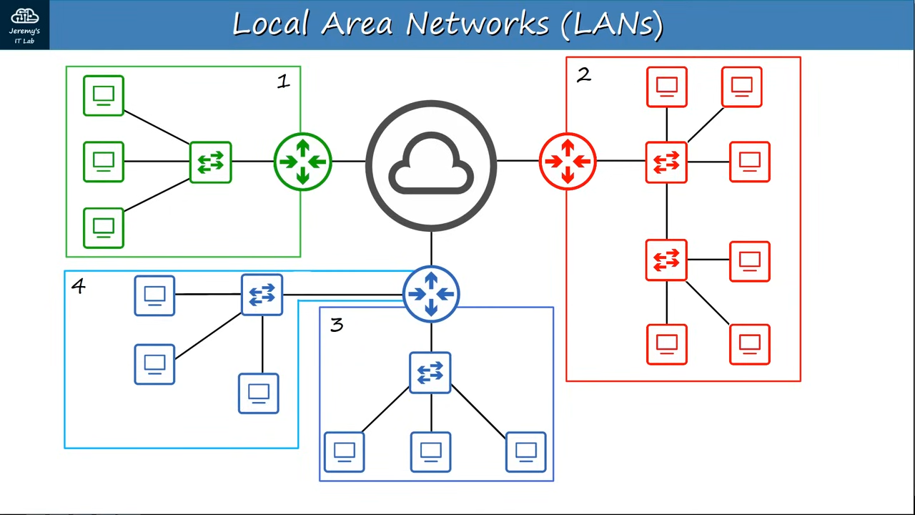

* When switches are connected to router but not connected to each other, they create separate LANs

Ethernet Frame

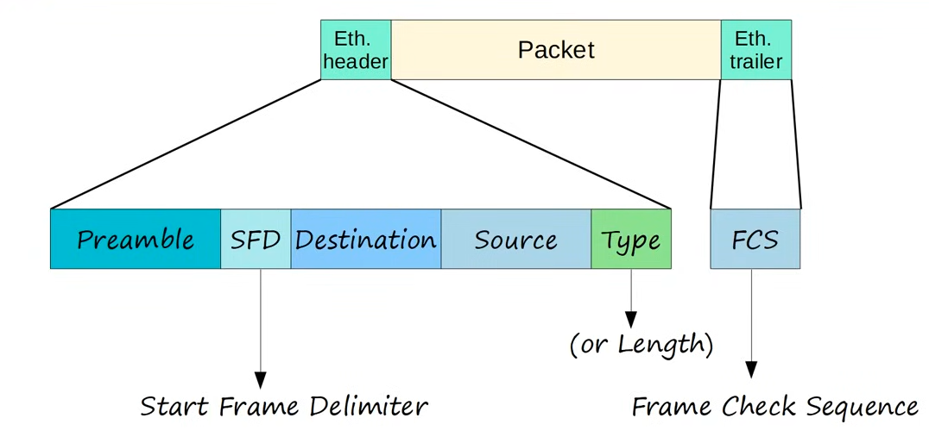

* Preamble
  + Length: 7 bytes = 56 bits
  + Alternating 1 and 0 (10101010 * 7)
  + Allow devices to synchronize their receiver clocks
* SFD
  + Start Frame Delimiter
  + Length: 1 byte = 8 bits
  + 10101011
  + Indicates the end of the preamble and the beginning of the rest of the frame
* Destination & Source
  + Indicate the devices sending and receiving the frames
  + Consists of the destination and source MAC address
  + MAC = Media Access Control
  + 6 byte = 48 bit address of the physical device
* Type/Length
  + 2 bytes = 16 bits
  + Indicate type/length of encapsulated packet
  + If the value of the field is 1500 or less, it indicates the LENGTH of the encapsulated packet in bytes
  + A value of 1536 or greater indicates the TYPE of the encapsulated packet (usually IPv4 or IPv6), and the length is determined via other methods
  + IPv4 = 0x0800 = 2048
  + IPv6 = 0x86DD = 34525
* FCS
  + Frame Check Sequence
  + 4 bytes = 32 bits
  + Detects corrupted data by running 'CRC' algorithm over the received data
  + CRC: Cyclic Redundancy Check
    - Cyclic refer to cyclic codes
    - Redundancy refers to the fact that the 4 bytes enlarges the frame w/o adding any new info
    - Check refers that is checks for error

* Total = 26 bytes (header + trailer)

MAC Address

* 6 byte (48 bit) physical address assigned to the device when it is made
* A.K.A 'Burned in Address' (BIA)
* Globally unique
* First 3 bytes are the OUI (Organizationally Unique Identifier) which is assigned to the company making the device
* The last 3 bytes are unique to the device itself
* Written as 12 hexadecimal characters

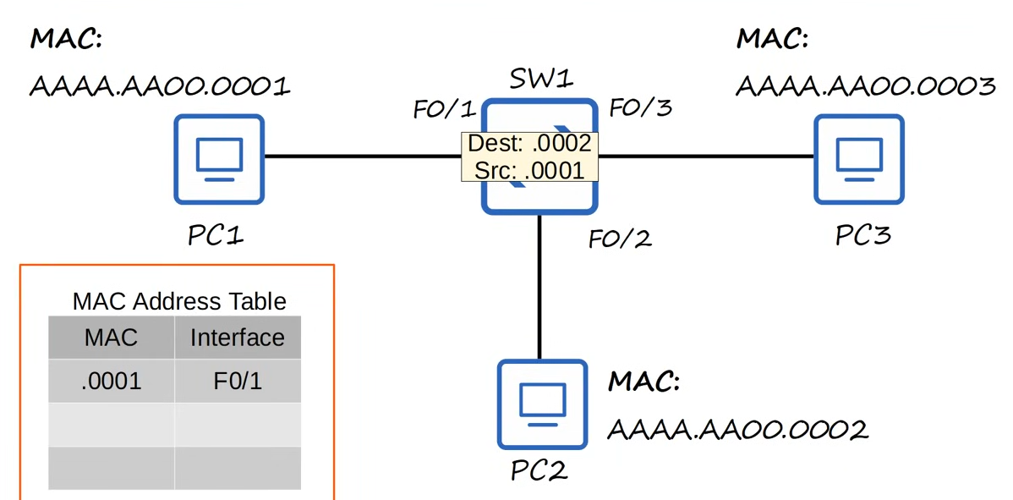

* F0/1
  + Refers to the interface
  + 'F': Fast Ethernet - 100Mbps
* MAC Address Table
  + Dynamically learned MAC Address
  + Switch will know MAC address of source device only when receive frame from the source
* Unicast Frame: A frame destined for a single target
* Unknown unicast frame
  + When the destination is not in the MAC address table
  + Will need to FLOOD the frame
  + Sends the frame on all interface except the one it received from
  + PC3 ignores the frame
  + PC2 receives the packet and decapsulate the packet
  + If it does not send out any packet, the switch will not know the interface of the receiver
  + So, if PC1 sends a packet to PC2 again, will still need to flood the interface
* Known unicast frame
  + Destination in the MAC address table already
  + FORWARD to the correct destination
* For Cisco devices, dynamic MAC address are removed from the MAC address table after 5 minutes of inactivity

Example

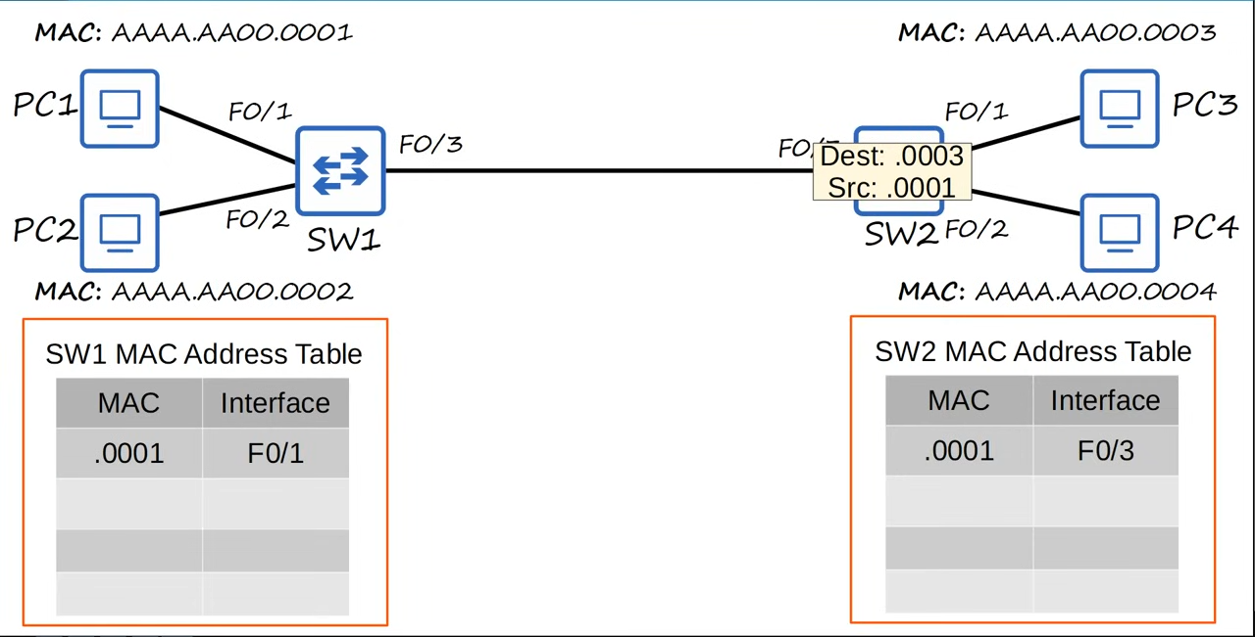

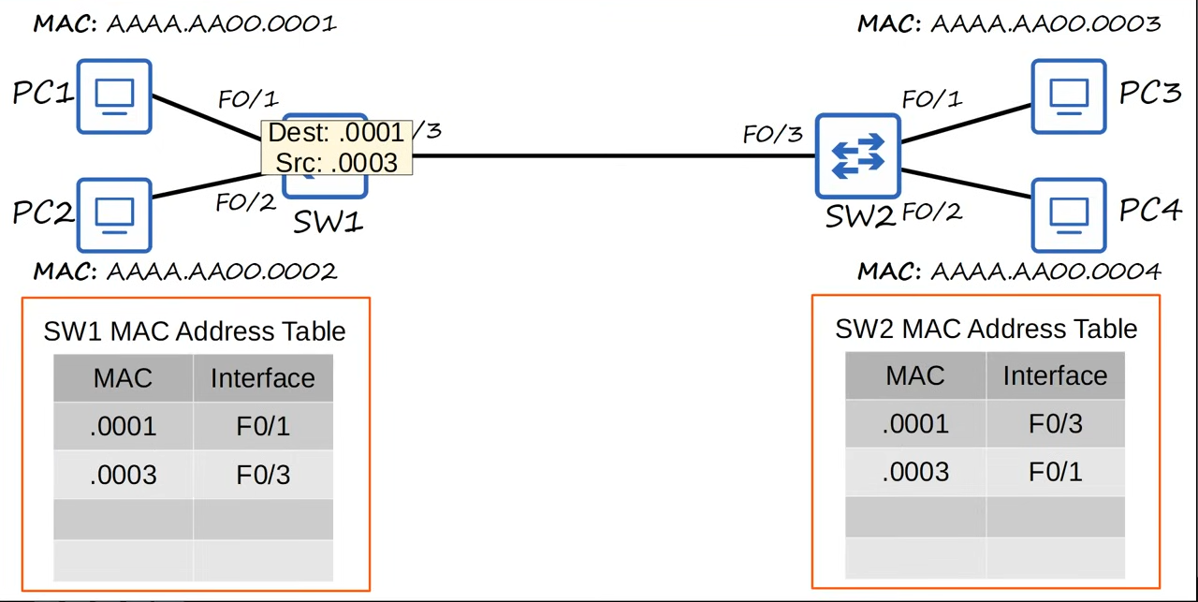

## Ethernet LAN Switching (Part 2)

Ethernet Frame

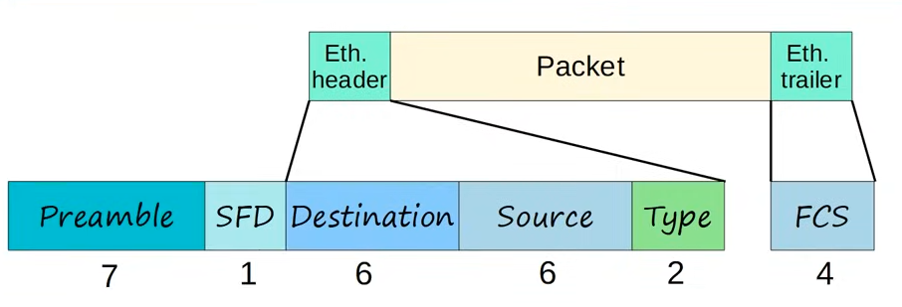

* The preamble + SFD usually not considered as part of the Ethernet header
  + Depends on how you define it
  + Still included in all Ethernet frames
* Size of Ethernet header + trailer = 18 bytes
* Minimum size for an Ethernet frame
  + 64 bytes
  + Header + Payload (packet) + Trailer
  + Minimum payload size = 64 - 18 = 46 bytes
  + If payload smaller than 46 bytes, padding bytes added (all 0's)

Ethernet LAN Switching

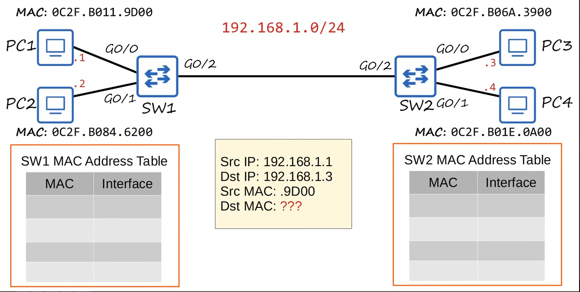

* When sending data, you only know the IP address of the receiver and not the MAC address
* Switches operate at layer 2 only, so need to know the MAC address
* Address Resolution Protocol
  + Used to discover the MAC address using a known IP address
  + Consists of 2 messages
    - ARP request
    - ARP reply
  + ARP request is broadcast

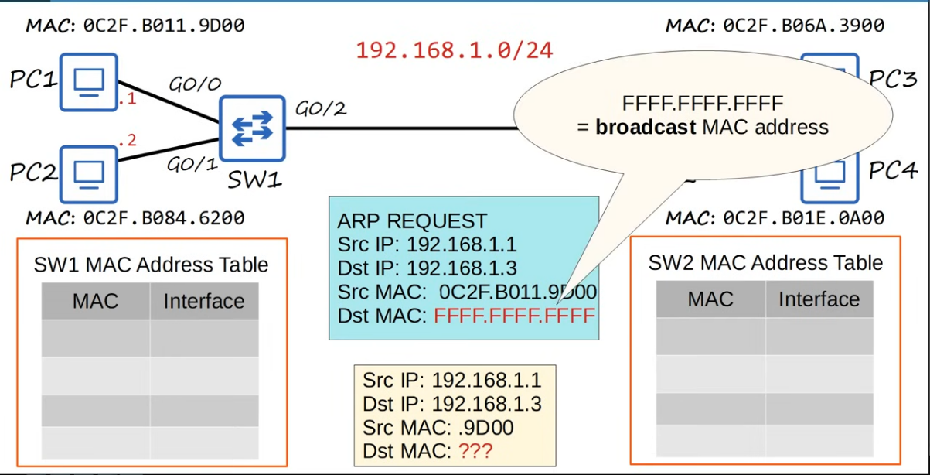

* ARP reply is unicast

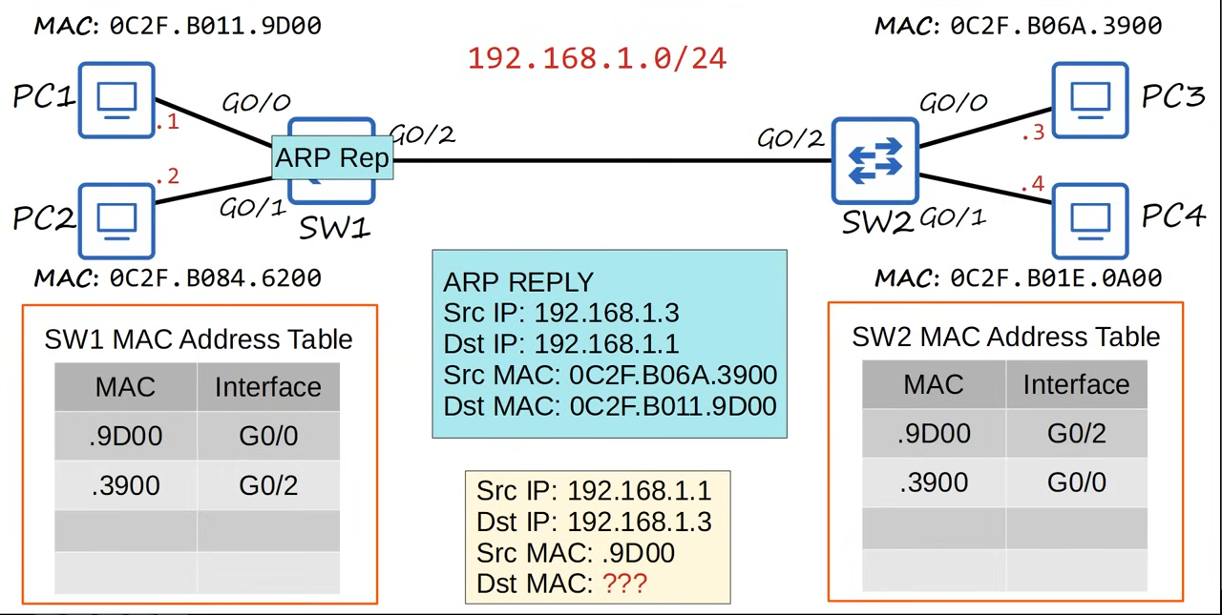

* To view ARP table on pc, use command "arp -a"
  + Internet address - IP address
  + Physical address - MAC address
  + Type static - default entry
  + Type dynamic - learned via ARP

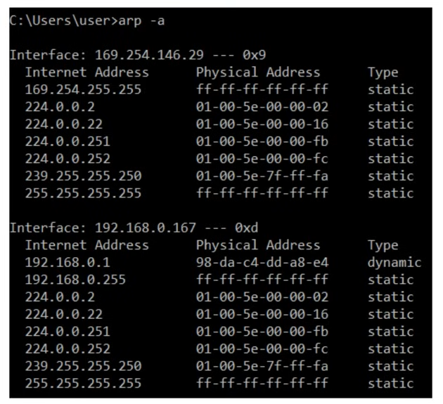

* Ping
  + A network utility that is used to test reachability
  + Measures round-trip time
  + Uses 2 messages
    - ICMP Echo Request
    - ICMP Echo Reply
    - Both are unicast, so need to know the MAC address first
  + Command is "ping {ip_address}"

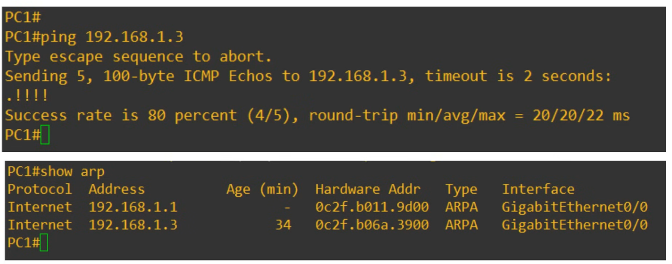

* By default, will send 5, 100byte ICMP Echos
* '.' : failed ping
* '!': successful ping
* First ping fail because of ARP
  + PC1 does not know the destination MAC address, so need to use ARP, causing the first ping to fail
  + After knowing MAC address, the pings were successful

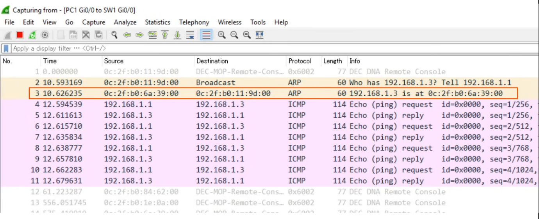

MAC Address Table

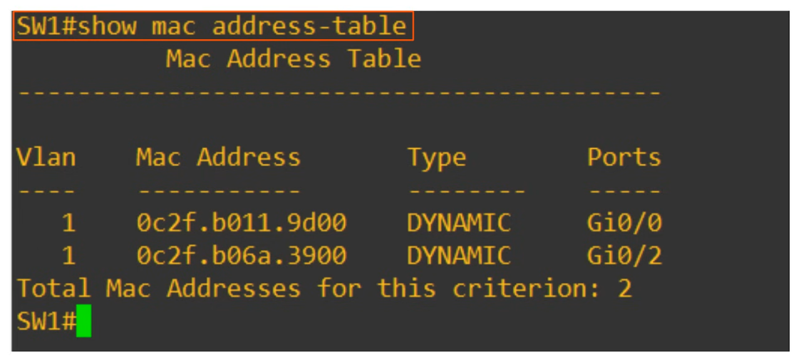

* Command in Cisco CLI "show mac address-table"
* VLAN - default = 1
* Ports = interfaces

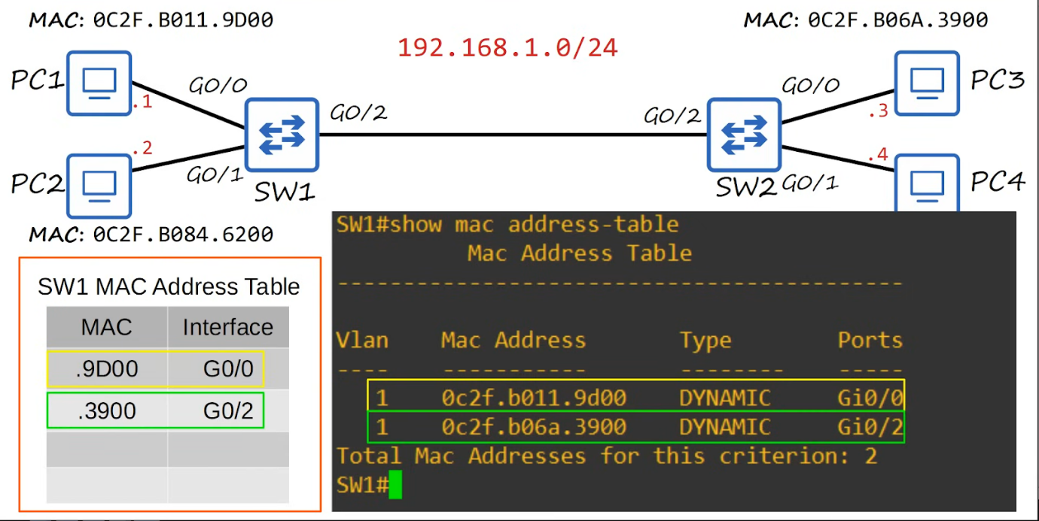

Clearing the MAC Address Table

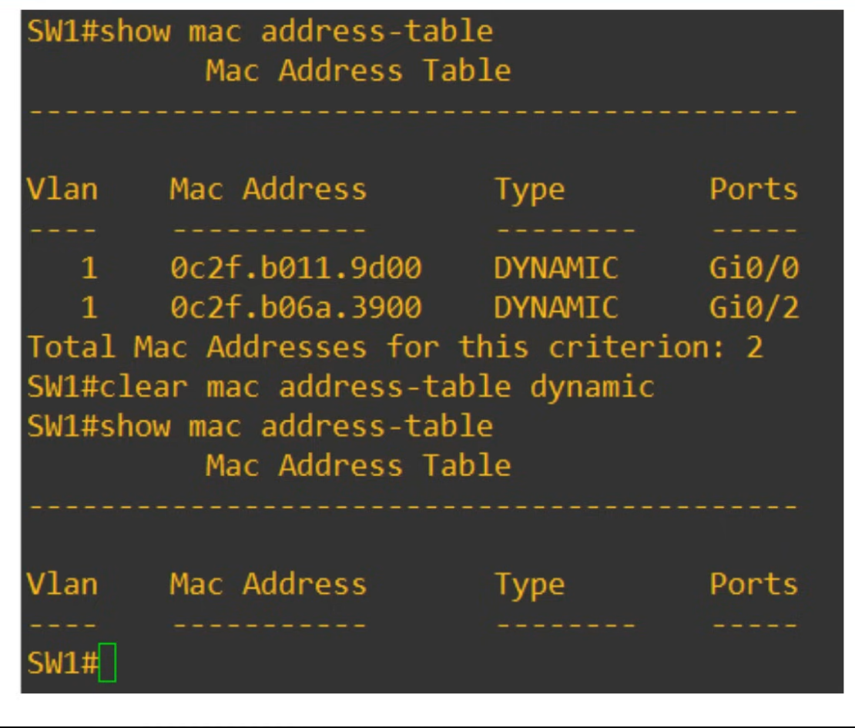

* Ageing: After 5 mins, removed from table
* Use **"clear mac address-table dynamic"** to manually remove all
* OR **"clear mac address-table dynamic address {MAC_address}"**

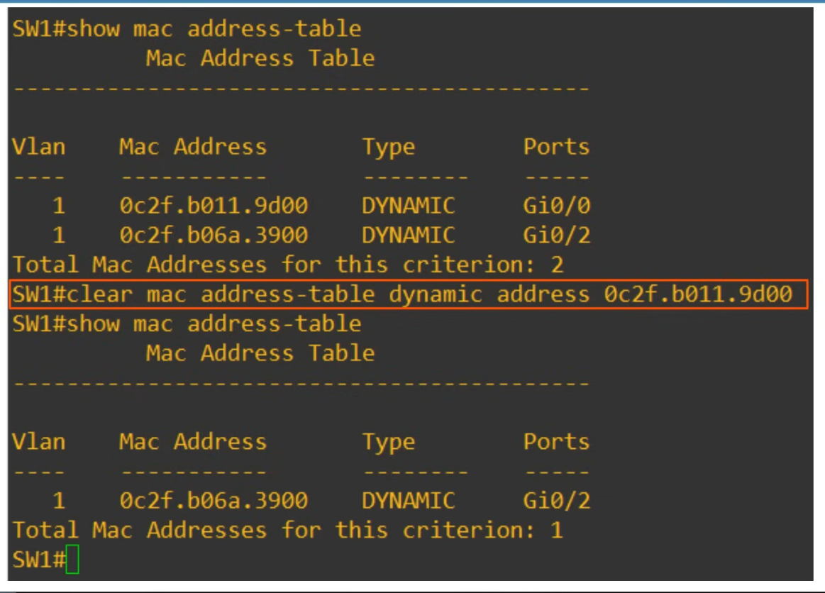

* OR "clear mac address-table dynamic interface {interface-id}"

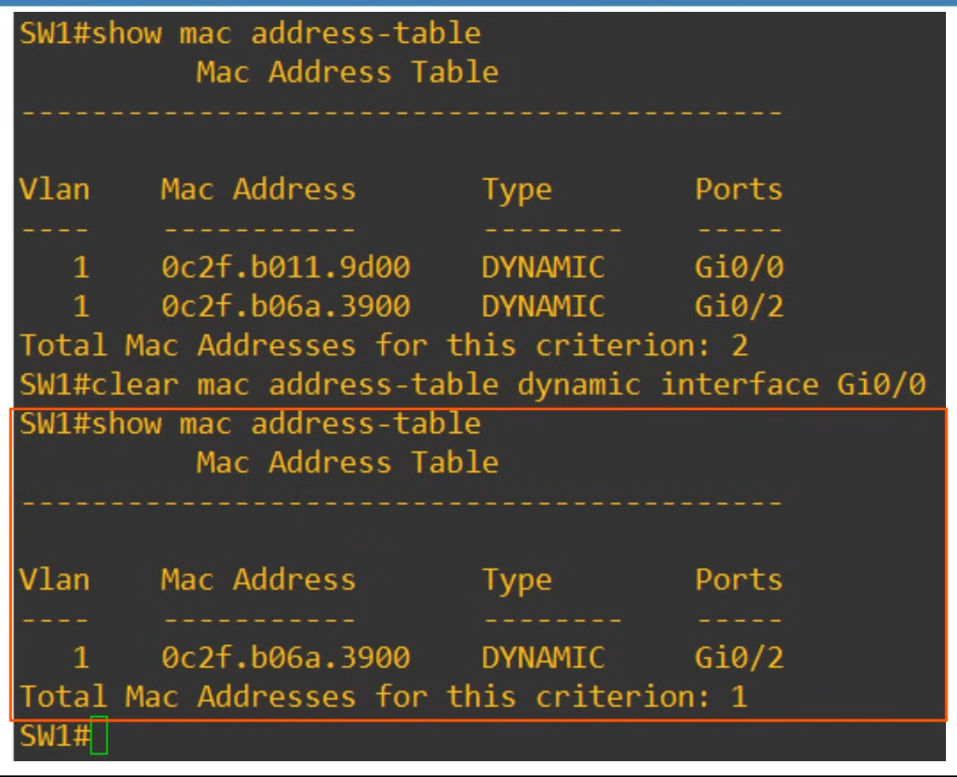

Ethernet Frame

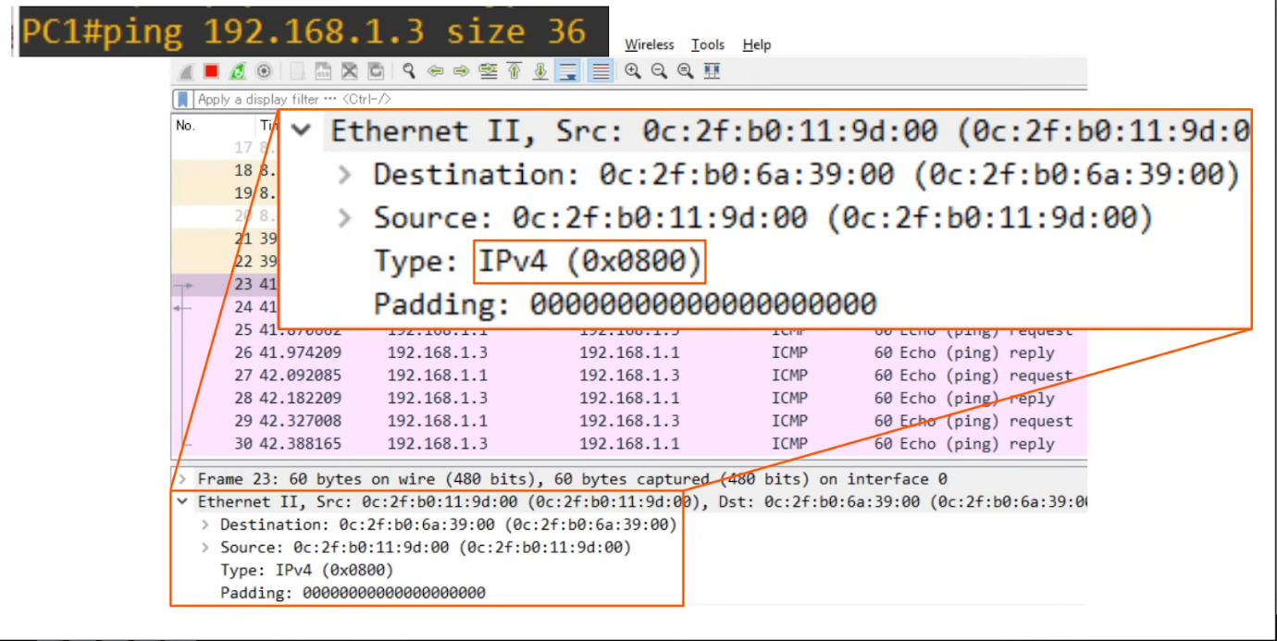

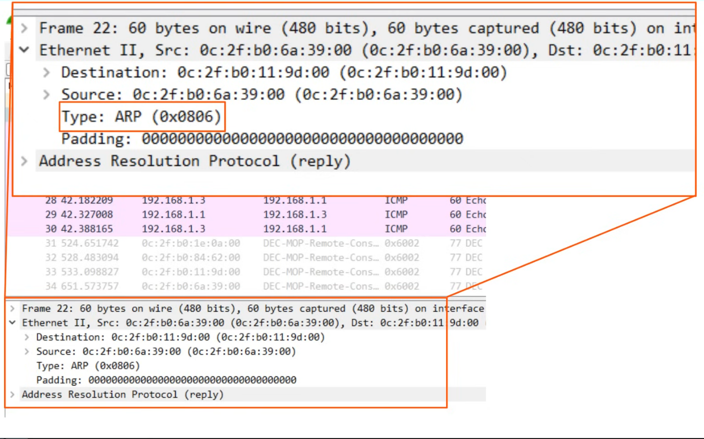

# IPv4 Addressing

## IPv4 Addressing (Part 1)

**IPv4  Header**

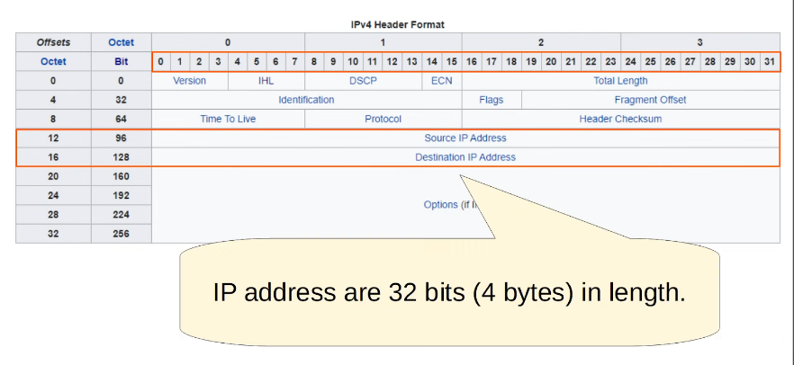

**IPv4 Address**

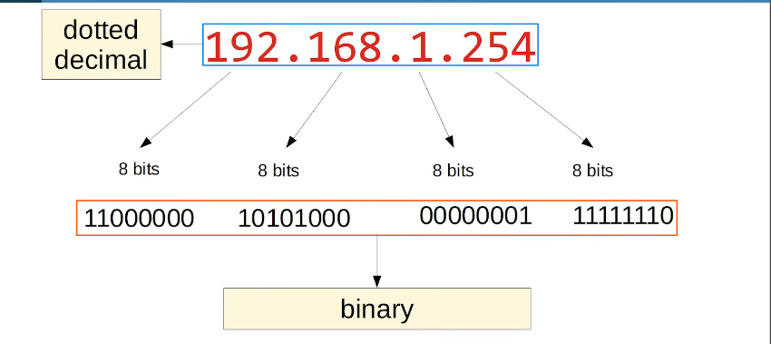

* 'octet': the group of 8 bits
  + So each 8 bits is an octet
* Dotted decimal so that easier for human to read

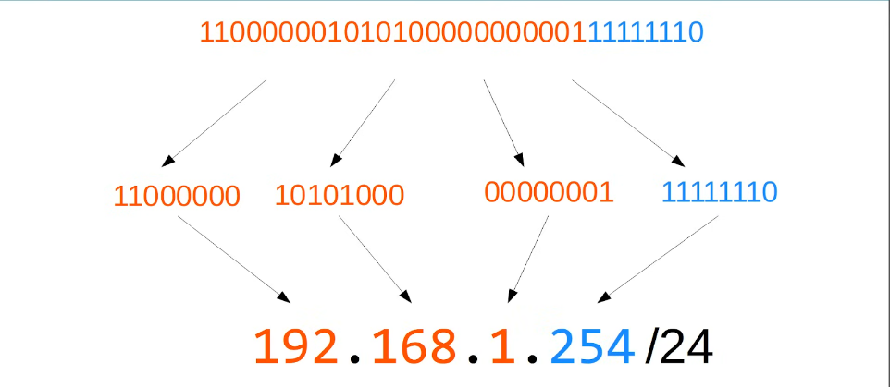

* The /24 at the end
  + Shows that the first 24 bits of the address refers to the network portion of the address
  + The remaining 8 bits refers to the host portion

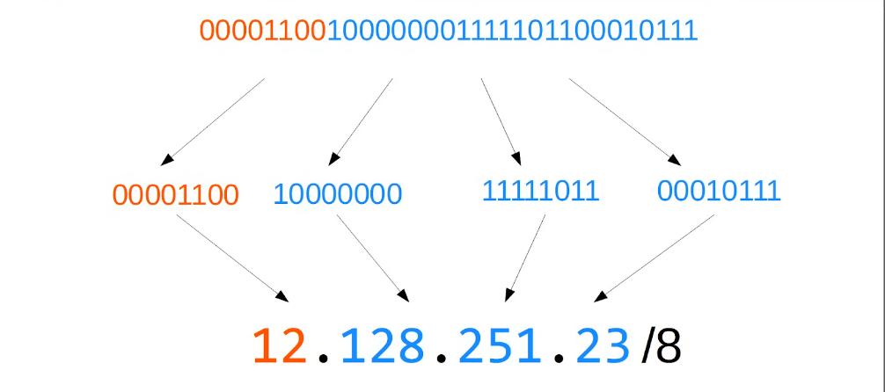

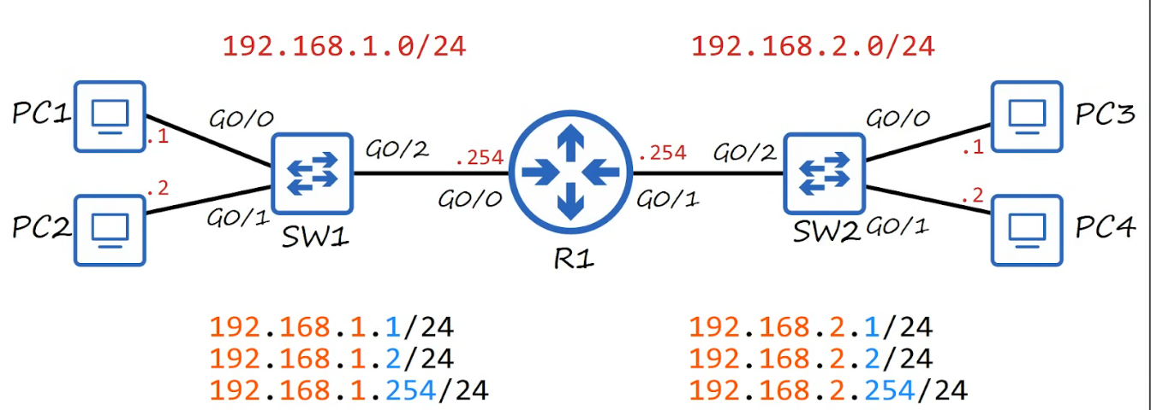

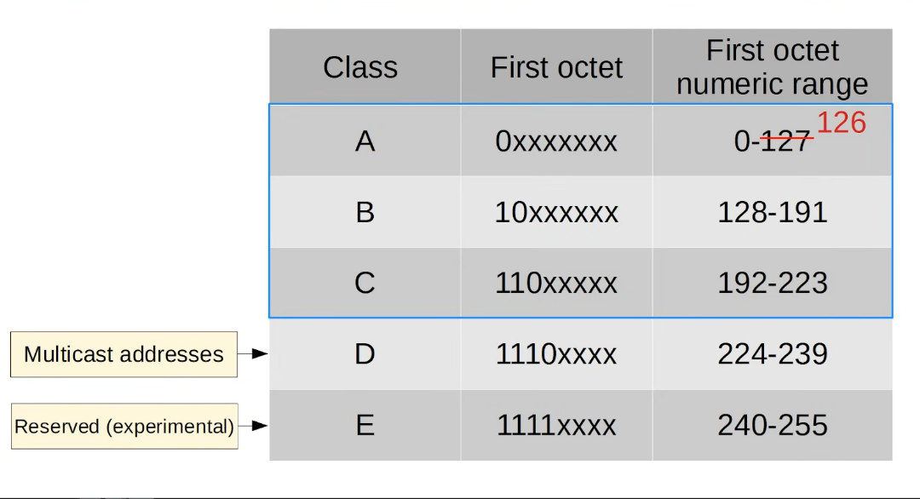

**Loopback Addresses**

* Address range 127.0.0.0 - 127.255.255.255
* Used to test the 'network stack' (think OSI, TCP/IP model) on the local device

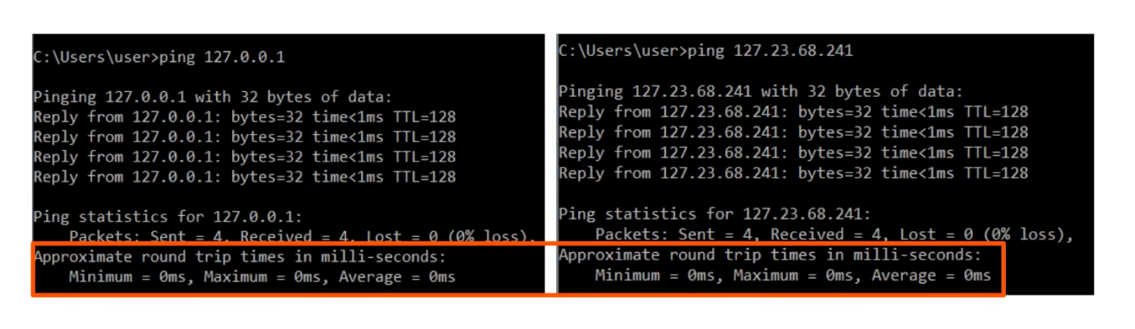

* Pinging your own computer

**IPv4 Address Classes**

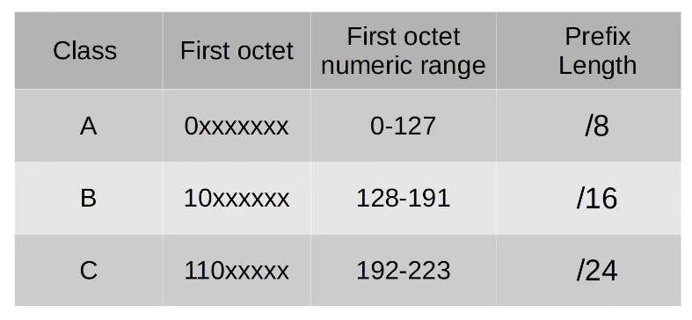

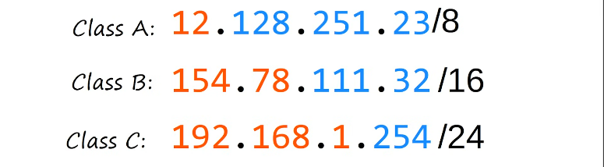

* Class A: more host, but less network
* Class C: more networks, but less hosts

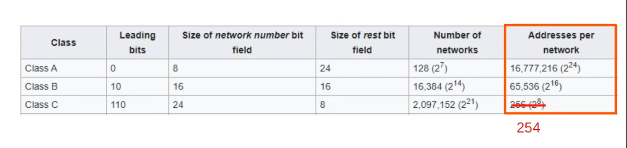

* For the last column, the first and last address is reserved
  + First address is the network address
  + Last address is the broadcast address, used to broadcast to all hosts in the network

**Netmask**

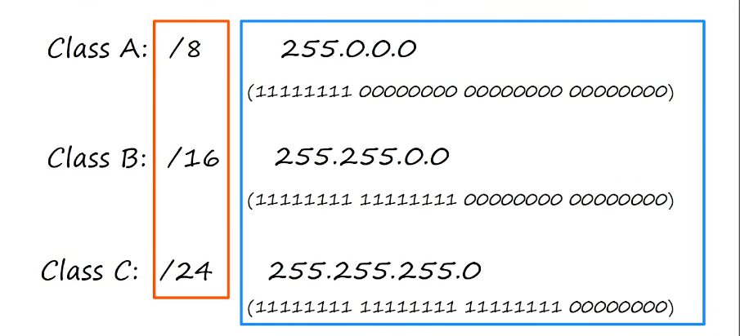

* They are the same thing represented differently

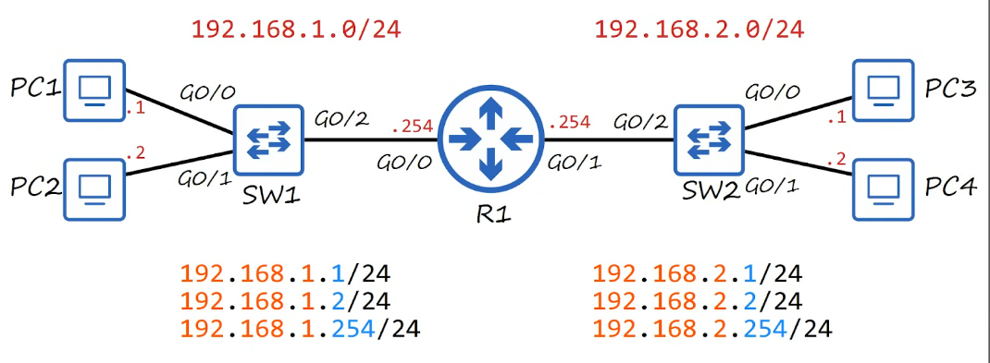

* Host portion of the address is all 0's - Network address
  + See picture above, 192.168.1.0 and 192.168.2.0 are network addresses
  + Cannot be assigned to a host
* Host portion of the address is all 1's - Broadcast address
  + Cannot be assigned to a host

**Review**

* Dotted decimal and binary
* Network portion/ Host portion of IPv4 address
* IPv4 classes
* Prefix length / netmasks
* Network addresses / Broadcast addresses

## IPv4 Addressing (Part 2)

Max Hosts per Network

* Max hosts per network = 2n - 2
* Subtract 2 because
  + Host portion all 0 is network address
  + Host portion all 1 is broadcast address
* First usable address
  + Host portion = 1
  + Host portion = all 1 except LSB

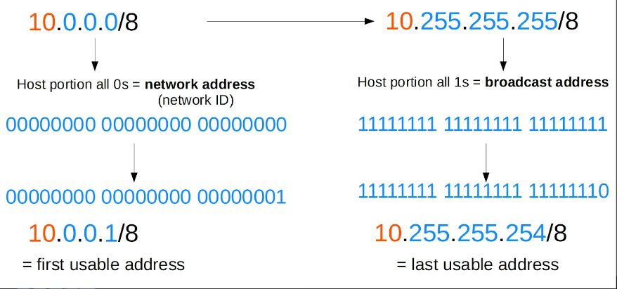

CLI

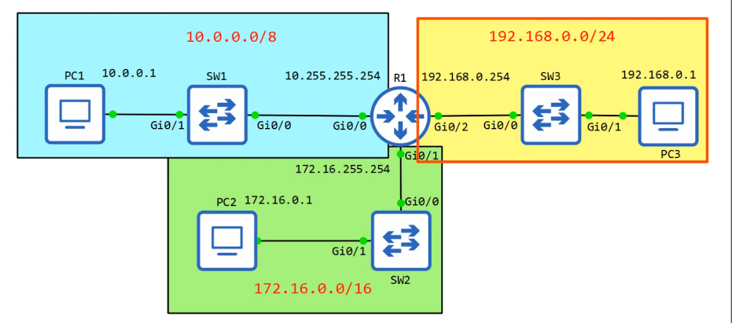

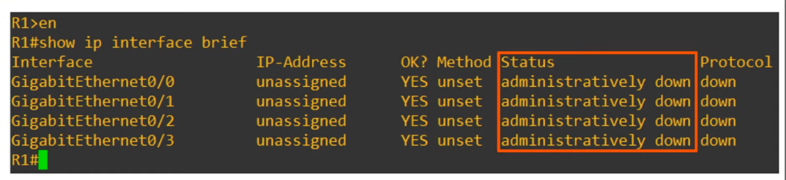

* "administratively down": interface has been disabled with the "shutdown" command
* Default status for Cisco router interfaces
  + Even when the interface is already connected
* For switches, default is NOT "administratively down"
* "Status" : Layer 1 status (e.g. cable is down)
* "Protocol" : Layer 2 status (e.g. is Ethernet working properly between this device and the device it is connected to)

Interface Configuration Mode

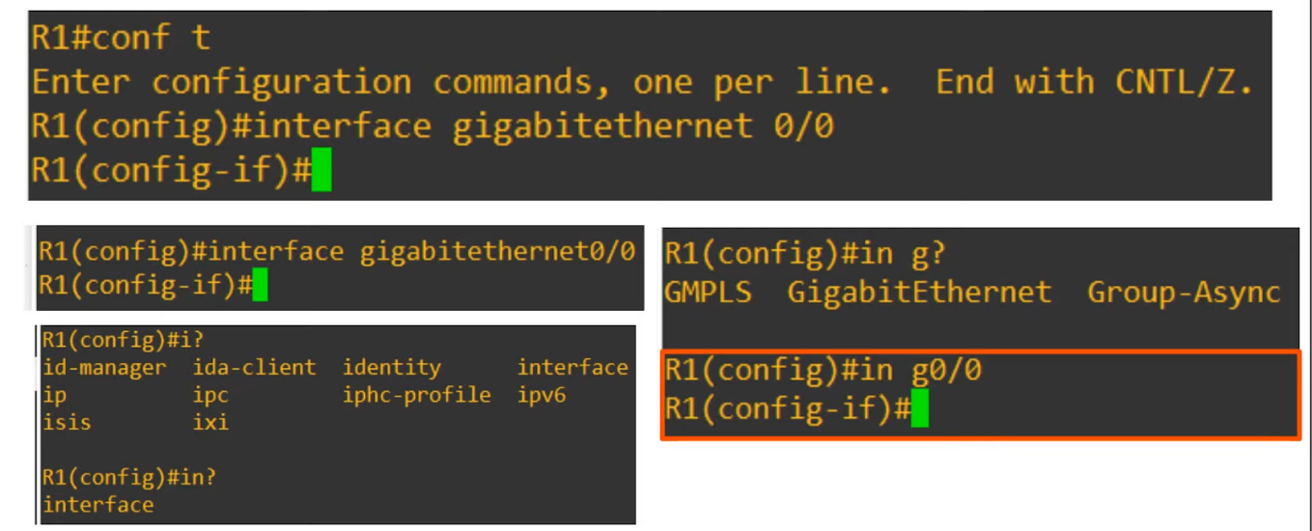

Configuring IP Address

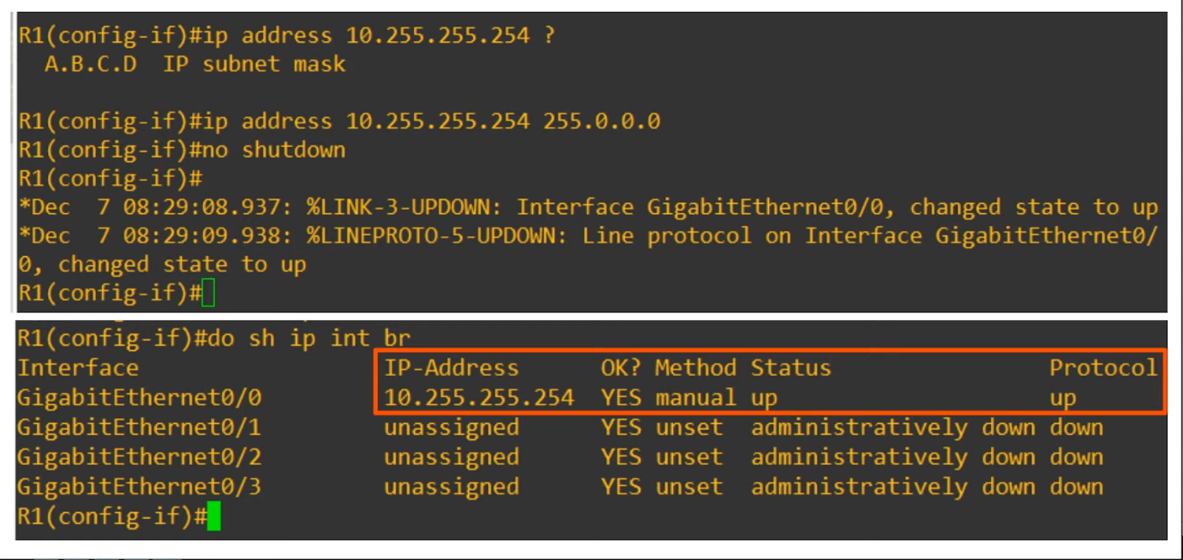

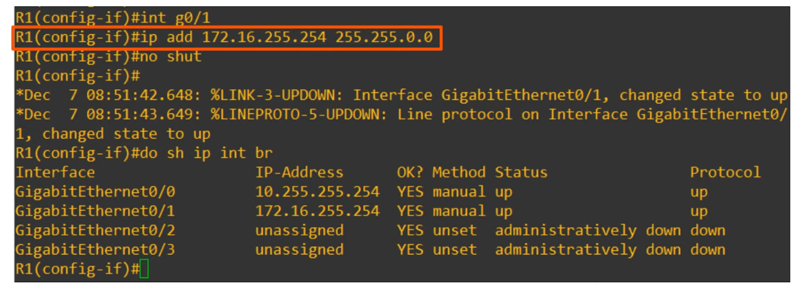

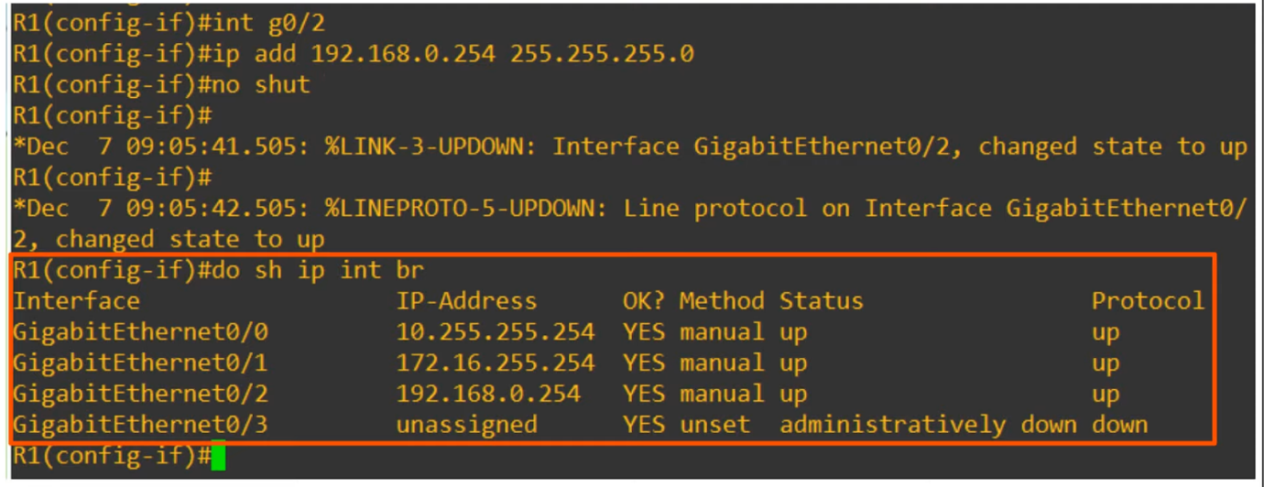

More "show" commands

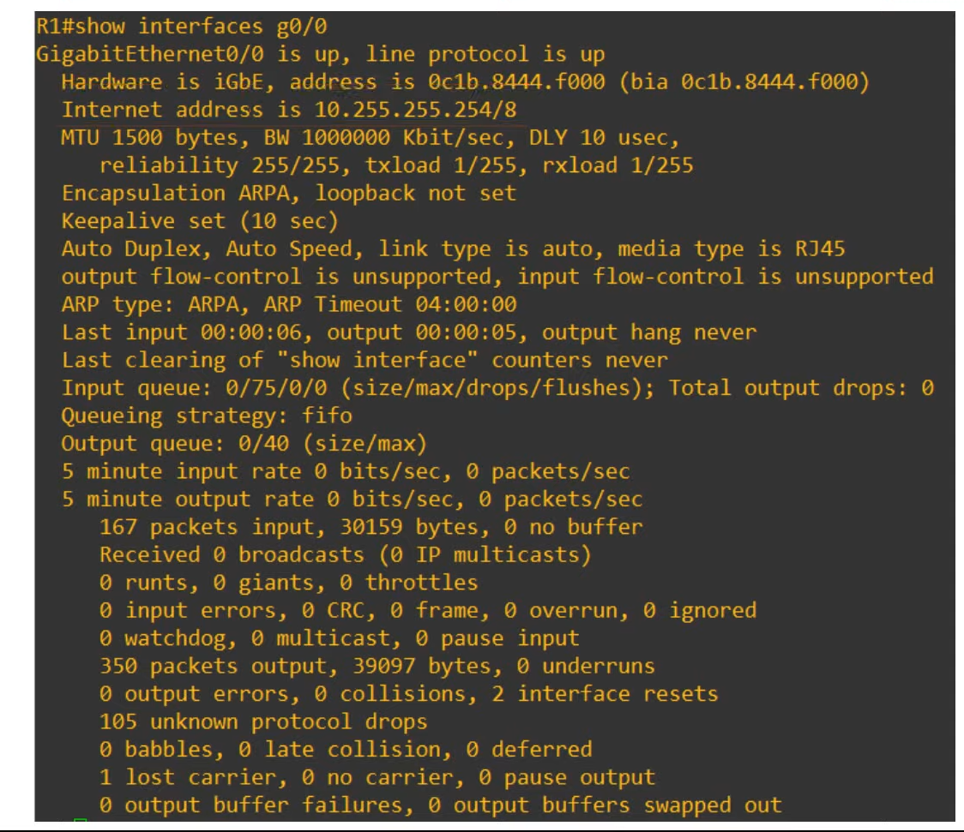

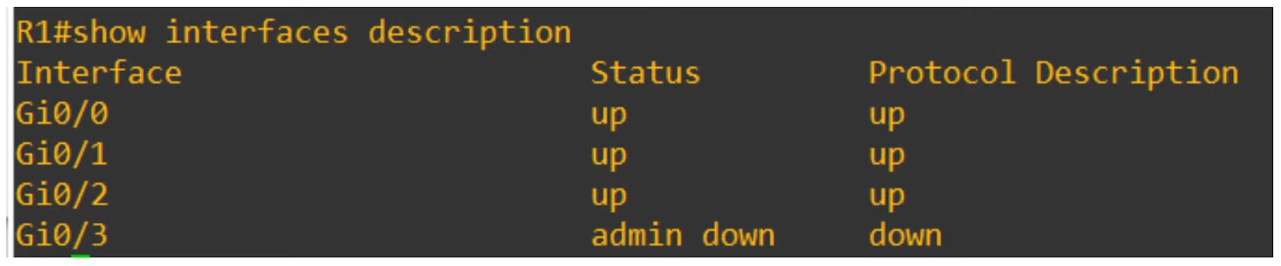

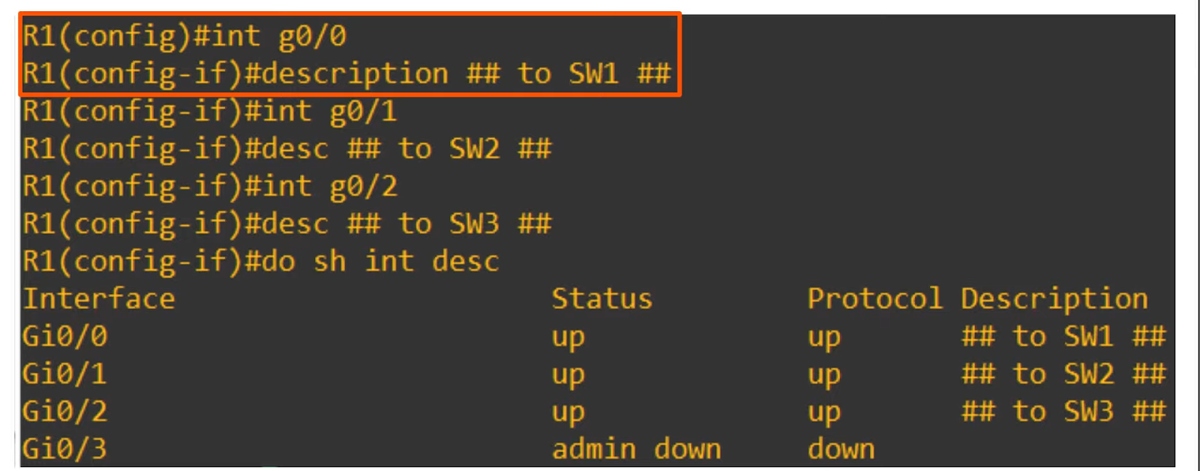

Topics Covered

* IPv4 address classes (review, clarification)
* Finding , for a particular network
  + Max number of hosts
  + Network address
  + Broadcast address
  + First useable address
  + Last useable address
* Configuring IP addresses on Cisco devices

Commands

* **show ip interface brief** (privileged mode)
* To set IP address
  + **interface {interface}** (e.g. gigabitethernet0/0 OR g0/0, global mode)
  + **ip address {ip address} {subnet mask}** (interface mode)
  + **no shutdown** (interface mode)
  + **description {description}** (interface mode)
* **show interfaces {interface}** (privileged mode)
* **show interfaces description** (privileged mode)

# Switch Interfaces

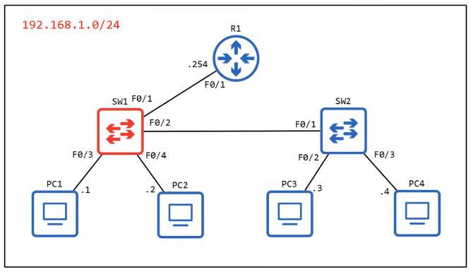

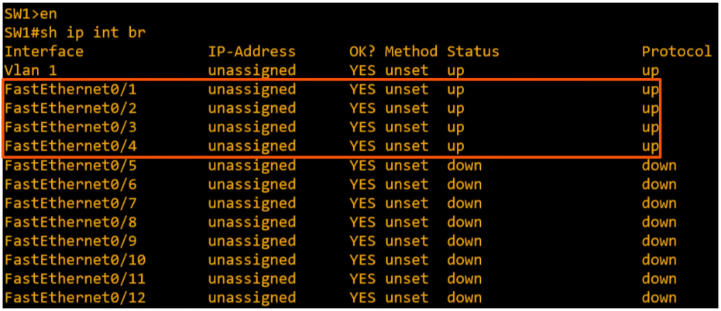

* By default, switches NOT shutdown unlike routers
  + Will either be up/up if connected
  + Down/down if not connected
* Difference between "down" and "administratively down"
  + "down": not connected to anything
  + "admin down": 'shutdown' command applied

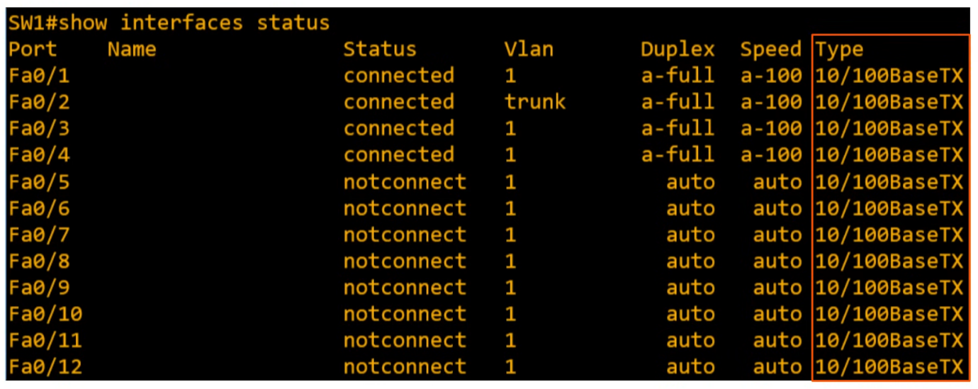

* Duplex
  + "a-full": auto full duplex

Configure Speed & Duplex

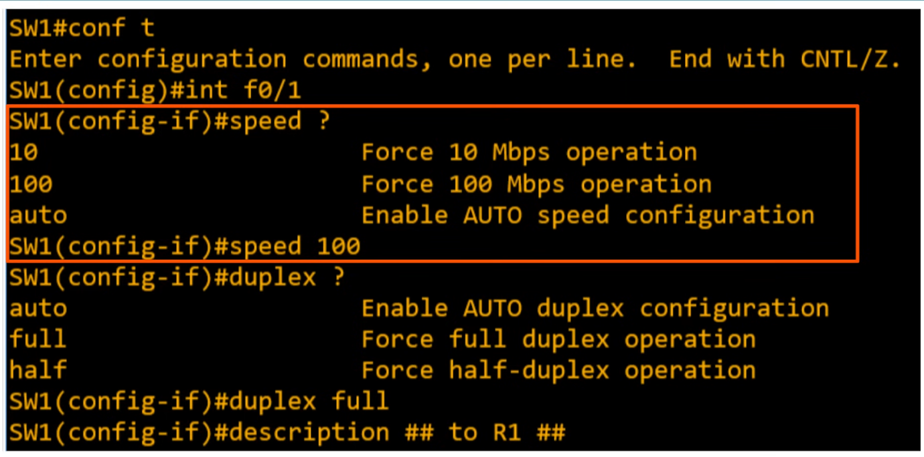

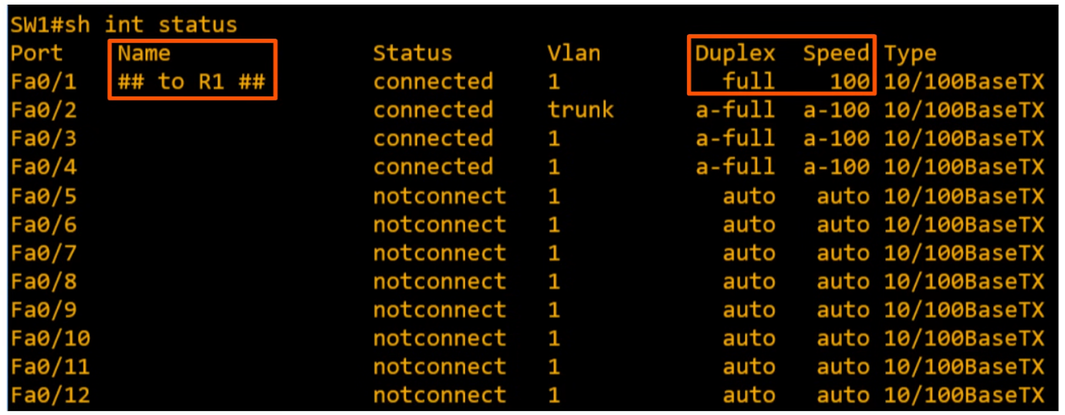

Shutdown Not-used Interface

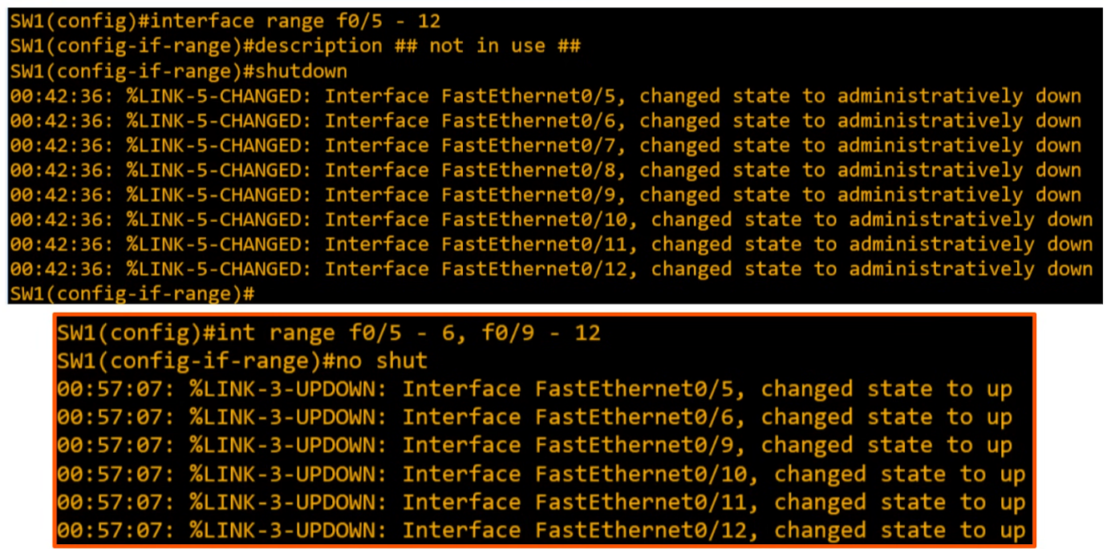

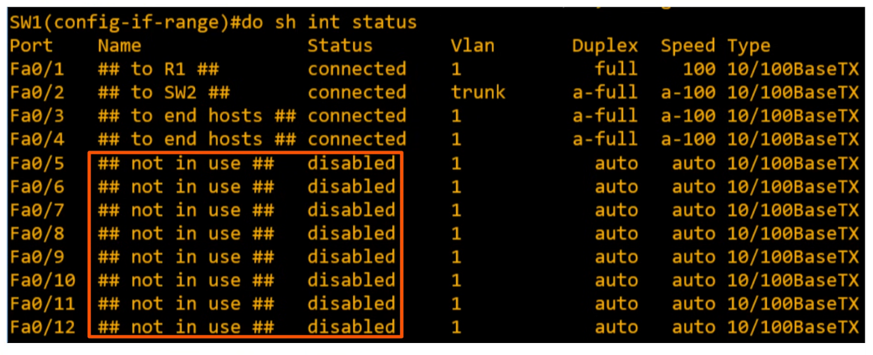

* Full duplex
  + Device can send and receive at the same time
* Half duplex
  + Can only send or receive at the same time

Hub

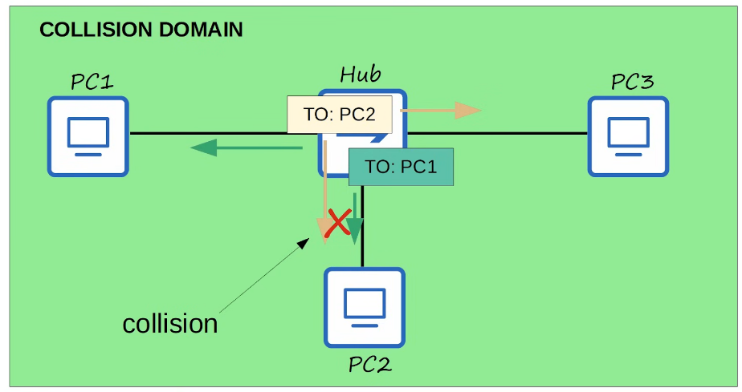

* Hub is like a repeater, sends out message received to everyone
* Only the destination will recognise and accept, the rest will ignore
* Collision can occur when hub transmit multiple messages at the same time

CSMA/CD

* Carrier Sense Multiple Access / Collision Detection
* Before sending, devices listen to collision domain until they detect that other devices are not sending
* If a collision occur, the device sends a jamming signal to inform the other devices that a collision occurred
* Each device will wait a random period of time before sending frames again
* The process repeats

Switch Collision Domain

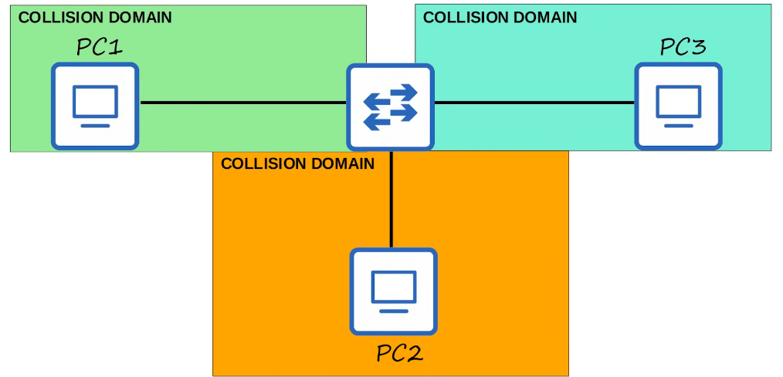

* Less likely for collision to occur
* If occur, likely due to configuration

Speed/Duplex Auto-negotiation

* Interfaces that can run at different speeds (10/100 or 10/100/1000) have default settings of 'speed auto' and 'duplex auto'
* Interfaces 'advertise' their capabilities to the neighbouring device, and they negotiate the best speed and duplex settings they are both capable of

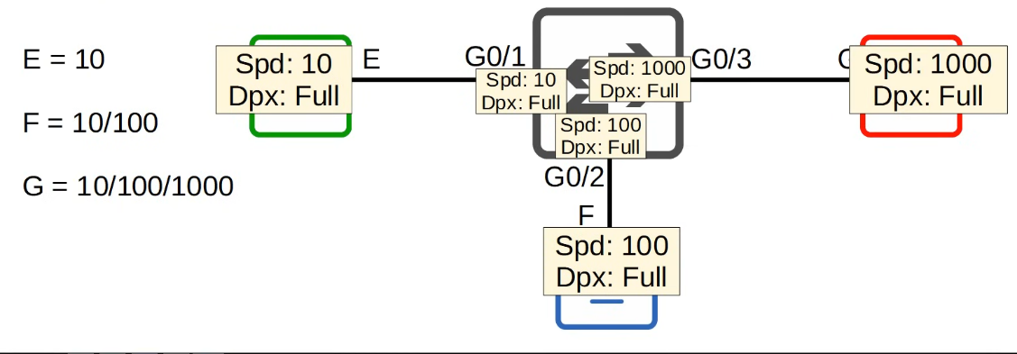

* What if autonegotiation is disabled?
  + Speed
    - The switch will try to sense the speed that the other device is operating at
    - If cannot, it will use the slowest supported speed
  + Duplex
    - If speed is 10 or 100 Mbps, half duplex
    - If 1000 or more, full duplex

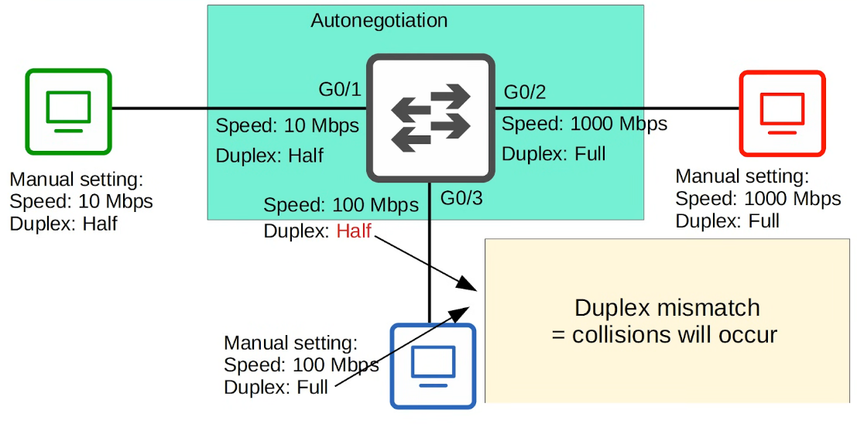

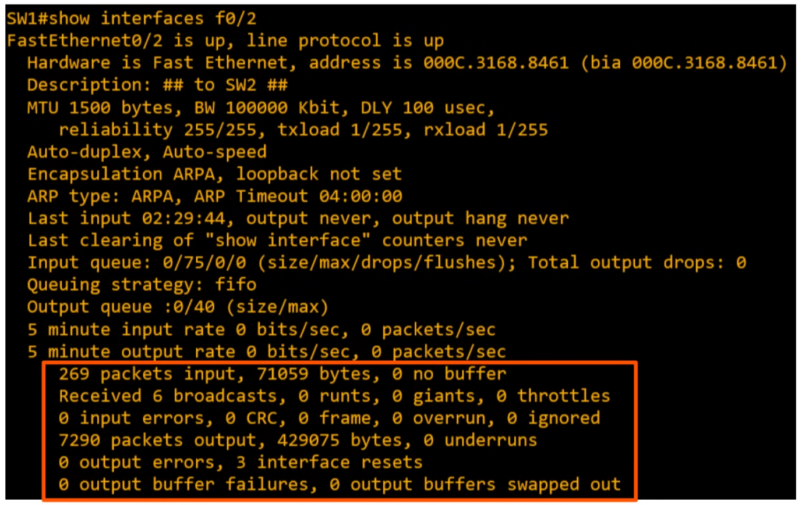

* Runts
  + Frames that are smaller than the min Ethernet frame size (64 bytes)
* Giants
  + Frames that are larger that the max Ethernet frame size (1518 bytes)
* CRC
  + Frames that failed the CRC check (in the Ethernet FCS trailer)
* Frame
  + Frames that have an incorrect format (due to an error)
* Input errors
  + Total of various counters, such as the above four
* Output errors
  + Frames the switch tried to send, but failed due to an error

Review

* Interface speed & duplex
* Speed & duplex auto negotiation
* Interface status
* Interface counters & errors

# IPv4 Header

Content

* IPv4 Structure
* Fields of the IPv4 header

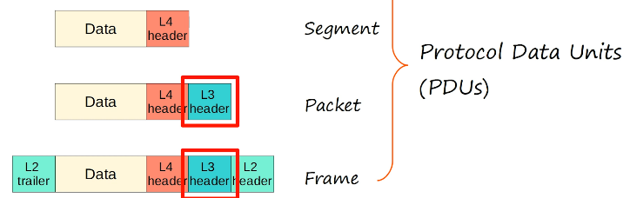

Header

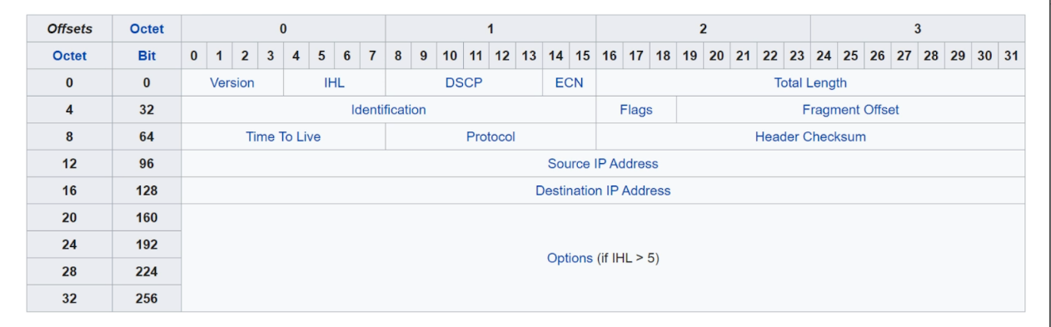

* **Version**
  + 4 bits
  + Indicates version of IP used
  + IPv4 = 0100 (4)
  + IPv6 = 0110 (6)
* **Internet Header Length (IHL)**
  + 4 bits
  + The final field of the IPv4 header (Options) is variable in length, so this field is necessary to indicate the total length of the header
  + Identifies the length of the header **in 4-bytes increment**
  + Value of 5 = 5 * 4 bytes = 20bytes
  + Min value is 5 = 20 bytes
  + Max value is (1111) 15 = 60 bytes
* **Differentiated Services Code Point (DSCP)**
  + 6 bits
  + Used for QoS (quality of service)
  + Used to prioritize delay-sensitive data (streaming voice/video etc)
* **Explicit Congestion Notification (ECN)**
  + 2 bits
  + Provides end-to-end (btw 2 endpoints) notification of network congestion **without dropping packets**
  + Optional feature that requires both endpoints and the underlying infrastructure to support it
* **Total Length**
  + 16 bits
  + Indicates the total length of the packet (L3 + L4 segment)
  + Measured in bytes (NOT 4 bytes increment)
  + Min value 20 (IPv4 header with no encapsulated data)
  + Max value 65,535 (16 bits all 1)
* **Identification Field**
  + 16 bits
  + If a packet too large and is fragmented, this field used to identify which packet the fragment belongs to
  + All fragments of the same packet will have their own IPv4 header with the same value in this field
  + Packets are fragmented if larger than the MTU (Max Transmission Unit)
  + MTU usually 1500 bytes (max size of Ethernet frame)
  + Fragments are reassembled by the receiving host
* **Flags field**
  + 3 bits
  + Used to control/identify fragments
  + Bit 0: Reserved, always set to 0
  + Bit 1: Don't fragment (DF bit), used to indicate a packet that should not be fragmented
  + Bit 2: More fragments (MF bit), set to 1 if there are more fragments in the packet, set to 0 for the last fragment
  + Unfragmented packets will always have their MF bit set to 0
* **Fragment Offset**
  + 13 bits
  + Used to indicate the position of the fragment within the original, unfragmented IP packet
  + Allow fragmented packets to be reassembled even if the fragments arrive out of order
* **Time To Live**
  + 8 bits
  + A router will drop a packet with a TTL of 0
  + Used to prevent infinite loops
  + Originally designed to indicate the packet's max lifetime in seconds
  + In practice, indicates a 'hop count'  - each time the packet arrives at a router, the router decreases the TTL by 1
  + Recommended default TTL = 64
* **Protocol**
  + 8 bits
  + Indicates the protocol of the encapsulated L4 PDU
  + Value of 6: TCP
  + Value of 17: UDP
  + Value of 1: ICMP
  + Value of 89: OSPF (dynamic routing protocol)
* **Header Checksum**
  + 16 bits
  + A calculated checksum used to check for errors in the IPv4 header
  + When a router receives a packet, it calculates the checksum of the header and compares it to the one in this field of the header
  + If they do not match, the router drops the packet
  + Used to check for error in IPv4 header only
  + IP relies on the encapsulated protocol to detect errors in the encapsulated data
  + Both TCP and UDP have their own checksum fields to detect errors in the encapsulated data
* **Source/Destination IP Address**
  + 32 bits
  + IPv4 address of sender and receiver
* **Options**
  + 0 - 320 bits
  + Rarely used
  + If the IHL field is greater than 5, it means that Options are present

WireShark

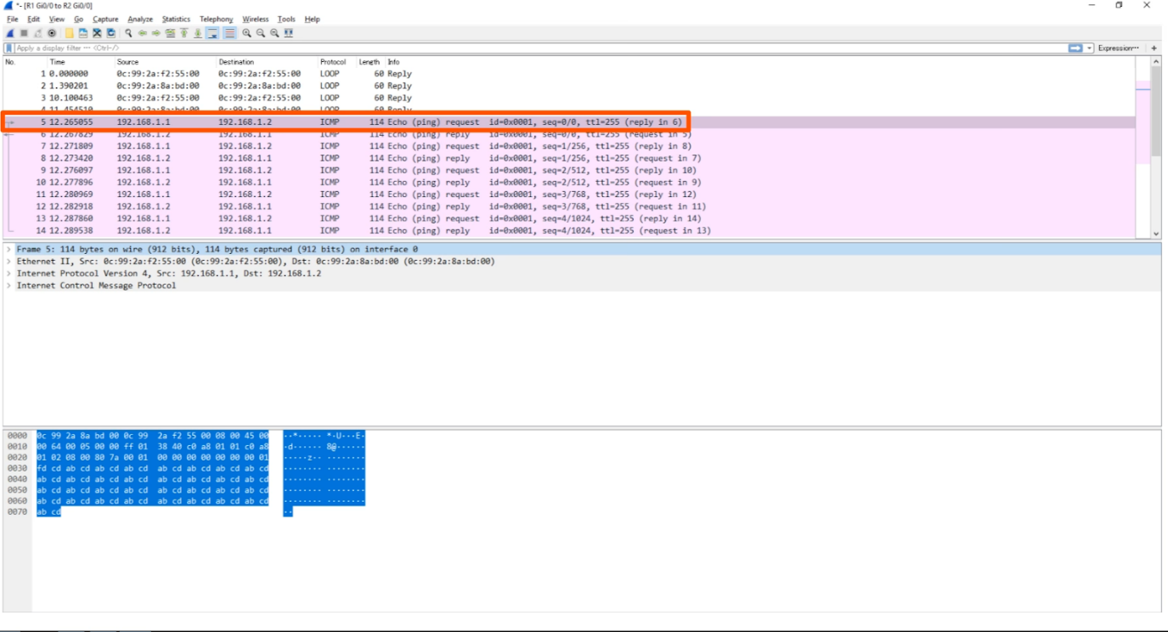

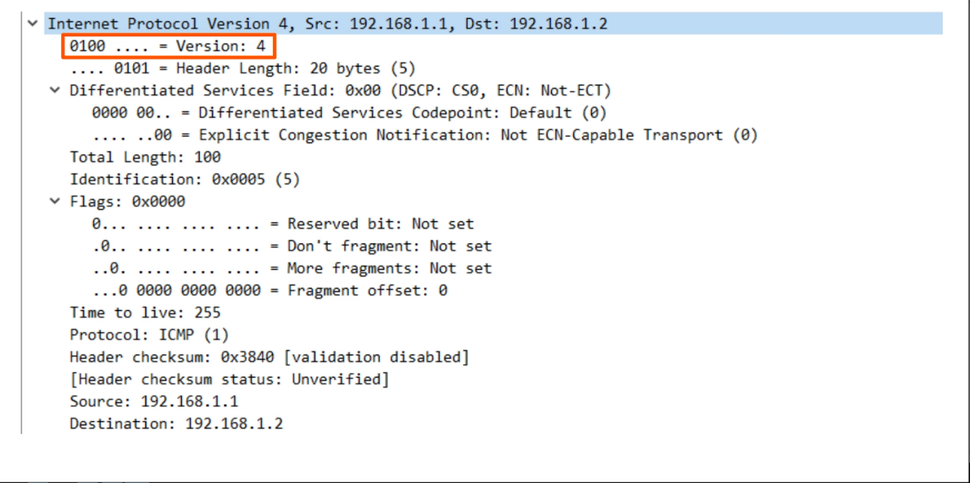

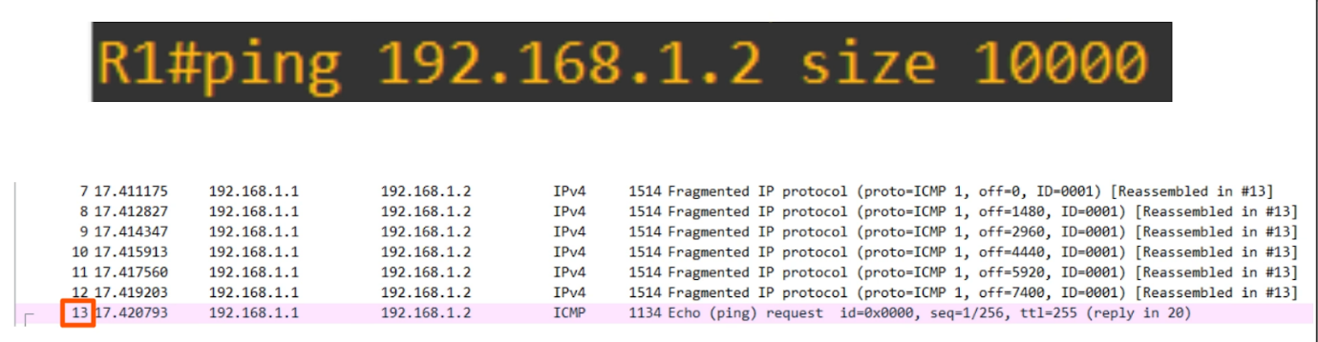

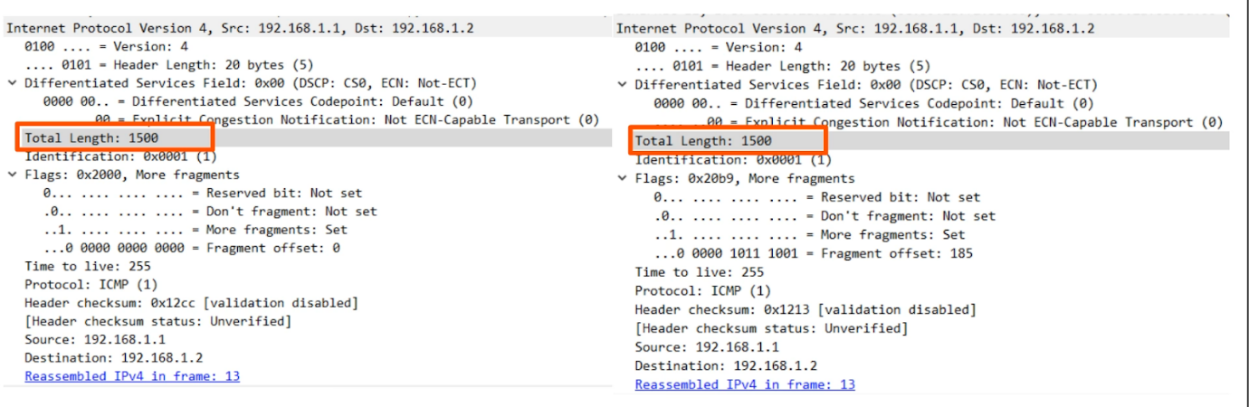

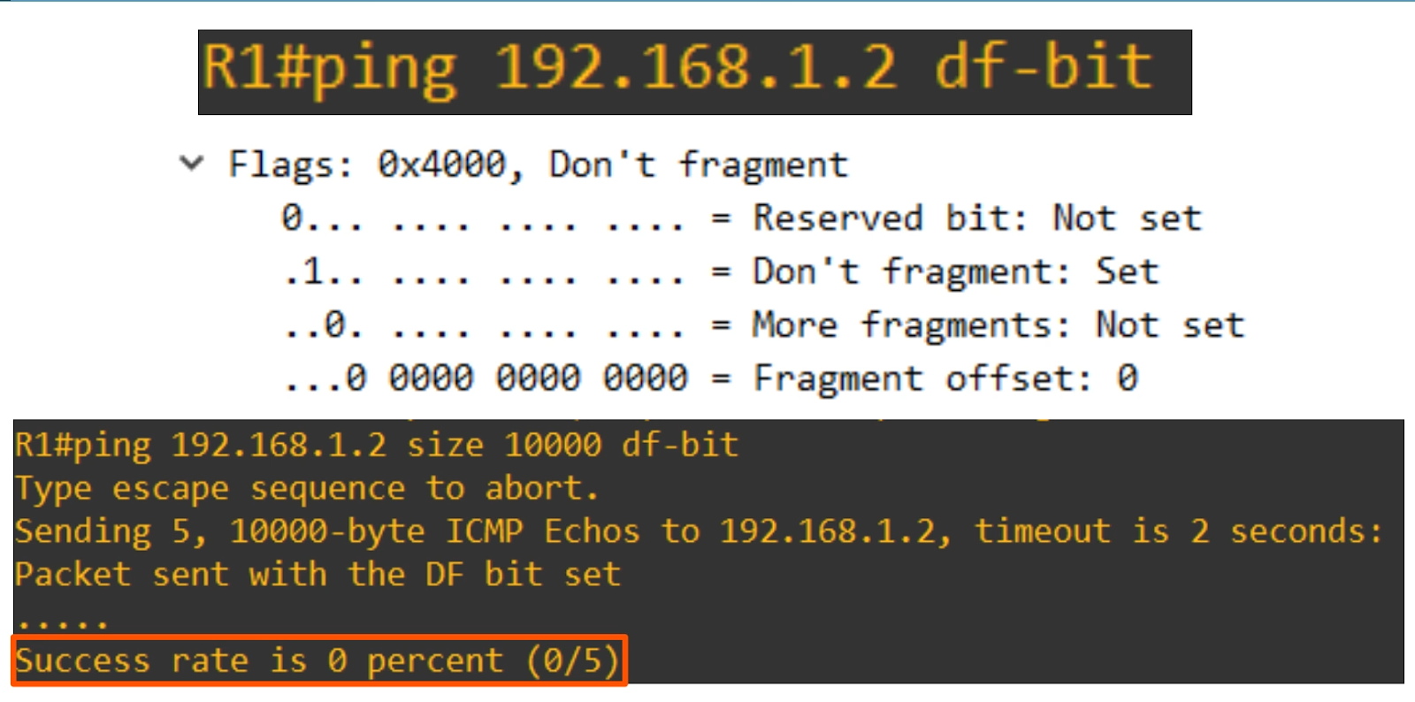

# Routing Fundamentals

## Routing Fundamentals

Topics

* What is routing?
* Routing table on Cisco routers
  + Connected routes
  + Local routes
* Routing fundamentals (route selection)

What is routing?

* Routing is the process that routers use to determine the path that the IP packets should take over a network to reach their destination
  + Routers store routes to all of their known destinations in a **routing table**
  + When routers receive packets, they look in the **routing table** to find the best route to forward the packets
* 2 main routing methods (ways to learn the route)
  + **Dynamic Routing**
    - Routers use dynamic routing protocols (e.g. OSPF) to share routing  information with each other automatically and build their routing tables
  + **Static Routing**
    - Manually configure routes on router
* A **route** tells the router
  + To send a packet to destination X, you should send the packet to **next-hop** Y
    - **'next-hop'**: the next router in the path to the destination
  + OR if the destination is directly connected to the router, to send it directly to the destination
  + OR if the destination is the router's own IP address, receive the packet for yourself (don't forward it)

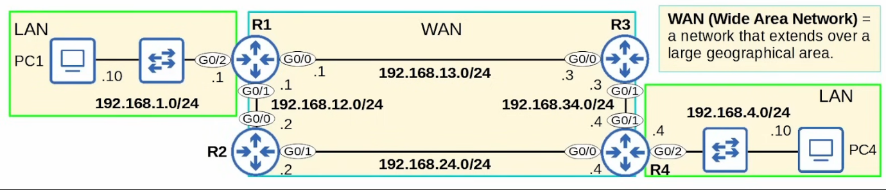

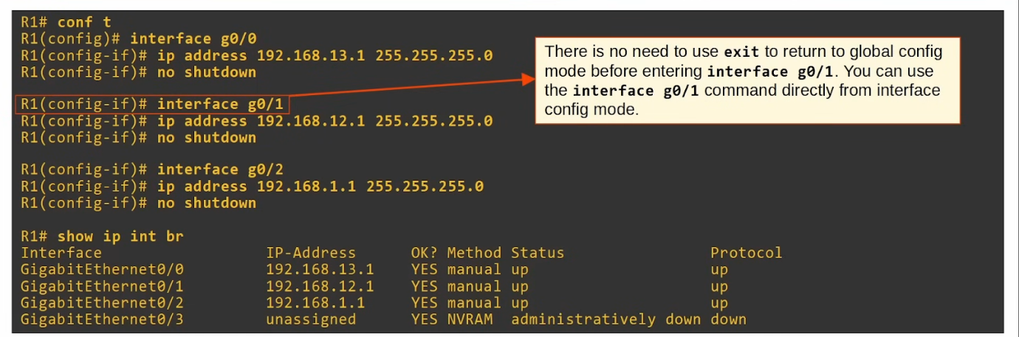

'show ip route'

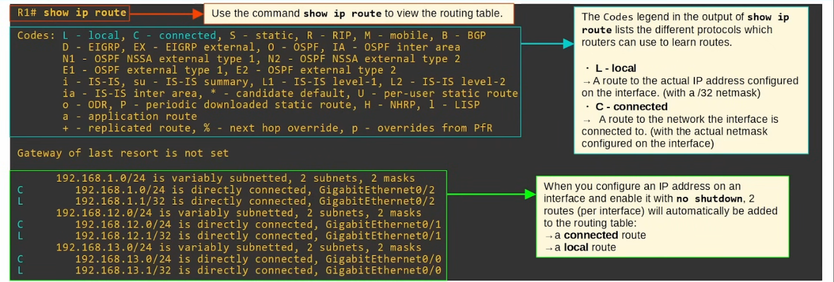

* Local and Connected routes are not part of dynamic/static routing
  + They are automatically added

Connected and Local Routes

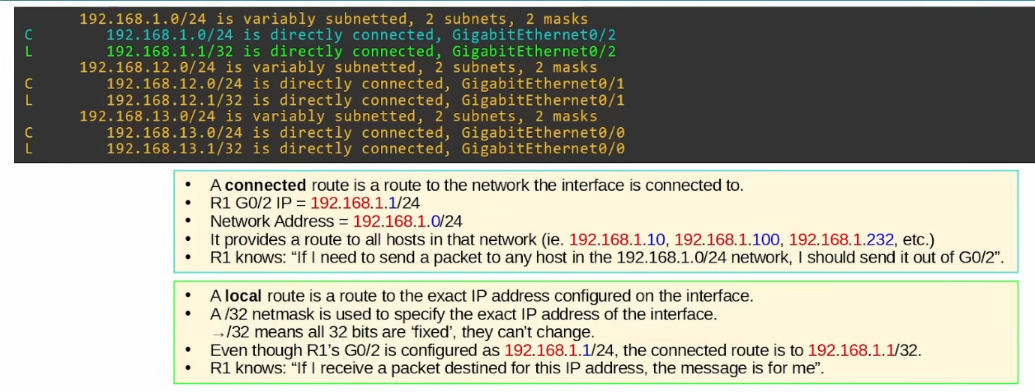

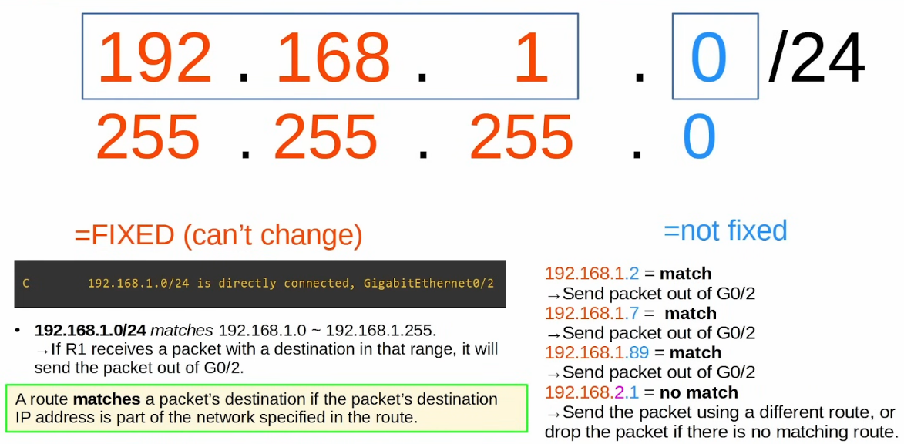

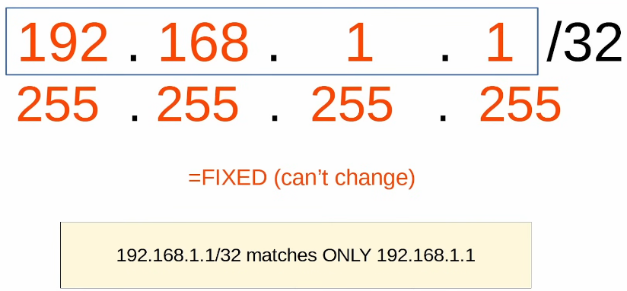

Route Selection

* If R1 receives a packet destined for 192.168.1.1, it will be matched by both Local & Connected routes
  + **192.168.1.0**/24 (connected)
  + **192.168.1.1**/32 (local)
* The **most specific** route will be chosen
  + Local will be chosen
* **Most specific** matching route = the matching route with the longest prefix
* R1 will receive the packet for itself, rather than sending it out
* Local route = keep the packet, don't forward

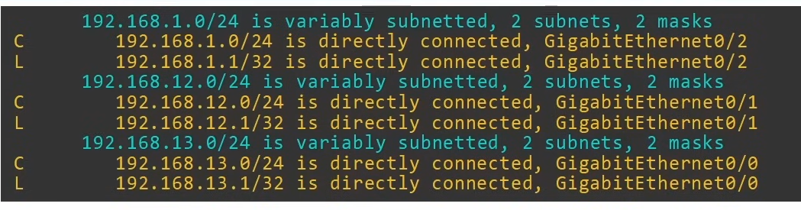

* **"192.168.1.0/24 is variably subnetted, 2 subnets, 2 masks"**
  + In the routing table, there are 2 routes to subnets that fit within the 192.168.1.0/24 class C network, with 2 different netmasks (/24 and /32)
  + Generally can ignore them and just take note of the actual routes

Route Selection Practice

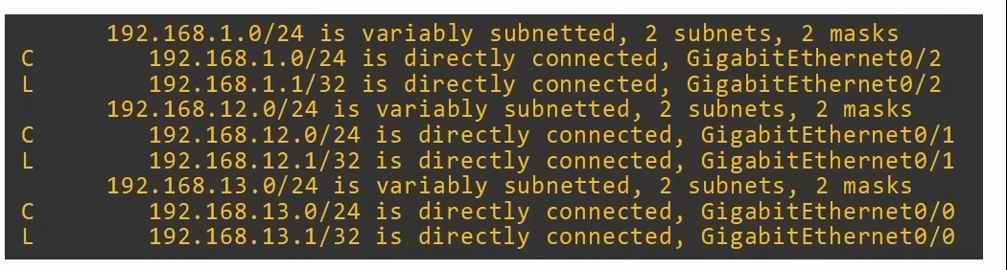

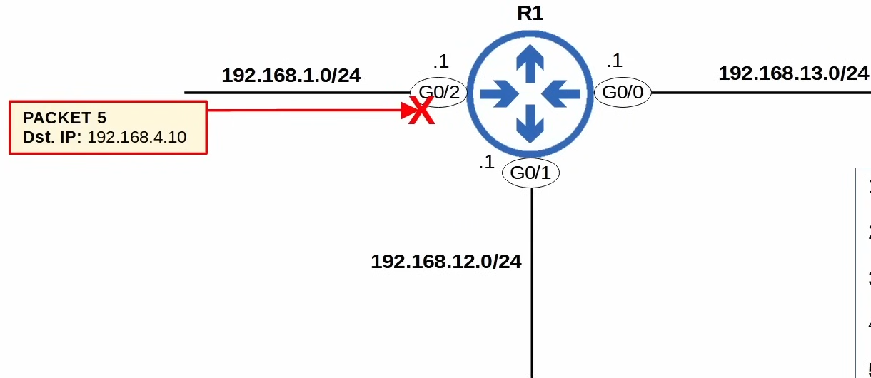

* Destination IP: 192.168.1.1
  + Receive for myself
* Destination IP: 192.168.13.3
  + Send to destination (connected to g0/0)
* Destination IP: 192.168.1.244
  + Send to destination (connected to g0/2)
* Destination IP: 192.168.12.1
  + Receive for myself
* Destination IP: 192.168.4.10
  + Drop (no route)

Summary

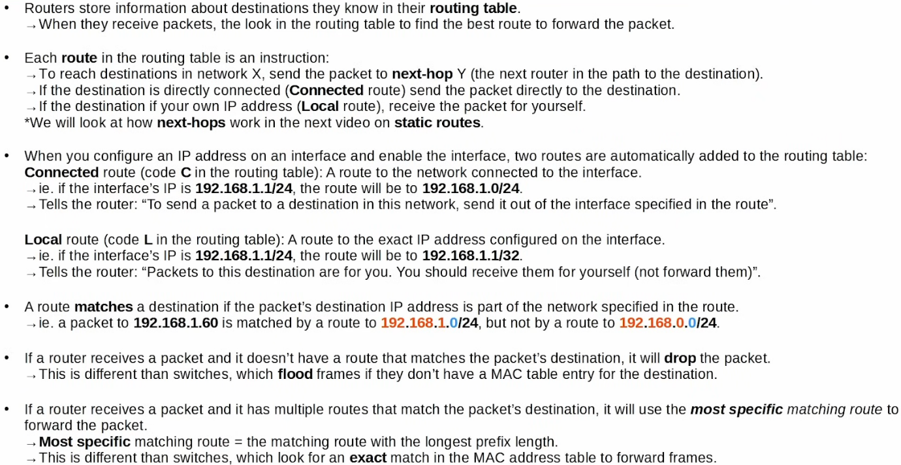

## Static Routing

Topics

* Review: Connected and Local routes
* Intro to static routes
* Static Route config
* Default Routes

Routing Packets: Default Gateway

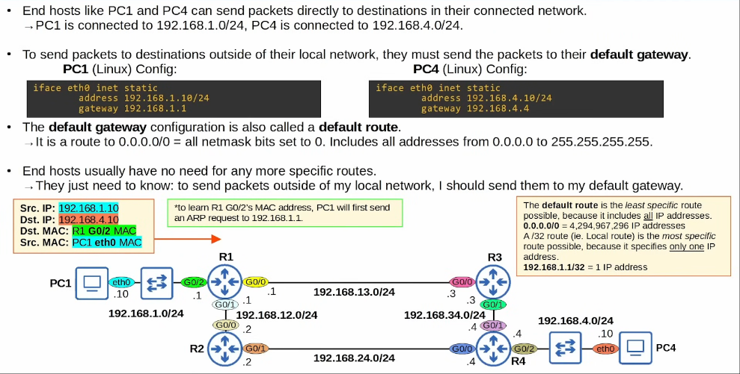

Routing Packets: Static Routes

* When R1 receives frame from PC1, it will de-encapsulate (remove L2 header/trailer) and look at the inside packet
* It will check the routing table for the most specific matching route

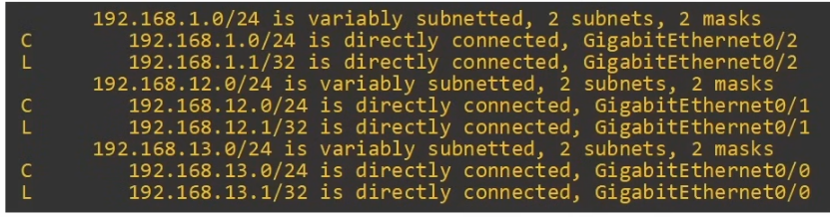

* R1 has no matching routes in its routing table
  + Drop the packet
* 2 possible paths
  + PC1->R1->R3->R4->PC2
  + PC1->R1->R2->R4->PC2
* Possible to configure the router to use both paths
  + Use as load balance - some packets go path 1 some go path 2
  + Use path 1 as main and path 2 as back up

Static Route Configuration

* Each router needs 2 routes
  + Route to PC1
  + Route to PC4
  + Ensures **2-way reachability**
* Side note
  + Routers don't need routes to all networks in the path to the destination
  + They just need to know who to send next if want to send to a particular host
* R1 already has a Connected route to 192.168.1.0/24 (R1's network)
* R4 already has a Connected route to 192.168.4.0/24 (R4's network)
* Other routes must be manually configured

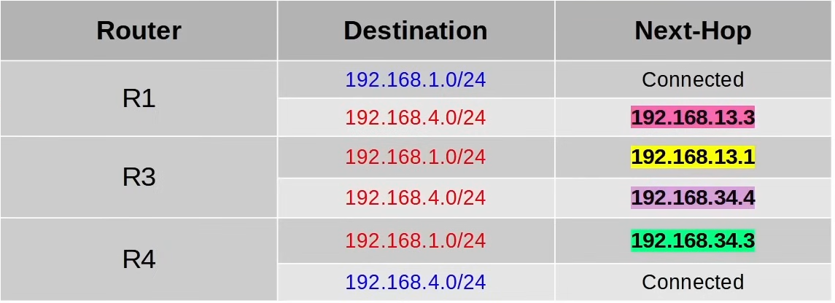

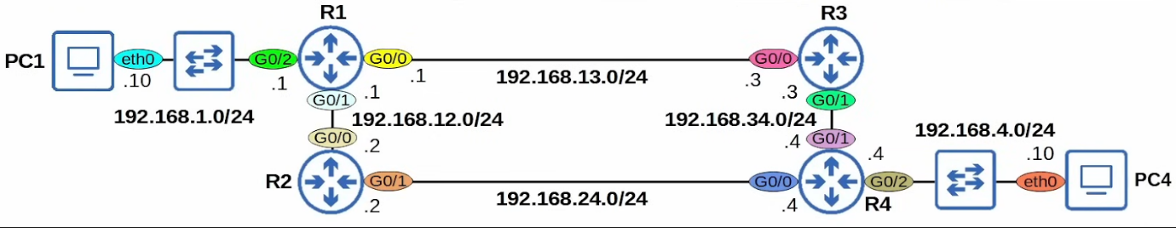

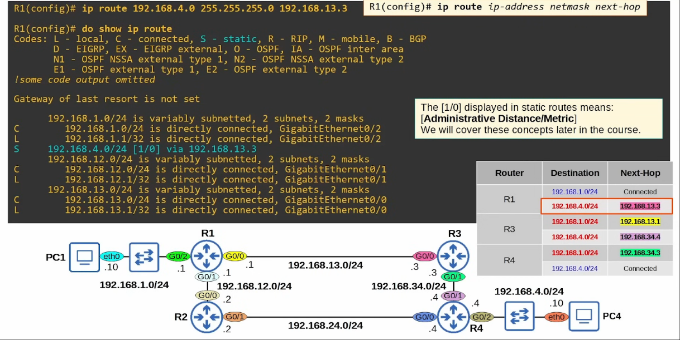

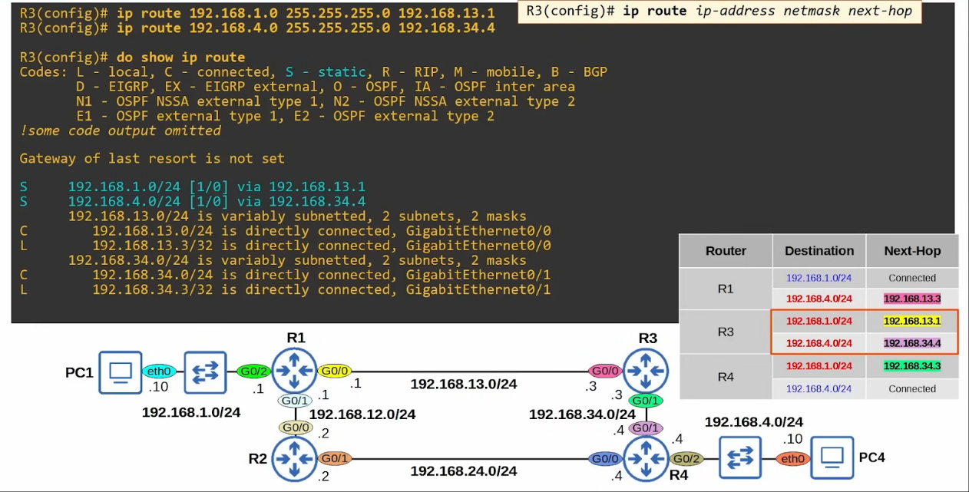

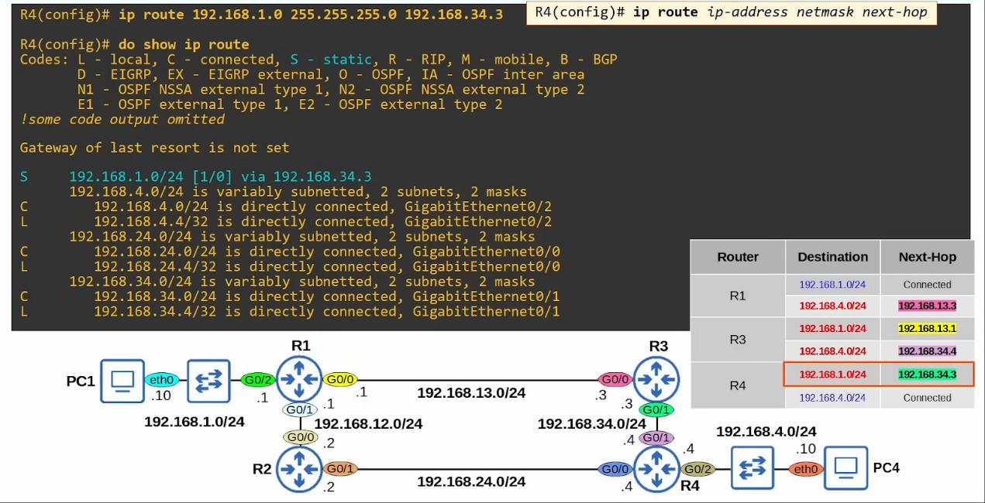

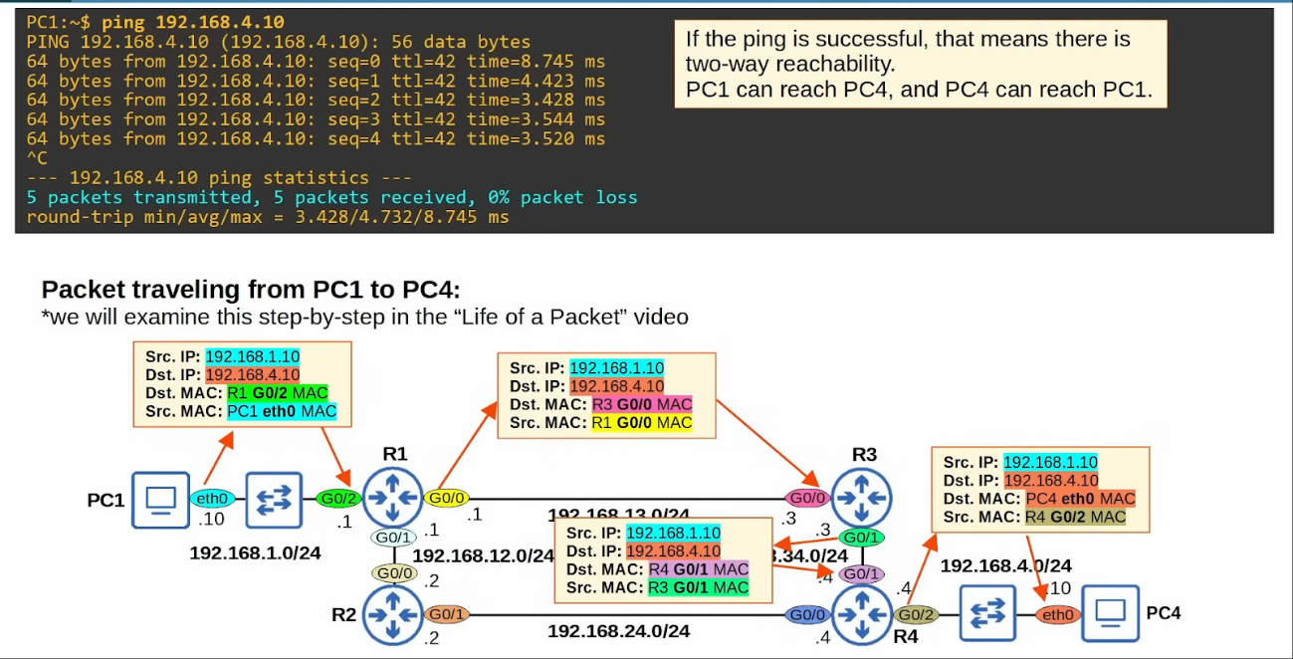

* Every time the packet is encapsulated and de-encapsulated, the source and destination MAC address changes while the source and destination UP remains the same

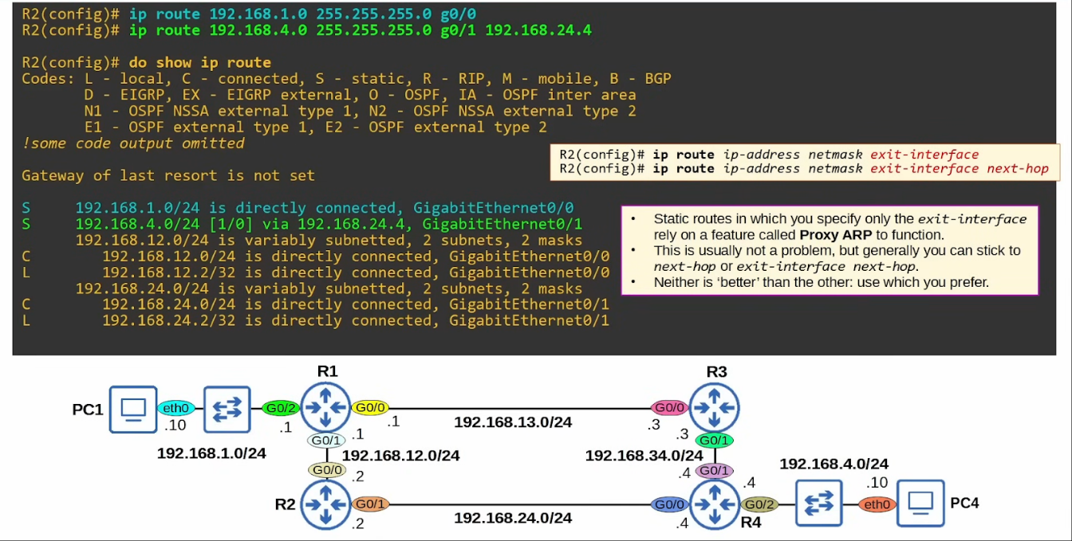

Default Route

* A **default route** is a route to 0.0.0.0/0
  + It is the least specific route possible, consists of all IP address
* If router don't have any more specific routes that match a packet's destination IP address, the router will forward the packet using the **default route**
* A default route is often used to direct traffic to the Internet
  + More specific routes are used for destinations in the internal corporate network
  + Traffic to destinations outside of the internal network is sent to the Internet

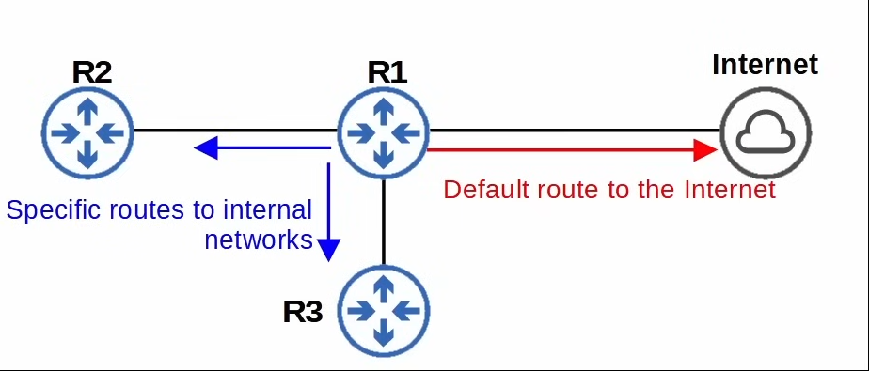

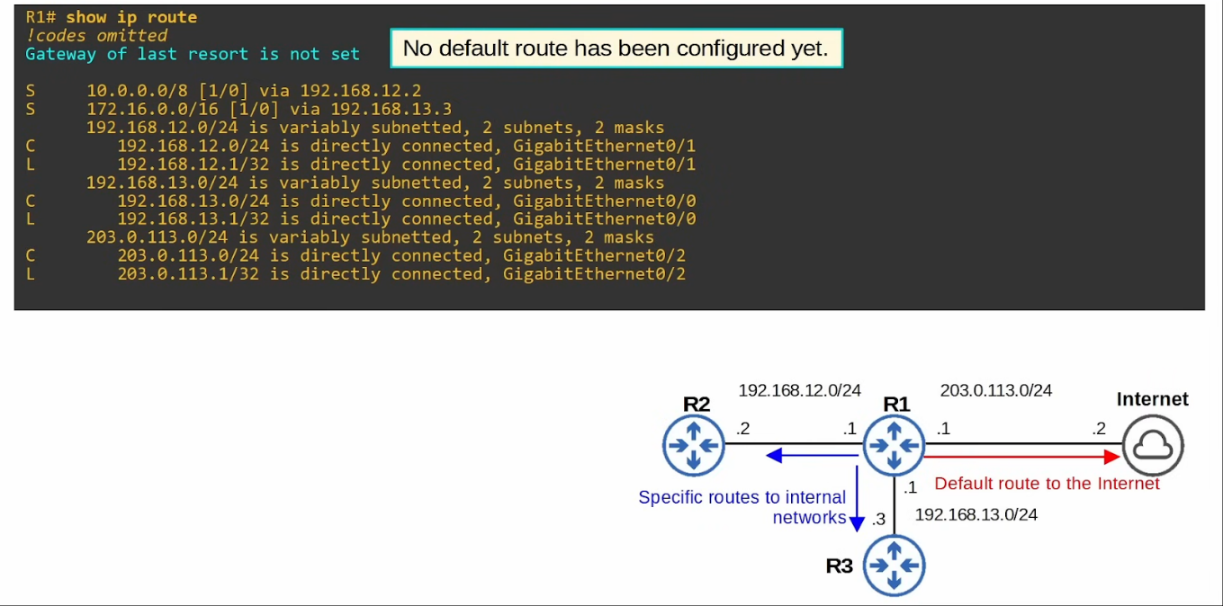

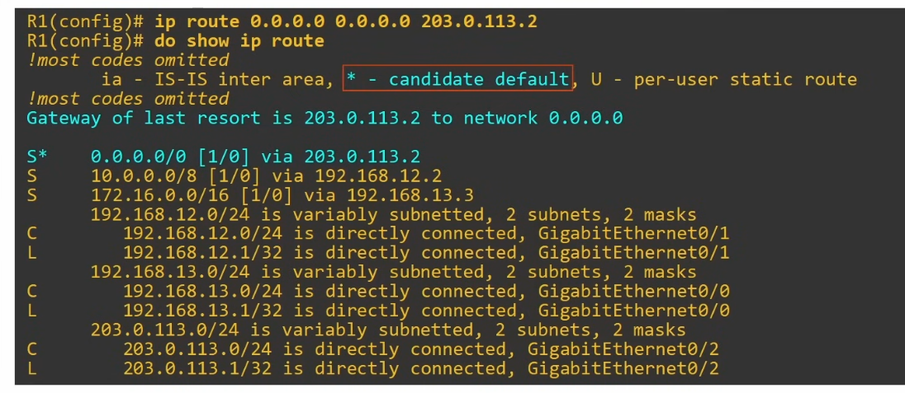

Things Covered

* Intro to Static Routes
* Static Route config
  + **"ip route <ip-address> <netmask> <next-hop>"**
  + **"ip route <ip-address> <netmask> <exit-interface>"**
  + **"ip route <ip-address> <netmask> <exit-interface next-hop>"**
* Default routes

## Life of a Packet

Things Covered

* Entire process of sending a packet to a remote destination
  + Includes ARP, encapsulation and decapsulation

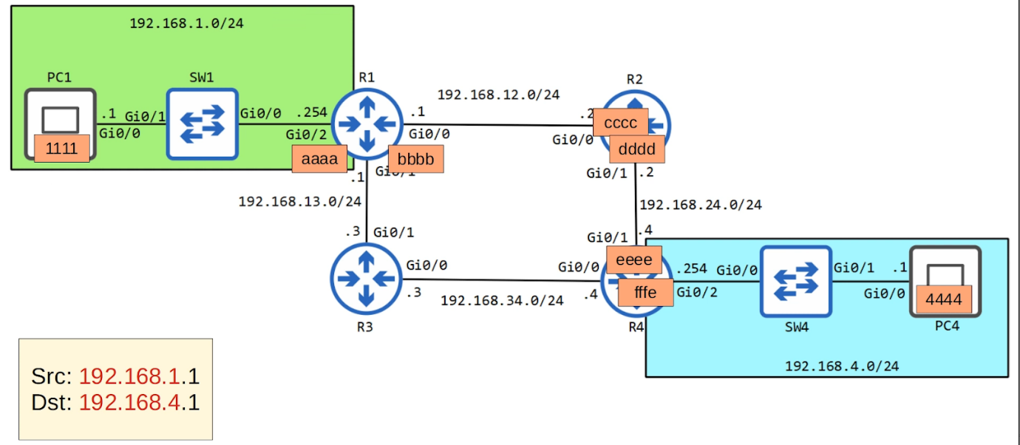

**PC1 -> R1**

* Sending from PC1 to PC4
* PC1 realises that PC4 is not in the same network due to different network address
* PC1 will need to send to the default gateway
* PC1 need to send ARP request (broadcast) to find the MAC address of R1

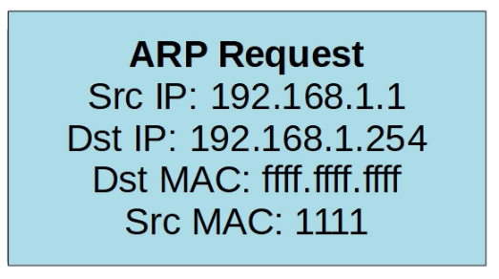

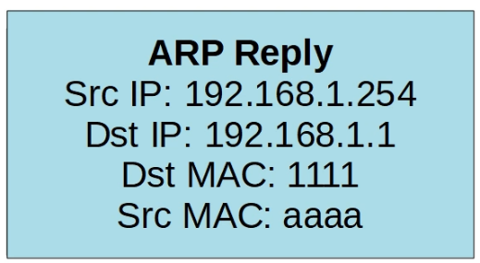

* R1 sends an ARP reply (unicast) to PC1
* Once PC1 has the MAC address, send to R1

**R1->R2**

* R1 receives and removes the Ethernet header
* R1 looks up the destination in its own routing table

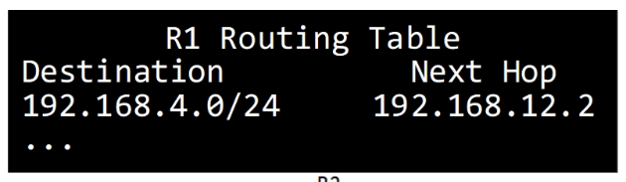

* R1 now needs to encapsulate the packet with a new Ethernet header with the MAC address of 192.168.12.2
* R1 However, don't know the MAC address
* R1 Send ARP request
* R2 send ARP reply
* R1 now knows R2 MAC address and send the packet to R2

**R2->R4**

* R2 removes Ethernet header
* Looks up destination on its own routing table

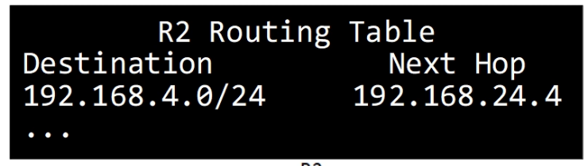

* Same process as R1->R2
  + Send ARP request
  + Get MAC address
  + Send to R4

R4->PC4

* Same thing as above
* Send ARP since don't know MAC of PC4
* IP header remained the same throughout
* Switches don't encapsulate/de-encapsulate the packet
  + They only learn the MAC address of device when packets are sent on the interface

PC4->PC1  (Reversed)

* Now all the routers have the MAC address of the other routers in the path
* No ARP request are sent

# Subnetting

 Things covered

* CIDR (Classless Inter-Domain Routing)
* Process of subnetting

IPv4 Address Classes

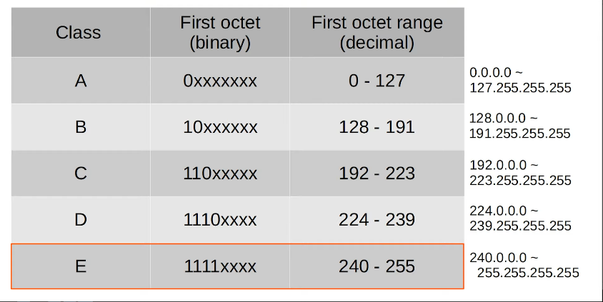

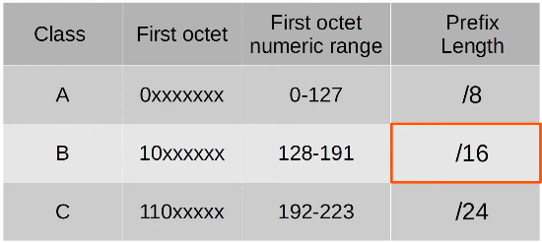

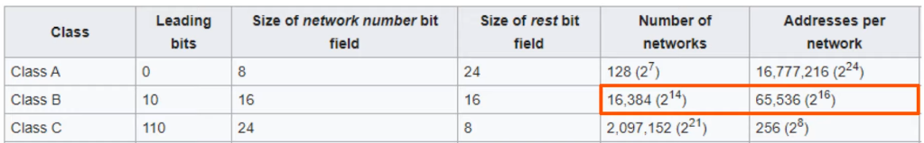

* The IANA (Internet Assigned Numbers Authority) assigns IPv4 addresses/networks to companies based on their size
* E.g. A large company may receive class A network while a small company receives a class C network
* However, leads to many wasted IP addresses

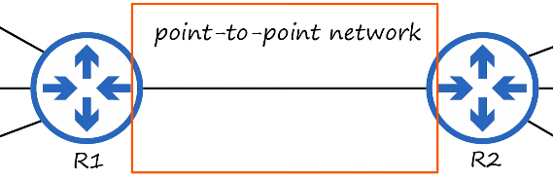

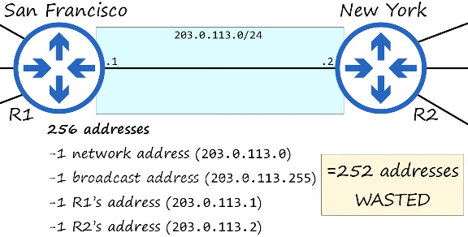

Classless Inter-Domain Routing (CIDR)

* Requirements for Class A = /8, Class B = /16, Class C = /24 were removed
* Allows larger networks to be split into smaller networks, allowing greater efficiency
* These smaller networks are called 'subnetworks' or 'subnets'
* Can have
  + /25 - 255.255.255.128 -> 2^7 - 2 = 126 usable address
  + /26 - 255.255.255.192 -> 2^6 - 2 = 62 usable address
  + /27 - 255.255.255.224 -> 2^5 - 2 = 30 usable address
  + /28 - 255.255.255.240 -> 2^4 - 2 = 14 usable address
  + /29 - 255.255.255.248 -> 2^3 - 2 = 6 usable address
  + /30 - 255.255.255.252 -> 2^2 - 2 = 2 usable address
    - E.g. If use /30 the remaining address blocks in /24 can still be used in other subnets
  + /31 - 255.255.255.254 -> 2^1 -2 = 0 usable address
    - Can be used in point-to-point networks
    - No need for network address and broadcast address
    - Used for the 2 routers

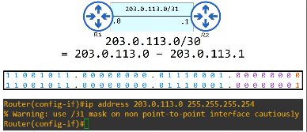

* /32 - 255.255.255.255
  + Can be used to create a static route to 1 specific host

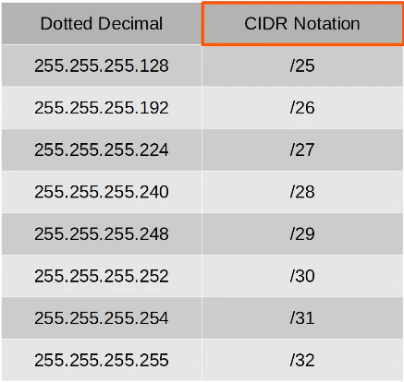

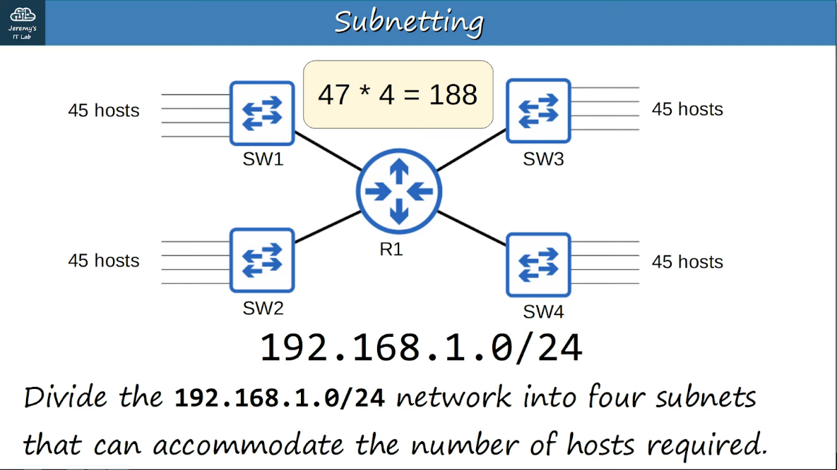

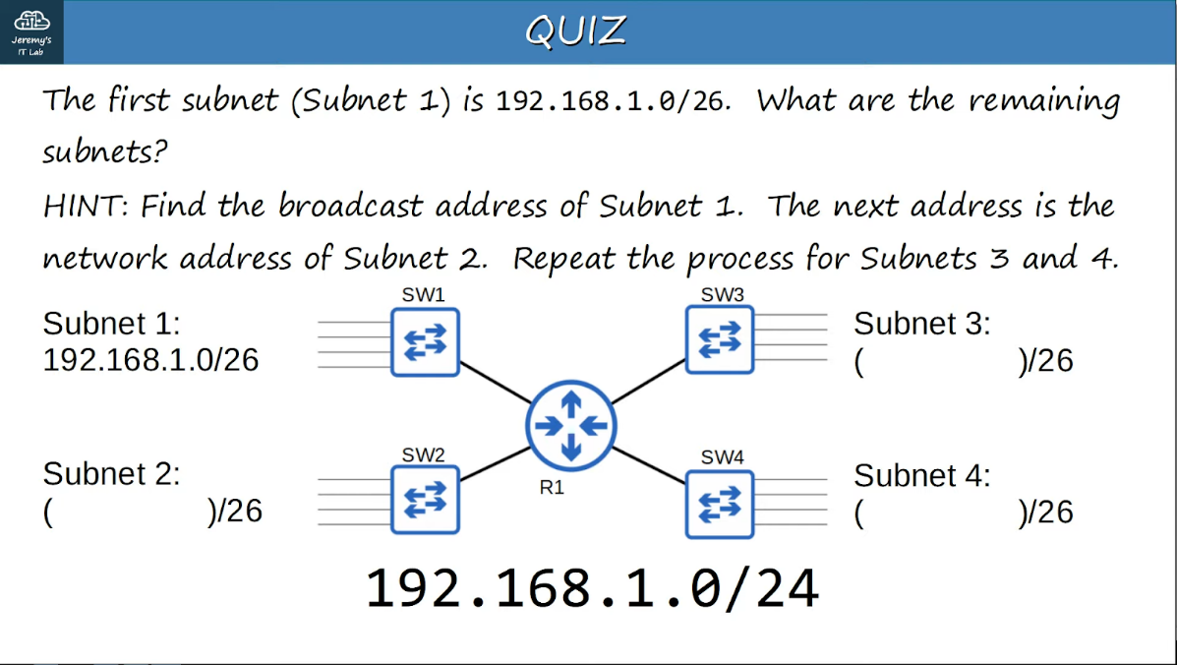

2^6 = 64 for each subnet

Subnet 1: 0 - 63

Subnet 2: 64 - 127

Subnet 3: 128 - 191

Subnet 4: 192 - 255

Example

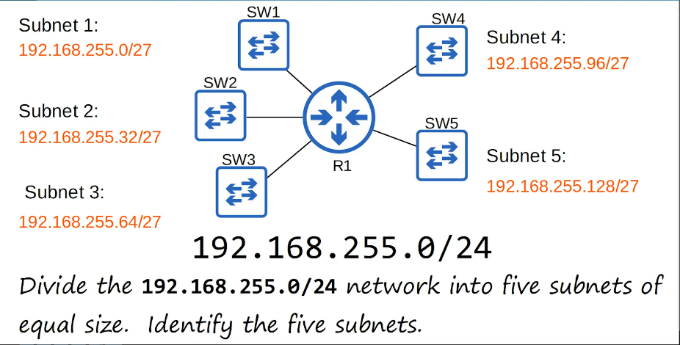

* When given n networks to divide
  + 2^b >= n
  + E.g. 2^3 = 8 <= 5
  + Last octet = **111**0 0000
  + Network portion of last octet = 111 - 128+64+32
  + Address of each subnet is 0, 0+32, 0+32+32…

Example

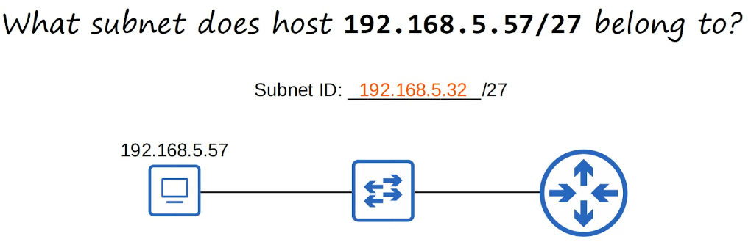

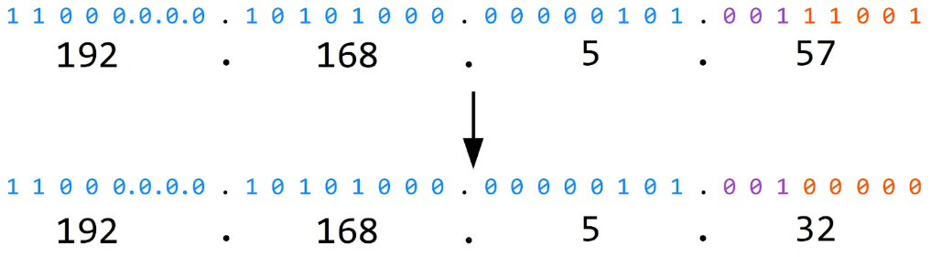

Example

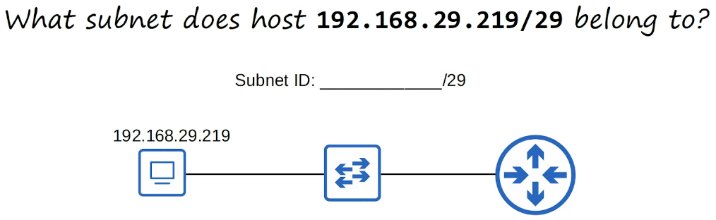

* Last octet = 1101 1011
* /29 -> 5 MSB
* Network portion = 1101 1000 -> 216
* Answer = 192.168.29.216

Subnets/Hosts (Class C)

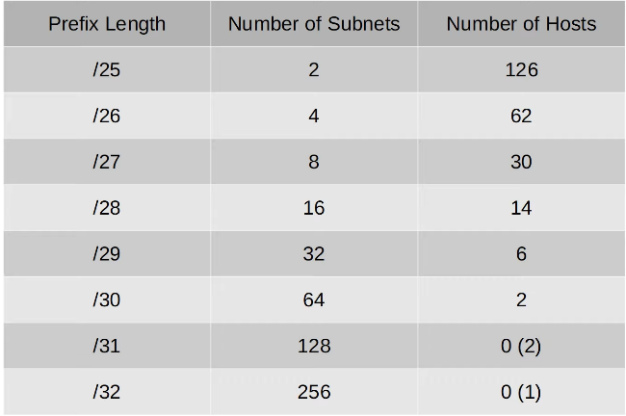

* For /31, can be used for point-to-point connection
  + With no network and broadcast address
* For /32, can be used for routing

Class B Subnetting

* Exactly same process as Class C

Example

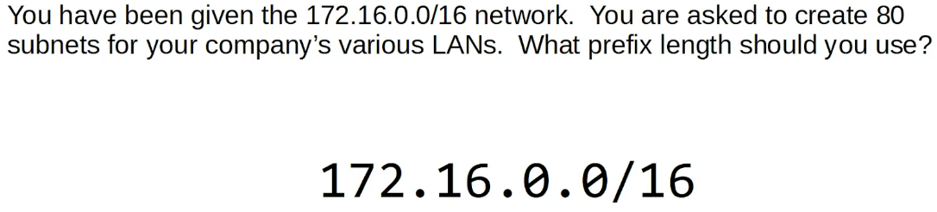

* 2 ^ 6 = 64
* 2^7 = 128
* 7 bits needed for last 2 octets for network portion
* 1111 1110. 0000 0000
* Subnet 1 = 172.16.0.0
* Subnet 2 = 172.16.2.0
* Multiples of 2
* Therefore 16+7 = /23

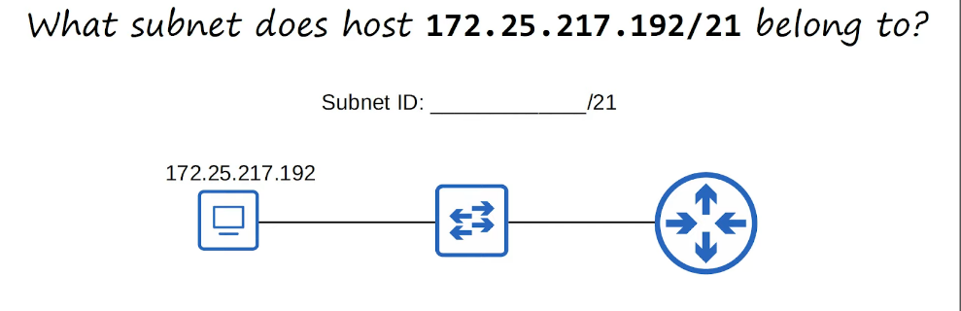

* 217 -> 1101 1001
* 1101 1000 = 216
* Ans = 172.25.216.0

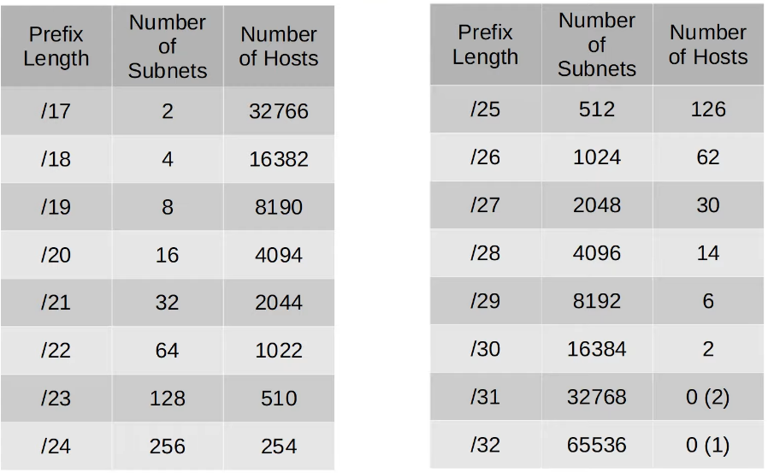

Class A Subnetting

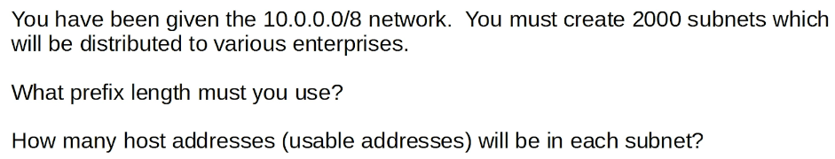

* 2^10 = 1,024
* 2^11 = 2,048
* Ans : 8 + 11 = /19
* Num of host address bits = 24 - 11 = 13
* 2^13 = 8,192 -2 = 8,190

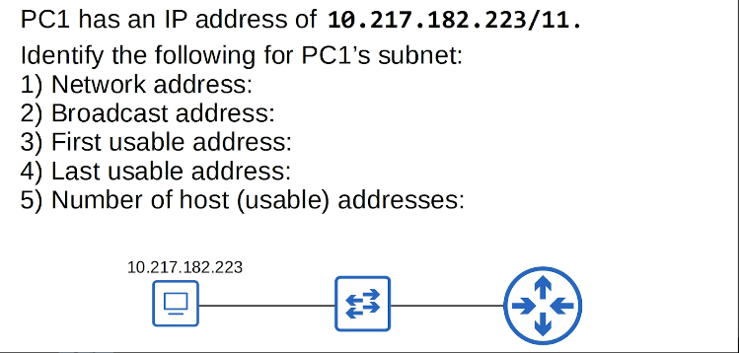

Q1)

* 217 -> 1101 1001
* 1100 0000 -> 192
* 10.192.0.0

Q2)

* 1101 1111 -> 223
* 10.223.255.255

Q3)

* 10.192.0.1

Q4)

* 10.223.255.254

Q5)

* 2^(32-11)=2,097,152
* 2097152-2=2 097 150

Variable Length Subnet Masks (VLSM)

* VLSM is the process of creating subnets of different sizes, to make your use of network addresses more efficient
* More complicated than FLSM

Step to solve VLSM

1. Start from the largest to smallest
2. Assign the appropriate netmask size
3. Get the network and broadcast address
4. Use the next address after broadcast address for the next subnet
5. Repeat Step 1

# VLAN

## VLAN Intro

Things Covered

* What is a LAN
* Broadcast domains
* What is a VLAN
* What is the purpose of VLAN
* How to configure VLAN

What is a LAN

* LAN
  + A single **broadcast domain** including all devices in that broadcast domain
* A broadcast domain
  + The group of devices which will receive a broadcast frame (destination MAC FFFF.FFFF.FFFF) sent by any 1 of the members

Broadcast Domain/LANs

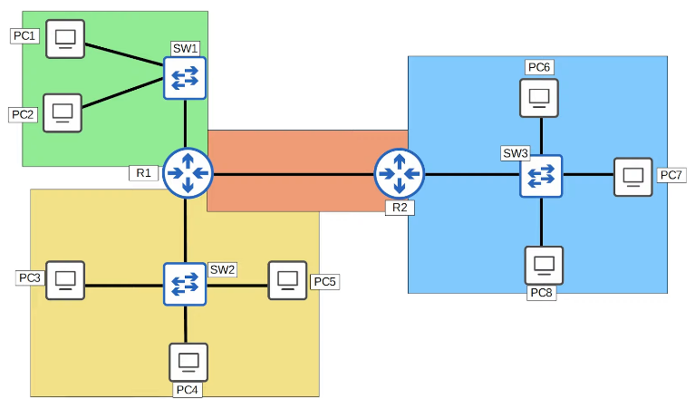

What is a VLAN

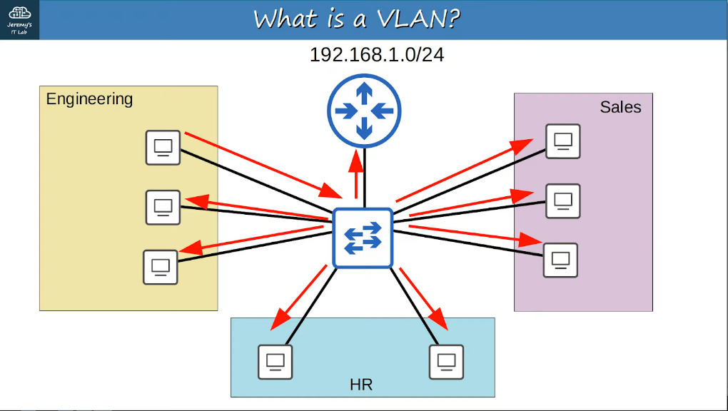

* Performance
  + Lots of unnecessary broadcast traffic can reduce network performance
* Security
  + Even within the same office, you want to limit who has access to what. You can apply security policies on a router/firewall
  + However, this is 1 LAN, so there won't be any effect

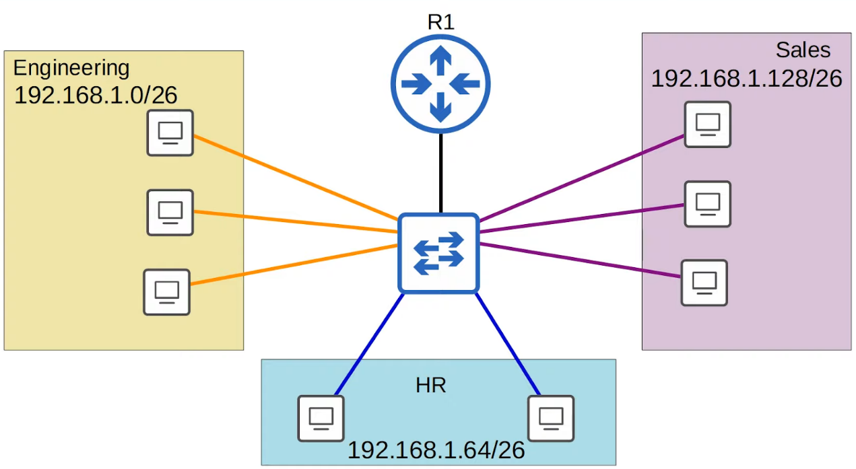

* When sending a broadcast message (MAC dest FFFF.FFFF.FFFF) from PC1, it will still be sent to all PCs even though they are in different subnets
* This is because switches operate at Layer 2 and only deal with MAC address
* Although we separated the 3 departments into 3 subnets (Layer 3) they are still in the same broadcast domain (Layer 2)

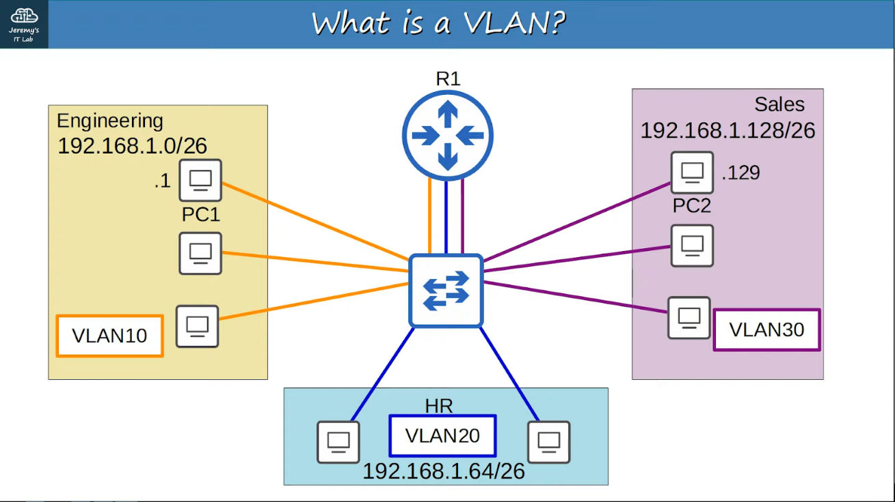

* Need to configure the switch
* Switch will not forward traffic btw VLANs, including broadcast/unknown unicast traffic
* Switch does not perform inter-VLAN routing, must send through the router
  + PC1 -> SW -> R1 -> SW -> PC2
* VLANs
  + Are configured on switches on a per-interface basis
  + Logically separate end hosts at Layer 2
* Switches do not forward traffic directly btw hosts in different VLANs

Configuration

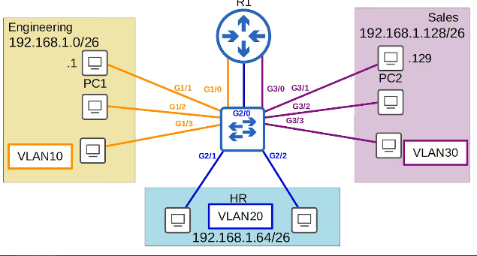

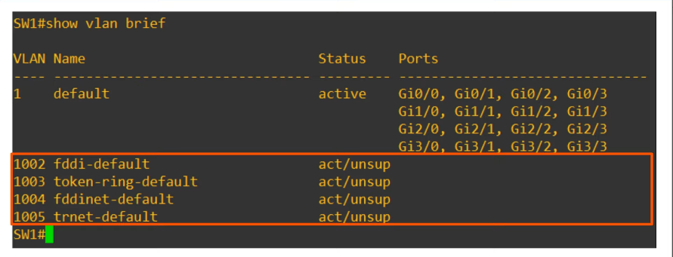

* VLANs 1, 1002-1005 exists by default, cannot be deleted
* 1002-1005 are old technologies, can ignore for CCNA

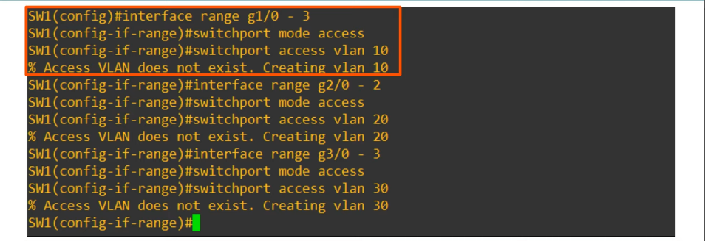

* "switchport mode access" sets the interface as an access port
* Access port
  + A switchport that belongs to a single VLAN, and usually connects to end hosts
  + Switchports which carry multiple VLANs are called 'trunk ports'

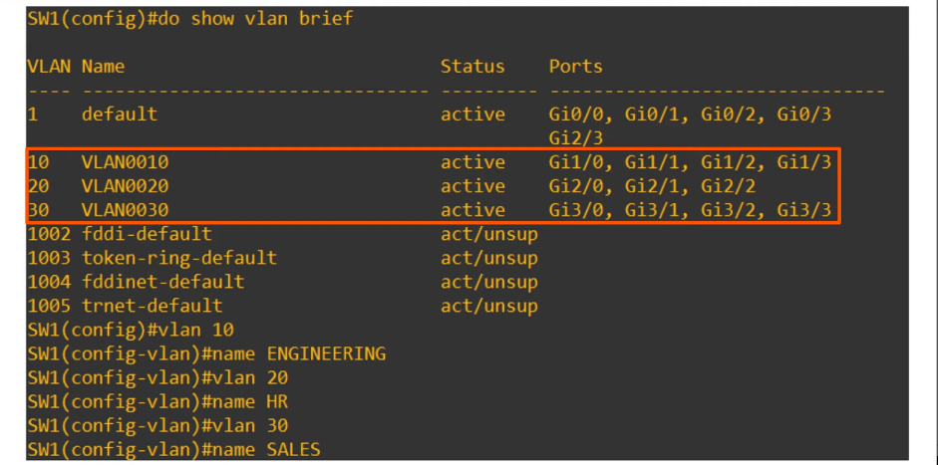

* "vlan 10" can also be used to create VLAN

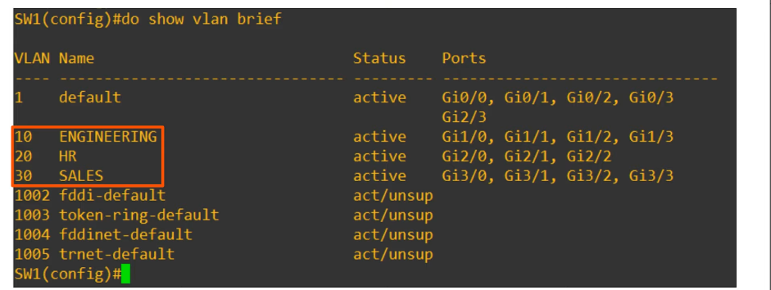

Commands

* **"show vlan brief"**
* **"interface <interfaces>**
  + <interfaces> : **"range f0/1-5"**
* **"switchport mode access"**
* **"switchport access vlan <VLAN_number>**
  + OR from global config mode, NOT interface mode
  + **"vlan <VLAN_number>**

## Trunk Ports

Things covered

* What is a trunk port
* What is the purpose of trunk ports
* 802.1Q encapsulation
* How to configure
* 'Router on a stick' (ROAS)

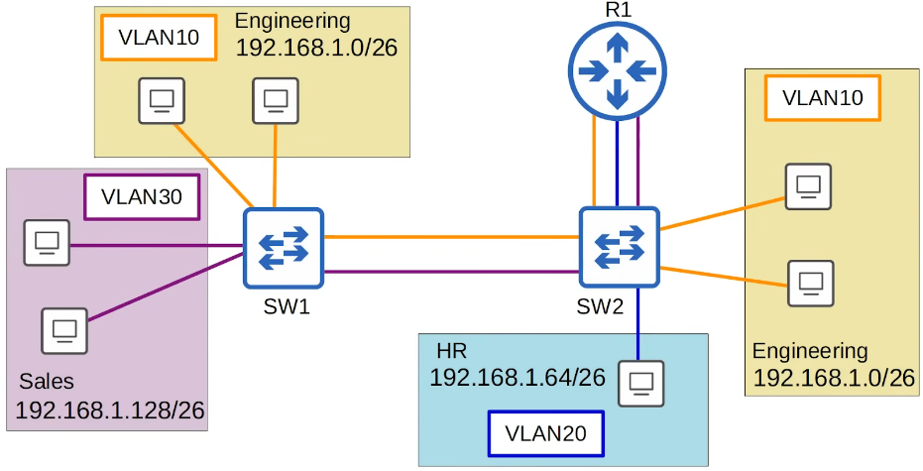

* There is no link in VLAN20 btw SW1 and SW2
* This is because there are no PCs in VLAN20 connected to SW1
* PCs in VLAN20 can still reach PCs connected to SW1, R1 will perform inter-VLAN routing

Trunk Ports

* For a small network for a few VLANs, possible to use separate interface for each VLAN
* However, if there is a large number of VLANs, it will lead to wasted interfaces, and routers often don't have enough interfaces for each VLAN
* Can use trunk ports to carry traffic from multiple VLANs on single interface
* Switches will 'tag' frames that they send over a trunk link
  + Allows the receiving switch to know which VLAN the frame belongs to
* Trunk ports = Tagged ports
* Access ports = Untagged ports

VLAN Tagging

* There are 2 main trunking protocols
  + ISL (Inter Switch Link)
  + 802.1Q (dot 1 q)
* ISL is old and not used in the real world
* Only need to know .1Q for CCNA

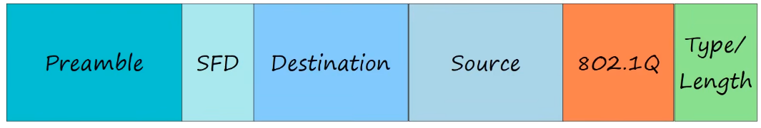

* The 802.1Q tag is inserted btw the Source and Type/Length field of the Ethernet frame
* 4 bytes
* Consists of 2 fields
  + Tag Protocol Identifier (TPI)
  + Tag Control Information (TCI)
* TCI consist of 3 sub fields

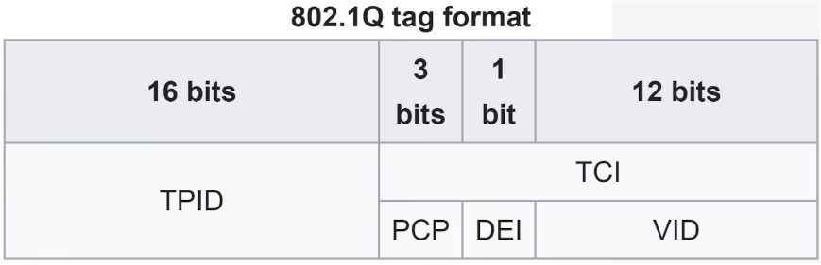

* TPID (Tag Protocol Identifier)
  + 2 bytes (16 bits)
  + Always set to 0x8100. Indicates the frame is 802.1Q tagged
* PCP (Priority Code Point)
  + 3 bits02.Q
  + Used for Class of Service (CoS), which prioritizes important traffic in congested networks
* Drop Eligible Indicator (DEI)
  + 1 bit
  + Indicates if frame can be dropped if network is congested
* VID (VLAN ID)
  + 12 bits
  + Identifies the VLAN the frame belongs to
  + 12 bits = 4096 VLANs, 0 - 4095
  + However VLANs 0 and 4095 are reserved and cannot be used
  + Actual range of VLANs: 1 - 4094
  + Cisco's proprietary ISL also has a VLAN range 1 - 4094

VLAN Ranges

* The range (1 - 4094) is divided into 2 sections
  + Normal VLANs : 1 - 1005
  + Extended VLANs : 1006 - 4094
* Some older devices don't support the extended VLANs, but modern switches do support them

Native VLAN

* 802.1Q has a feature called the **native VLAN** (ISL don't have the feature)
* The native VLAN is VLAN1 by default on all trunk ports
  + However, can be manually  configured on each trunk port
* The switch does not add an 802.1Q tag to frames in the native VLAN
* When a switch receives an untagged frame on a trunk port, it assumes the frame belongs to the native VLAN.
* **It's very important that the native VLAN matches**

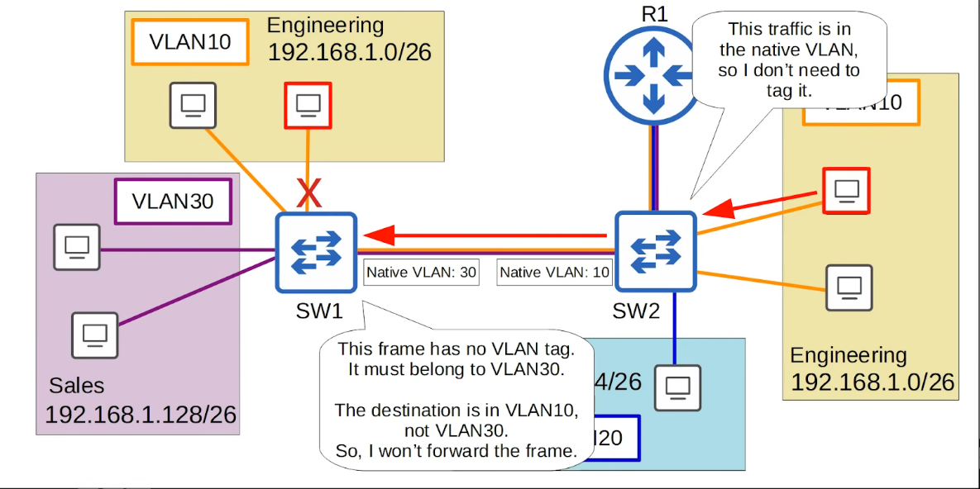

Configuration

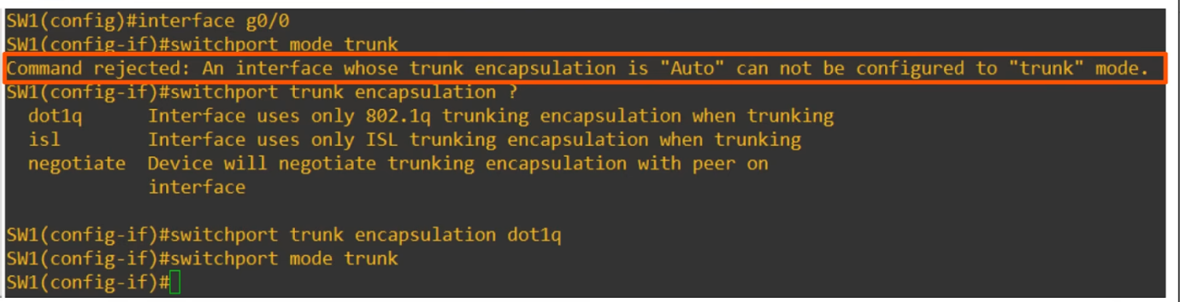

* Many modern switches do not support Cisco's ISL at all. The only support dot1q
* However, switches that do both (like in the example) have a trunk encapsulation of 'Auto' by default
* To manually configure the interface as a trunk port, you must first set the encapsulation to dot1q or ISL
  + On switches that only have dot1q, not necessary
* After setting the encapsulation type, you can then configure the interface as  a trunk

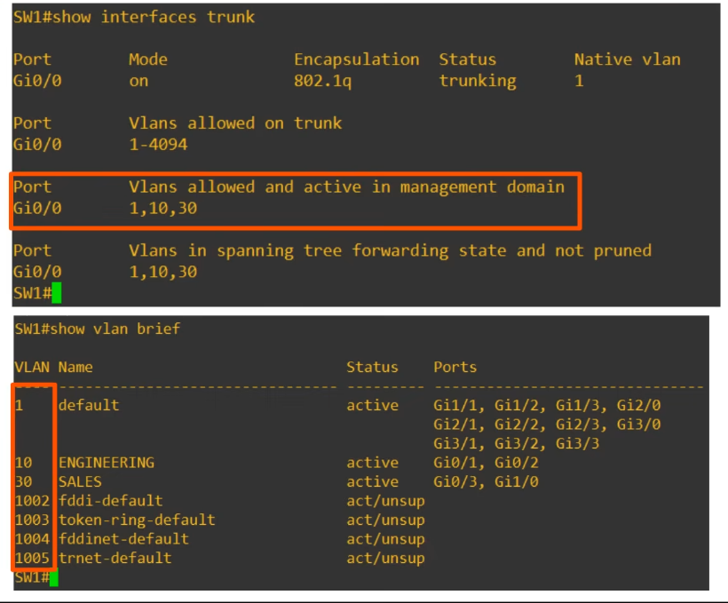

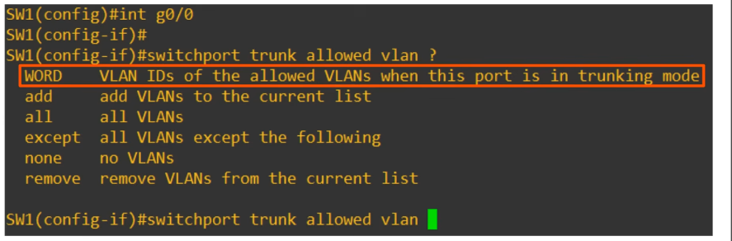

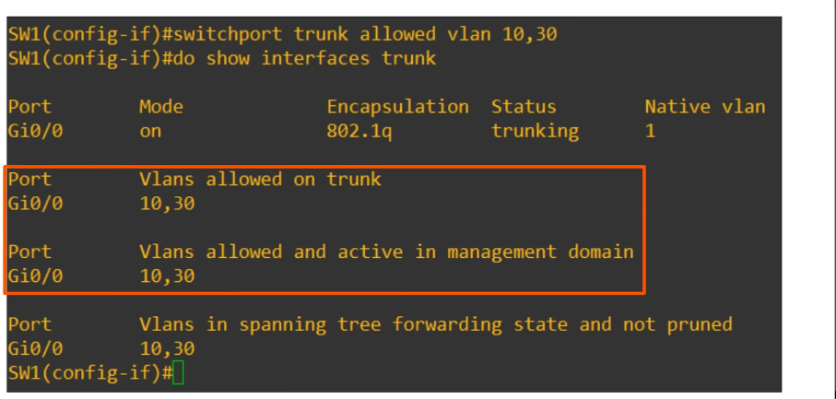

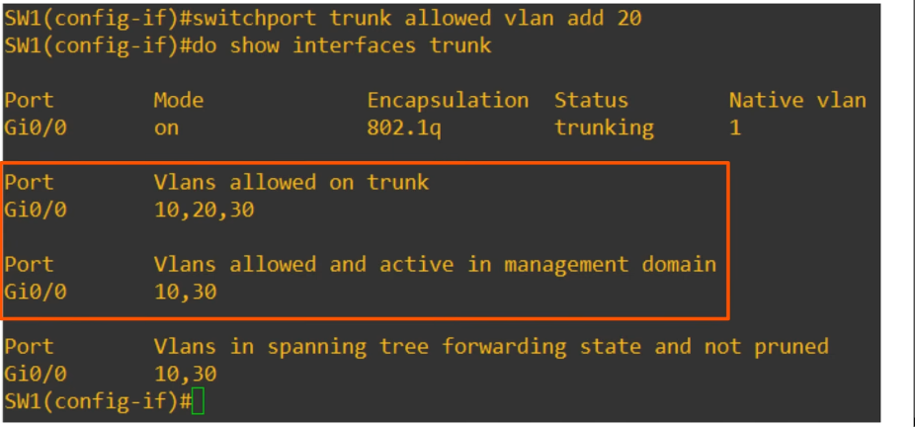

* VLAN20 has not been created yet, so not in the "Vlans allowed and active in management domain"

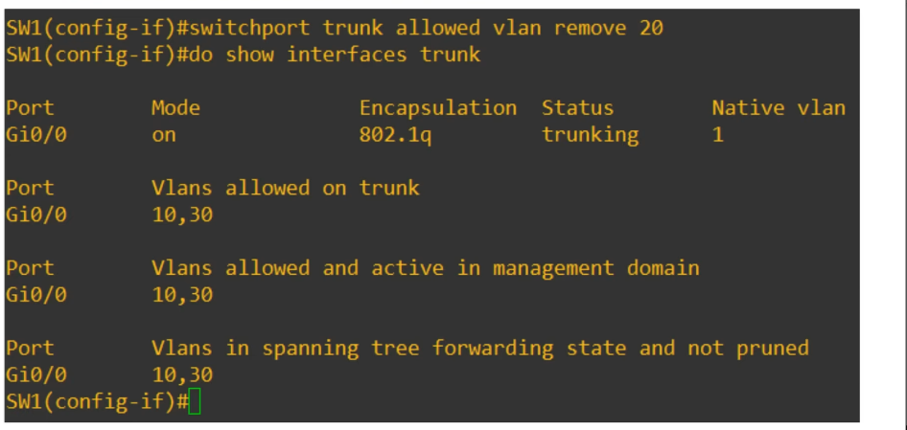

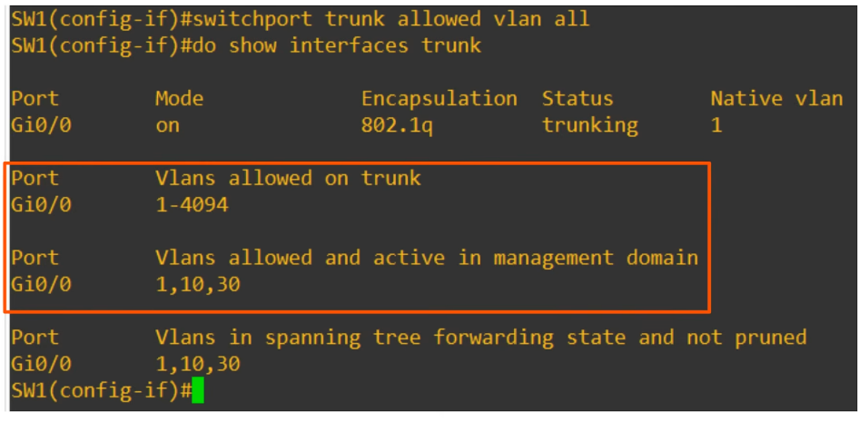

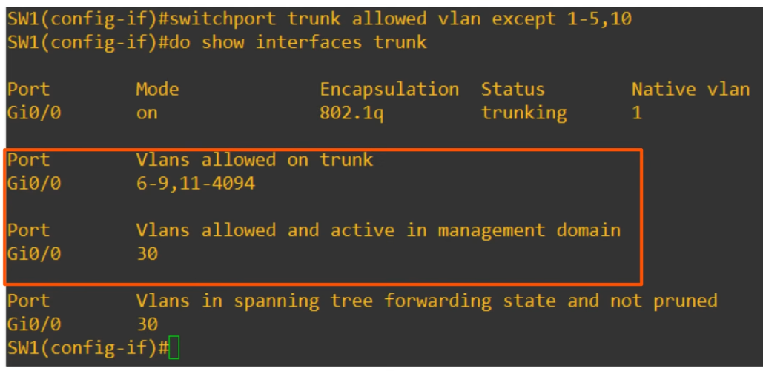

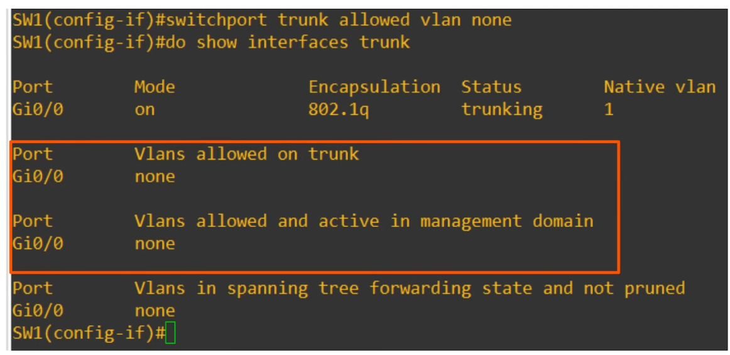

VLAN

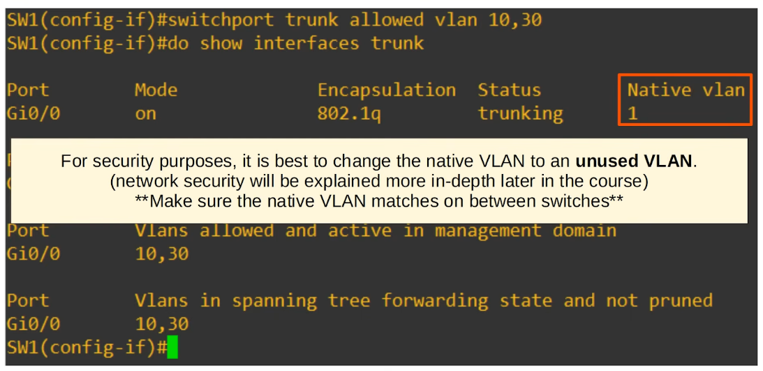

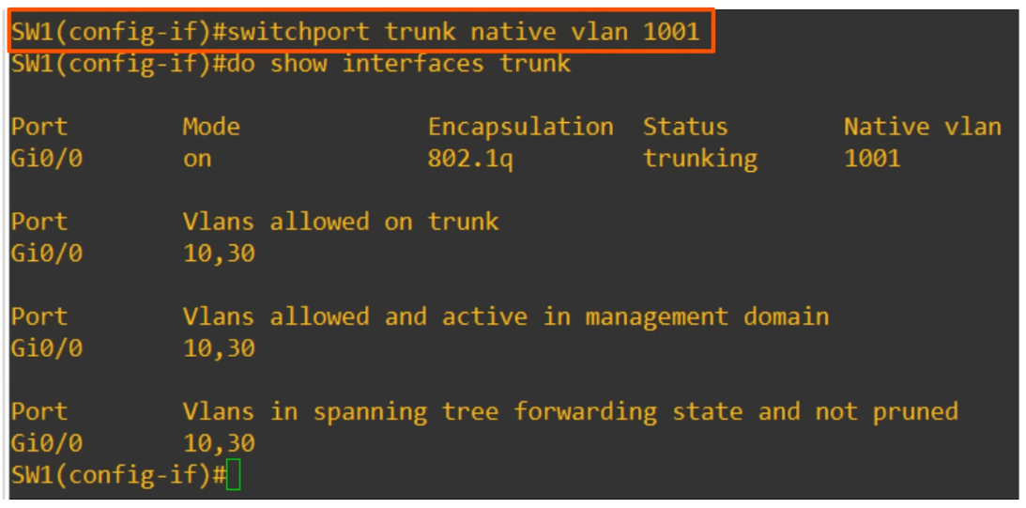

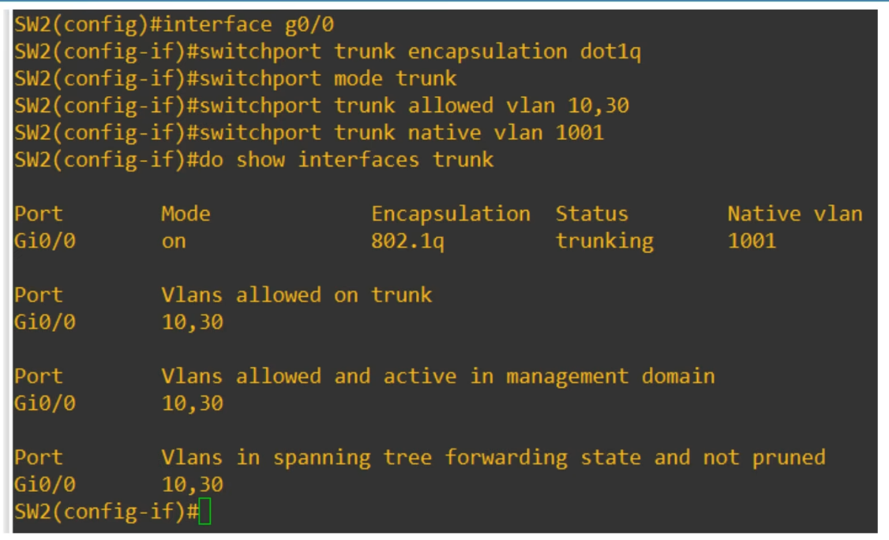

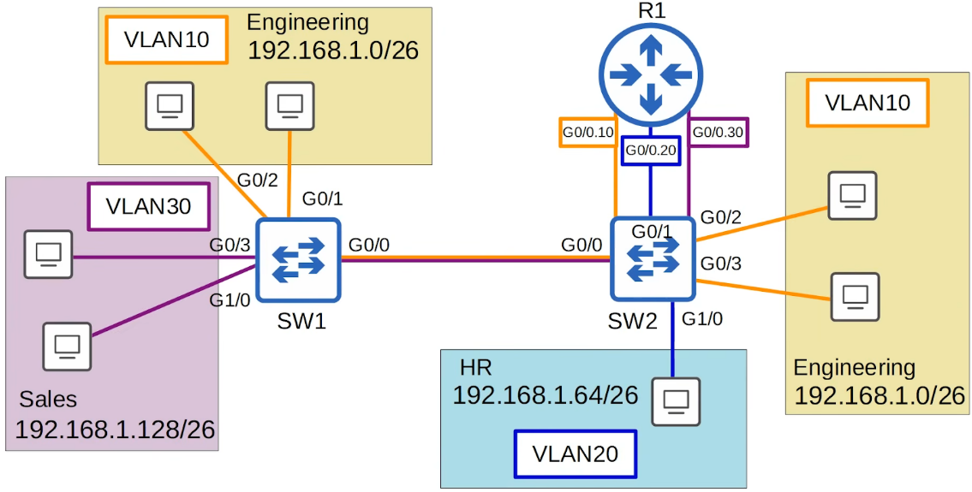

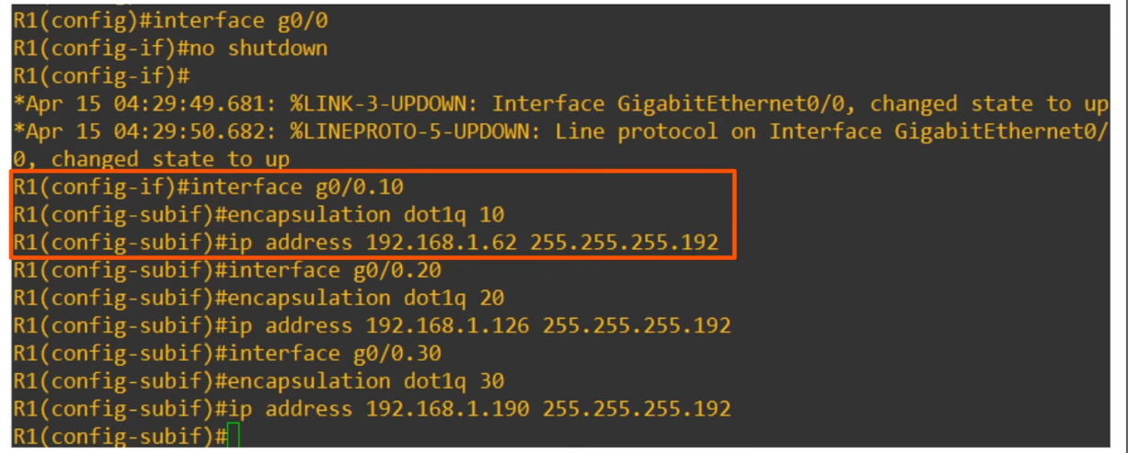

* Good practice to make the interface the same number as the VLAN
  + E.g. VLAN10 = g0/0.10

ROAS (Router on a stick)

* Used to route btw multiple VLANs using a single interface on the router and switch
* The switch interface in configured as a regular trunk
* The router interface is configured using sub-interfaces
  + You configure the VLAN tag and IP address on each sub-interface
* The router will behave as if frames arriving with a certain VLAN tag have arrived on the sub-interface configured with that VLAN tag
* The router  will tag frames sent out of each sub-interface with the VLAN tag configured on the sub-interface

Commands

Switches

* **"interface <interface>"**
* **"switchport trunk encapsulation dot1q" OR**

**"switchport mode trunk"**

* **"switchport trunk allowed vlan <VLAN_number>**

**"switchport trunk allowed vlan add <VLAN_number>**

**"switchport trunk allowed vlan all"**

**"switchport trunk allowed vlan except <VLAN_number>"**

**"switchport trunk allowed vlan none"**

**"switchport trunk allowed vlan remove <VLAN_number>"**

* **<VLAN_number>: can be "1-5,30"**
* **"show interfaces trunk"**

* **"switchport trunk native vlan <VLAN_number>**
  + <VLAN_number> should be an unused one for security purposes
  + E.g. 1001

Routers

* **"interface <interface>"**
* **"no shutdown"**
* **"interface <sub-interface>"**
  + <sub-interface> : should be same as vlan_number
  + E.g. g0/0.10
* **"encapsulation dot1q <VLAN_number>"**
* **"ip address <ip_address>**"